

DIRECT TRAVEL WELCOMES YOU TO

Concur Travel

Using Self Registration

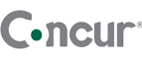
Direct Travel Welcomes You to the Concur Travel Online Booking Tool!
Your company has chosen to utilize Concur to enable you to quickly and easily manage your travel arrangements 24 hours a day, via your web browser. Click on the Direct Travel logo below to access Concur Travel Self Registration Link.

- Once you access the link you will be required to complete the form to set up your account.
- Your account will be created and you will receive an email to log in and create your password.
  - Passwords must be a minimum of seven characters using alphanumeric values.
- Once you have created a new password, you are required to complete your travel profile. You should click on PROFILE and activate your account by adding at least your home and business phone numbers.
- If you have an assistant who books your travel, please scroll down to the second to last box and click on "Add an Assistant".
  - Type the last name of your assistant in the box and then select the correct person.
  - Check the "Can book travel for me" box.
  - NOTE: The travel assistant/arranger must also activate their account in order to be able to book travel for others.
- Once you have completed these steps and activated your profile, you will be able to book travel.
Direct Travel’s Help Desk Support provides technical assistance with Concur Travel between the hours of 8:00AM and 8:00PM, Eastern Standard Time, Monday through Friday. You may also email onlinetoolsupport@dt.com or call 1-800-999-7939 to reach a technical support representative.
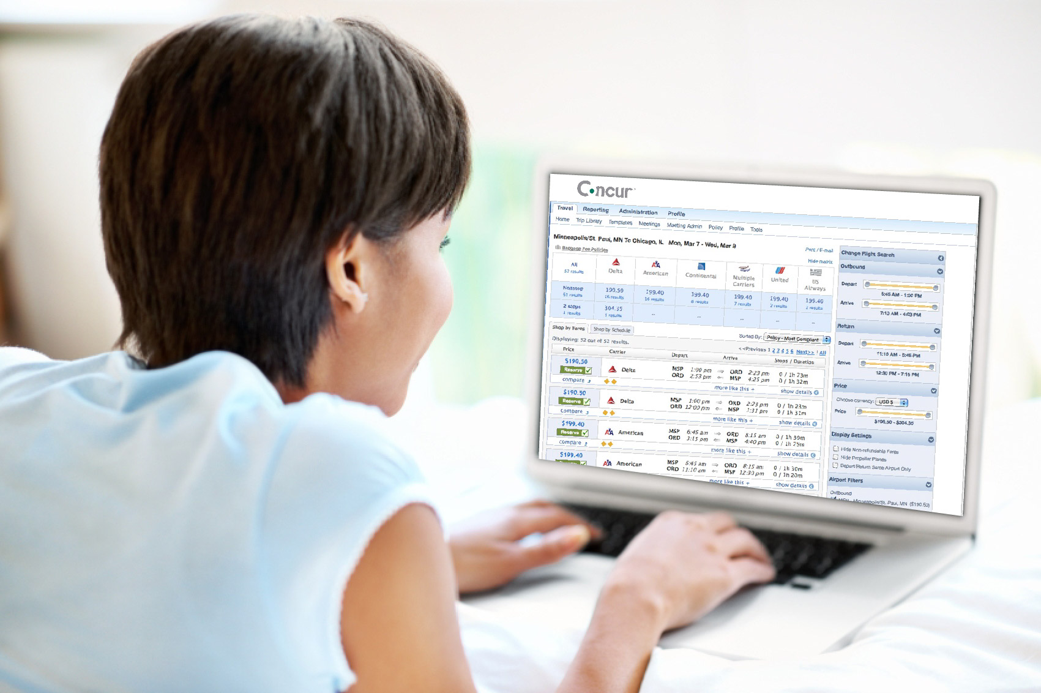
For support regarding travel issues, please contact your travel consultant.

