Tennessee State University
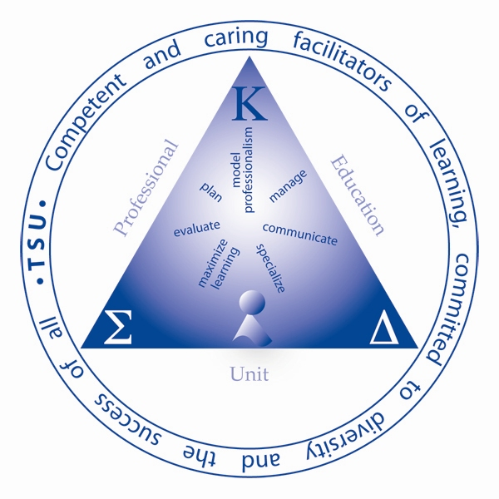

Professional Education Unit
Department of Teaching and Leaning
Philosophical Foundations of Education
EDCI 5260
Spring Semester

Instructor: XXXXXXXXXX
Phone: XXXXXXXXXX
E-mail: XXXXXXXXXX
Office Location: XXXXXXXXXX
Class Days/Times: XXXXXXXXXX
Office Hours: XXXXXXXXXX

Required Text:
Ozmon, H.A. & Craver, S.M. (2011). Philosophical foundations of education. (9th ed.) Prentice Hall. [ISBN-13: 9780131996250 $87.50 (new) $65.75 (used).]
Catalog Description:
A critical examination of the purpose of education in our elementary and secondary schools and the bearing of this purpose on problems of organization and administration, the selection of subject matter, and classroom practice. Consideration will be given to the significance of our education purpose and practice to our concept of a democratic society.

Field Experience: None

Course Proficiencies (Content Knowledge, Skills, Dispositions)
Content Knowledge: Students in EDCI 5620 are expected to …
- Discuss the contributions of historical and contemporary philosophers and discuss how their contributions have influenced our present educational system. (KS2, KS6, P2)
- Assess the work and contributions of these important philosophers and philosophies and analyze the works with regard to current educational issues. (KS2, KS3, KS6, P4)
- Identify and respond to philosophical keywords in a challenging and logical manner. (KS5, KS6, P4, P5)
- Compose a personal philosophy of education. (KS1, KS2, KS6, P4, P6)
Skills: Students in EDCI 5620 are expected to …
- Read, analyze, evaluate and discuss historical and contemporary philosophies in both oral and written form. (KS2, KS6, P2, P4)
- Use historical and contemporary philosophies to discuss observations and inferences in context of the teacher’s role in the educational process. (KS3, KS5, KS6, P5)
- Compare and contrast the positions of educational philosophers to explain how philosophical contributions build on previous ideas. (KS2, KS3, P2, P4)
- Use written and oral communication to explain the development of the philosophical foundations that tie theory to educational practice. (KS1,KS3, KS6, P4, P5)
- Identify, critique, and appropriately respond to assessments and criticism from members of the public and the media regarding public education. (KS5, KS6, P5)

Dispositions: Students in EDCI 5620 are expected to …
- Cooperate and communicate with the class instructor regarding course assignments, clarifications, exceptions, revisions and special requests pertaining to assignments and the action project. (KS4, KS5, KS6, D4, D6, P5)
- Cooperate and communicate with their classmates to complete in-class activities, course assignments, and projects. (KS4, KS5, KS6, D4, D6, P5)
- Comply with the standards of the National Research Act of 1974 and the Family Educational Rights and Privacy Act of 1974 in completing assignments, in class exercises, and projects. (KS 5, D5,D7, P5)
- Adhere to exemplary professional standards that demonstrate their commitment to excellence in education and that would distinguish themselves, the department, the University, and other associated agencies. (KS 5, D5,D7, P5)
- Explain how their own philosophical beliefs fit within the landscape of historical and contemporary philosophical beliefs and how the consideration of each tradition has contributed to their understanding of their roles as teachers and instructors. (KS5, P5)

Class Schedule
Readings are assigned on the dates below and must be read before the next class period. Even if a reading is not discussed in class, you are responsible for knowing the material in it.
Date | Aspect | Description | Comments
08/27 | Topics | Orientation, Introductions
08/27 | Assignments | Read Chapter 1
09/03 | NO CLASS - LABOR DAY HOLIDAY
09/10 | Topics | Idealism in Education
09/10 | Assignments | Read Chapter 2
09/17 | Topics | Realism in Education
09/17 | Assignments | Read Chapter 3
09/24 | Topics | Eastern Philosophies of Education
09/24 | Assignments | Read Chapter 4
10/01 | Topics | Pragmatism in Education
10/01 | Assignments | Read Chapter 5
10/08 | Topics | Reconstructionism in Education | Take-Home Midterm Due
10/08 | Assignments | Read Chapter 6
10/15 | NO CLASS – FALL BREAK
10/22 | Topics | Behaviorism in Education | Draft Growth Plan Due
10/22 | Assignments | Read Chapter 7
10/29 | Topics | Existentialism in Education | Draft Analysis Topic Due
10/29 | Assignments | Read Chapter 8
11/05 | Topics | Marxism in Education
11/05 | Assignments | Read Chapter 9
11/12 | Topics | Analytic Philosophy in Education
11/12 | Assignments | Read Chapter 10
11/19 | Topics | Postmodernism in Education | Professional Growth Plan Due
11/19 | Assignments | Handouts
11/26 | Topics | Individual Conferences | School Analysis Topic Due
11/26 | Assignments | Complete Term Project
12/03 | Topics | Term Project Presentations | Term Project Due
12/03 | Assignments | Prepare for Final Examination
12/10 | Topics | In-Class Comprehensive-Styled Final Examination

Grading System
Class Participation | 10%
School Improvement Analysis Topic Paper | 10%
Professional Growth Plan | 10%
Personal Philosophy of Education | 10%
Midterm Examination | 20%
Final Examination | 20%
Term Project | 20%
TOTAL | 100%

Course Policies
The University has directed faculty to give students a written statement of course policies. The policies below arose from events that took place in my classes or are required by the University. I will try to apply the policies uniformly yet remain responsive to unexpected situations.
ATTENDANCE/TARDINESS: Because of my interactive, small group approach to teaching, it is essential that you attend and be on time for each class. Many class periods will begin with a small group activity that is the basis for activities, discussions and application later in the period. If you arrive late, you will either miss the foundation for later activities or interfere with others’ learning. A roll sheet, which you must sign and is the official record of attendance, will circulate at the start of each class. You may sign in if you arrive after class begins, but you will be considered late. I reserve the right to lower your course grade if you frequently are late, do not attend or leave class early. Problems with the enrollment process or financial aid are not excused absences. Excused absences are rare and reserved for extreme situations or emergencies demanding personal attention.
WEATHER PROBLEMS: Class will meet for every class session except as noted in the syllabus or when the University is closed due to weather problems. I realize that some students must drive from locations where the weather conditions may be worse than in Nashville. I do not expect you to put yourself in danger to attend class; however, please notify me by email if dangerous weather prevents you from getting to class.
CLASSROOM CONDUCT: As the instructor, I have the primary responsibility for control over classroom behavior and maintenance of academic integrity, and can order temporary removal or exclusion from the classroom of any student engaged in disruptive conduct or conduct in violation of the general rules and regulations of the institution. Please do not use cell phones or text during class. Except for emergency situations, cell phones or pagers must either be turned off or put on silent during class. This includes texting. If there is an emergency, please step into the hall to use your phone.
LATE/MISSED WORK: Work is due on the date specified in the syllabus unless I announce a change in class. If you are going to miss class, you must make arrangements for someone else to turn in the work for you. If you are required to (or given the option to) resubmit a graded assignment, must be turned in the class period after I return the original work to you. I reserve the right to lower the grade for any work that is not turned in on time.
TEXTBOOKS: I rely heavily on the course text. Unless I inform you that the text has not arrived in the bookstore, you are expected to have it by the second week of class.
DISABLED STUDENTS: Should you have any health problem or handicapping condition that might interfere with your ability to perform the requirements of this course, please contact the Office of Disabled Student Services in 117 Floyd Payne Building (963-7400). Pursuant to an evaluation, they will give you documentation detailing the types of accommodations you are to receive. In order to meet your needs, I must have this documentation by the second week of class.
RECORDING DEVICES: Unless you receive prior permission, you may not make audio or video recordings in class. I believe that such recordings inhibit open discussion. Students who have a disability statement from the Office of Student Disabilities are exempt from this restriction.
ACADEMIC INTEGRITY: You are individually responsible for your own learning and work. Cheating or plagiarism will not be tolerated. Any material taken from another work (including your own previously submitted coursework) must be documented, and in no case can another’s work be used as one’s own without penalty. Never represent another’s work as your own (e.g., information received from others during examinations or submitting another’s assignments, papers). Use APA style to cite others’ work that you use to make your point. I am very good at using the internet and can easily spot when a student’s language use is inconsistent with previous work. To avoid the appearance of plagiarism, students doing collaborative projects should exercise extreme caution. If in doubt, check with me. In addition to discipline which may be imposed through regular institutional academic misconduct procedures, I retain the right to assign an “F” (or zero) for an assignment or an “F” in the course and to prohibit the student from attending class sessions for the duration of the semester.
CHILDREN: It is TSU policy that children may not be brought to the class, left unattended in a hallway or snack room, or allowed to remain unattended on campus. Faculty have been directed, in writing, to tell any student who brings children to class to leave. I will do so.

EDCI 5260 TERM PROJECT

As part of this course, students in EDCI 5260 will complete a term project that conforms to the following criteria.
  - For each chapter in the text, you must find and critique a recent journal article or journal-length professional resource.
  - Each critique must consist of two parts:
      - A summary of no less than one complete page reviewing the major points covered in the resource.
      - A critique/evaluation of no less than

