**Developing Service-Learning Courses**

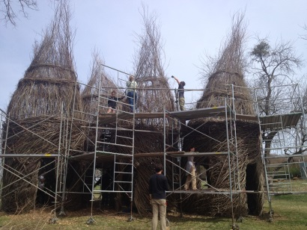

**Art students getting “hands-on” experience by assisting**

**Patrick Dougherty in assembling artwork at Cheekwood (currently on display)**

There are a number of ways to incorporate the service-learning component. Service-learning can be added to one section of an existing course, all sections of the course with a course change adding in the course description the requirement of a service-learning component (CARF), or developing a new course through the course proposal process (CARF).

**Considerations** are:

1. If adding service-learning to an existing course, the service-learning would be an assignment with a course learning outcome associated with that assignment and a detailed description of the assignment. This would seem to be a temporary measure and would rely on the same instructor continuing to teach the course or another instructor who would continue with the service-learning requirement.
2. To be consistent with multiple sections of a course, the course description could be revised to include the statement that there is a service-learning component. The revision would require the completion of a CARF and review by the University Curriculum Committee. The syllabus would include a course learning outcome related to the service project. A more detailed description of the service-learning assignment would be included. Several courses already state that service-learning is a part of the class.

**SL Designation:**

In order for students to avoid taking too many service-learning courses in one semester, courses and course sections need to be designated as such. One means of designating a service-learning course would be for the Department Head to enter SL after the course section number.

**Guide to Developing Service-Learning Courses:**

**(Currently under revision but 2011-2013 still available online)**

2011-2013 Guide to Developing Service-Learning courses:

<http://www.tnstate.edu/servicelearning/documents/SL%20Course%20Approval%20Manual.pdf>

Center for Service Learning personnel are available to work with individual faculty or with groups to assist in the development/revision of courses for service-learning. Workshops are typically held twice a year; the mini-grant application is posted on the Center’s webpage.

**Certificate of Acknowledgment of Service-Learning:**

The Center will provide a Certificate to students indicating their hours of completed service-learning if 20 hours or more. Currently, this is completed on a semester basis based on information provided by the course instructor.