HOOTSUITE Quick Guide

GO TO hootsuite.com and click “Login”

ENTER LOGIN INFO (keep this in a safe place; not online)

HOW TO POST:
- On leftnav, click edit icon

- Box will pop up.
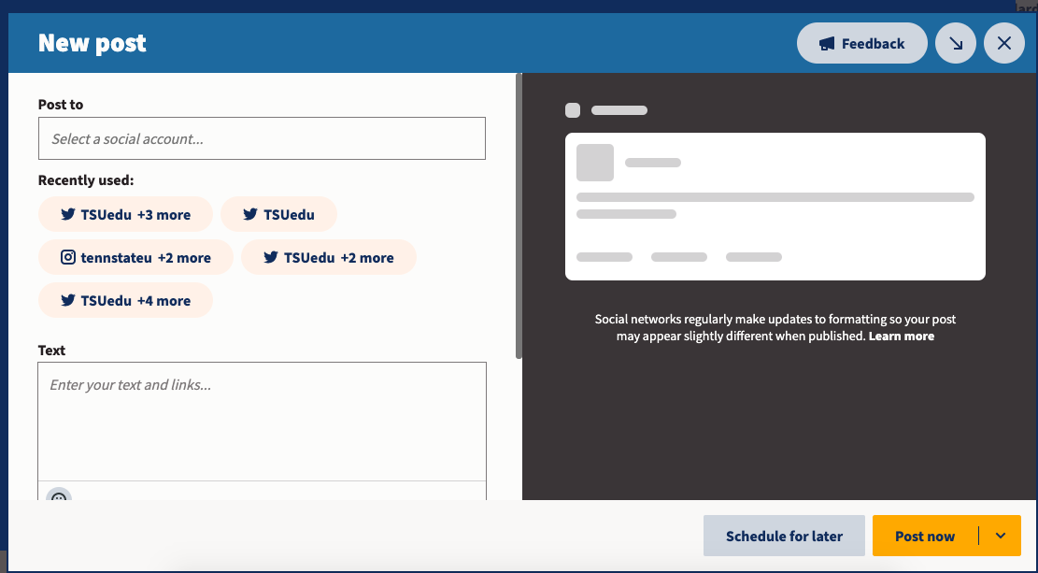
- Click inside “Post to” box. Check boxes next to each platform you’re posting to

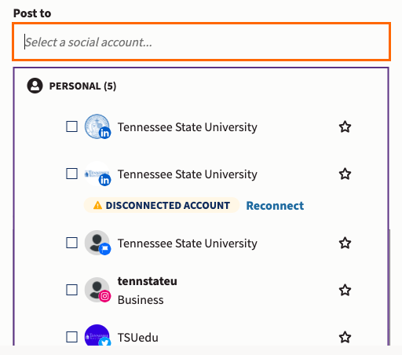

- Add the message you’re posting into the text box 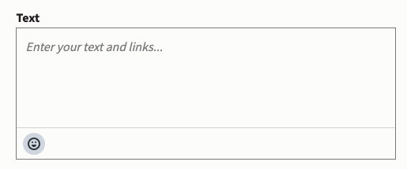

- In the Media box, drag and drop your photo or video

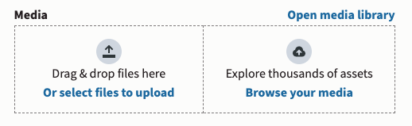

- To post immediately, click yellow button “Post Now”:

- To schedule a post for later, click blue button “Schedule for later”….and put in time and date. Click “Done” and yellow “Schedule” button

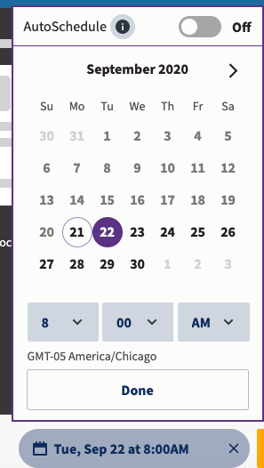

Additional Resource:
“How to use Hootsuite in 11 minutes” video - https://youtu.be/Bg1BcNDXBi4

