2012 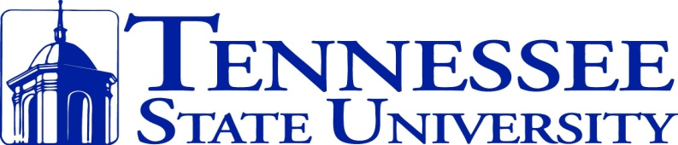

CLASSICAL GUITAR SEMINAR

**October 25-28** Faculty and Student Recitals Master Classes – Lessons - Guitar Orchestra

**Faculty:**

Matthew Cochran, John Huston, Stephen Mattingly, Richard Todd, Mitchell Weverka

**Special Guest Performers:**

José Antonio Escobar and Javier Contreras*

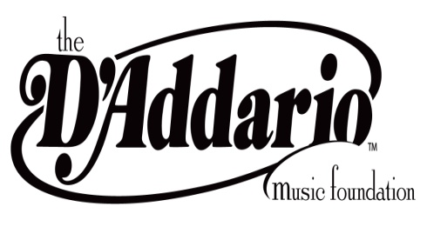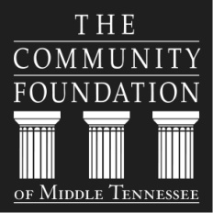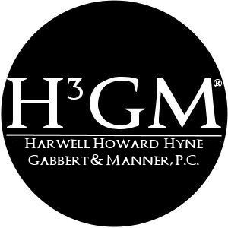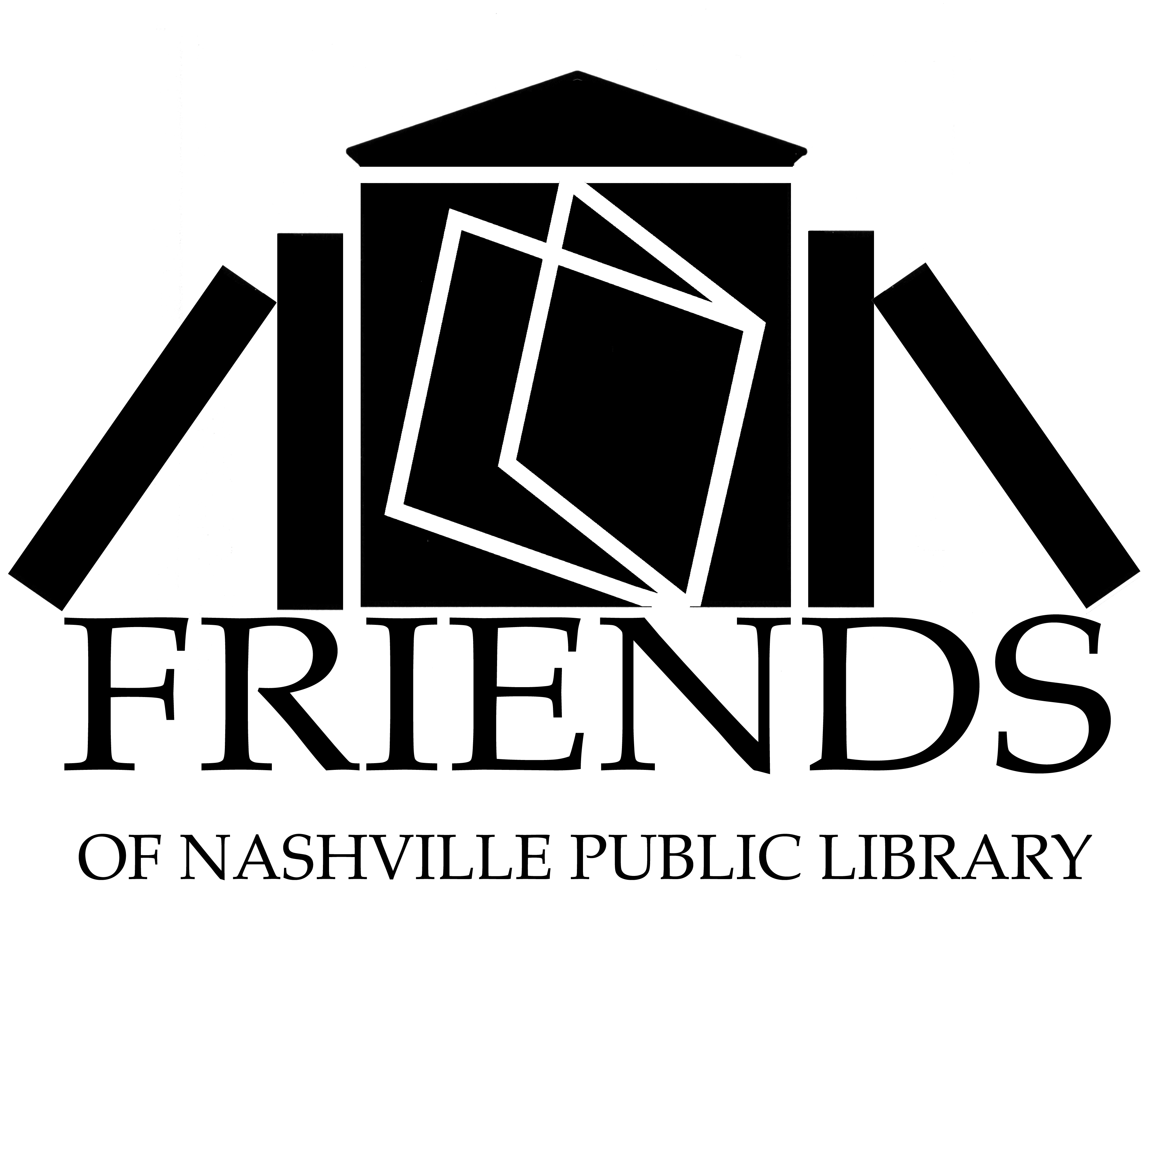

*will perform on the Virtuoso Series at the Nashville Main Library, sponsored by the Friends of the Nashville Public Library and the Community Foundation of Middle Tennessee.