Integration of Human Motion Tracker for Simulation of a Verification Test for Regenerative Environmental Control and Life Support System (R-ECLSS)

Tamara Rogers
Tennessee State University
NASA Faculty Fellow 2005
Marshall Space Flight Center

Human Motion Tracking Systems (HMTS) can be used for animating human models in virtual environments, in which these models can interact with other objects in this virtual world. This should be particularly useful when conducting aspects of human factors testing for systems under design, such as R-ECLSS. Currently, these verification tests require a tester to manually exercise a virtual human through the tests, possibly joint by joint, within the virtual system. The objectives of this project are 1) to further develop a system that integrates the human motion tracking hardware with a human model in a CAD environment, 2) to demonstrate the interaction of the human-guided human model with a CAD object model based on the actions of a live human interacting with a physical model, and 3) to provide recommendations for the enhancement of the system.

The project was able to demonstrate the effects of allowing the human model to be positioned by tracking a live human interacting with a physical mockup. The interaction configuration chosen allowed a live human being to interact with a mockup of one of the R-ECLSS racks. The actions of the human were mapped in to the software environment based on the motion of sensors in the HMTS suit. The use of a HMTS to interface with a human model in a CAD environment shows promise in reducing effort of the professional demonstrating the interactions. The existing system could be enhanced by reducing the effect of environmental interference.

2005

NASA Summer Faculty Research Opportunities

Marshall Space Flight Center

University of Alabama in Huntsville

Integration of Human Motion Tracker for Simulation of a Verification Test for Regenerative Environmental Control and Life Support System (R-ECLSS)

Prepared by: Tamara Rogers

Academic Rank: Assistant Professor

Institution and Department: Tennessee State University
Department of Computer Science

NASA/MSFC:

Directorate – code: Engineering – EV 12

MSFC Colleague: George Hamilton
Geoff Beech
Introduction

The Collaborative Engineering Center (CEC) is a facility at NASA’s Marshall Space Flight Center that provides an environment with several workstations and displays to facilitate collaboration within interdisciplinary teams. The Center includes computational and virtual facilities, including a virtual reality system and a Human Motion Tracking System (HMTS). The HMTS was developed in CEC Summer 2004 and incorporates an Ascension MotionStar magnetic tracking system, a CyberGlove, a backpack-based suit and the software to integrate it with EAI Jack. Further information about the system is available in [1]. One goal is to determine how the HMTS can be used in to present visualizations and to facilitate human factors engineering.

One particular application of the HMTS is animating human models in virtual environments. Human models can interact with objects in this virtual world. CAD models are used for the design and testing of complex systems, allowing for layout and evaluation with reduced time for iterations. Aspects of human factors testing can be conducted in these virtual environments. Currently, complex systems have prescribed protocols and tests for their verification process. In some of these verification tests, a virtual human is exercised through the tests with the virtual system. This typically requires an operator to manually manipulate the human model into desired poses and positions to interact with the object. Use of a human motion tracking system may ease the labor involved in conducting these verification tests by reducing the time and iterations required.

Experiment

The objectives of this project are 1) to further develop a system that integrates the human motion tracking hardware with a human model in a CAD environment, 2) to demonstrate the interaction of the human-guided human model with a CAD object model, and 3) to provide recommendations for the enhancement of the system.

Interactions between the professional performing the verification and the object to be verified can be afforded through various interfaces. For the types of verifications used in theses tests, the situations involve verifying people’s location and accessibility of objects in the environment. Table 1 shows various ways to conduct these simulations. Three potential schemes that arise from combinations of interfaces for modeling people interacting with designed systems are listed here.

- The first scheme involves a CAD model of this system and a CAD model of the human user of the system or device.
- The second scheme includes the CAD model of the device. In this case a live human being will drive the human model via the motion tracker.
- The third scheme involves the human being interacting with a physical model or mock-up. As the person interacts with the physical model, the person’s actions will be used to position the human model.

For the purpose of extending the work, the third scheme was selected and implemented. A person would interact with the physical mockup as demonstrating a desired requirement. The person will simultaneously serve as a puppeteer for the human computer model as the person’s actions map through the HMTS. In designing the software, the HMTS hardware would interface with existing human models in either the ERGO or the Jack software that are currently in use in the CEC. After exploring both options, the ERGO option was eliminated due to a lack of a direct vendor interface and support for interfacing with the sensor suit. The existing HMTS work was extended and demonstrated in the Jack environment.

The context for the demonstration of the interaction system is one verification test for the Regenerative Environmental Control and Life Support System (R-ECLSS) for the International Space Station (ISS). The criteria for selecting an R-ECLSS verification task were that it was consistent with current activities, had a verification by demonstration component, and utilized the level of accuracy of the available the physical mockup. The selected requirement is from the Urine Processor Assembly (UPA) of the Water Recovery System (WRS), see Figure 1, and met the above criteria. Requirement 3.3.7.3 Human Factors is representative of other requirements and one of the factors that will be simulated, Direction of Removal, is listed below. Table 2 shows the specification of the UPA requirement from [2], the specification of the verification from [2], and the specification of the Direction of Removal criterion to which the 3.3.7.3 refers [3].

In preparation for simulating this verification in the desired interaction configuration, the existing HMTS environment was extended. Custom configurations were made to configure the human model to the astronaut body size requirements [3]. The initialization script was extended to use this model and to load into the Jack environment the models of the objects in the physical environment. The demonstration procedure includes the following steps. The human puppeteer first puts on the HMTS suit and aligns the body so that the sensors closely align with the human model displayed on the screen. Once the CAD model of the WRS rack is loaded into the environment, the human puppeteer is free to move and execute the desired tasks. The tasks include approaching the rack and sliding out the drawer holding one of the orbital replacement units (ORUs), and returning its position. As the person performed the desired activities, the positions of the sensors and human figure were tracked and saved. These actions were then reloaded into Jack and replayed for view in Jack and export to video.

Discussion

The project was able to demonstrate the efforts of allowing the human model to be positioned by tracking a live human interacting with a physical mockup. There are several factors that were evidenced by this work which should be considered. The most significant factor is that of environmental interference, which was a known issue in the development of the HMTS. The reliability of the human motion is dependent upon signals from the magnetic trackers of the HMTS. Vendor documentation indicate that performance will be hindered by the presence of metals, such as are present in the general CEC environment and were used in the mockup.

The interaction configuration chosen allowed a live human being to interact with a physical object or model. The actions of the human were mapped in to the software environment based on the motion of sensors in the HMTS suit. There was not, however, information about the motion of the physical object. Therefore, the human factors information that can be captured from systems in this configuration would be limited to data that can be collected from the human.
Conclusion

The use of a HMTS to interface with a human model in a CAD environment shows promise in reducing effort of the professional demonstrating the interactions. The existing system shows limitations in interactions with substantial ferrous components. It is recommended that, to support continued use of the existing system, the facility utilize the manufacturer’s Environment Analyser. It is still noted that, even when optimizing the physical environment, if tasks utilize objects with these metals, there will still be interference issues. Efforts should be made to consider alternative sensor suites, such as optical sensors, wireless sensors, etc.

To analyze interactions between people and objects, it is also recommended to obtain several sensors that can be used to track the motion of objects in the environment. A small set that can be moved to the object or part of the object of interest should be beneficial for tracking object motion. This should facilitate automated updating the positions of parts of models, which currently require manual manipulation by the professional. A similar time benefit might be observed and is worth investigating.

This current work was implemented in Jack due to existing conditions, including time for the task and existing vendor interfaces. A final recommendation is to investigate interfacing to a CAD modeling environment that is designed to analyze process and motion. The ERGO model, which is interfaces with software in the CEC, is suited for process modeling, even though there is not currently vendor support for its interface with the existing motion tracking hardware.

These recommendations are toward the goal of facilitating the simulation of interactions between human beings and objects under design. Improving the fidelity of the human tracking and incorporating methods for observing results and processes within the systems under design are the objectives that should allow reaching this goal.

Acknowledgments

Discussions with Geoffrey Beech, Dr. Mariea Dunn Jackson, and Jacoby Berry are gratefully acknowledged. Mark Blasingame is acknowledged for providing technical guidance in the Collaborative Engineering Center. The author would like to thank and acknowledge the support of the NASA Summer Faculty Research Opportunities Program.

References

[1] Henderson, S., “Optimal Configuration of Human Motion Tracking Systems:
A Systems Engineering Approach”, NASA Summer Faculty Fellow Report, Summer 2004.

[2] MSFC-SPEC-3036D, October 9, 2003

[3] SSP 50005C, December 15, 1999

Table 1. Interaction Options for Simulating Human-Object Interactions
Human Figure | Object Model
Manipulated in software by tester | CAD model
Driven by live human | Physical model

Table 2. Representative Requirements
Requirement (R-ECLSS UPA)
3.3.7.3 Human factors.
The design of the UPA shall be in accordance with the following applicable paragraphs of SSP 50005:
11.5.3.1.H, Direction of Removal
Verification (R-ECLSS UPA)
4.3.7.3 Human factors.
This requirement will be verified by inspection, analysis and demonstration. An inspection of the drawings and an analysis shall be performed to ensure that the design of the UPA is in accordance with the applicable paragraphs of SSP 50005 as specified. A demonstration shall be performed during Qualification to ensure that the design of the UPA is in accordance with the applicable paragraphs of SSP 50005 as specified. The verification shall be considered successful when the inspection, analysis and demonstration indicate compliance.
Requirement (SSP 50005)
11.5.3.1 GENERAL MOUNTING DESIGN REQUIREMENTS
The following general requirements apply to mounting hardware:
H. Direction of Removal – Replaceable items shall be removable along a straight path until they have cleared the surrounding structure.

 | 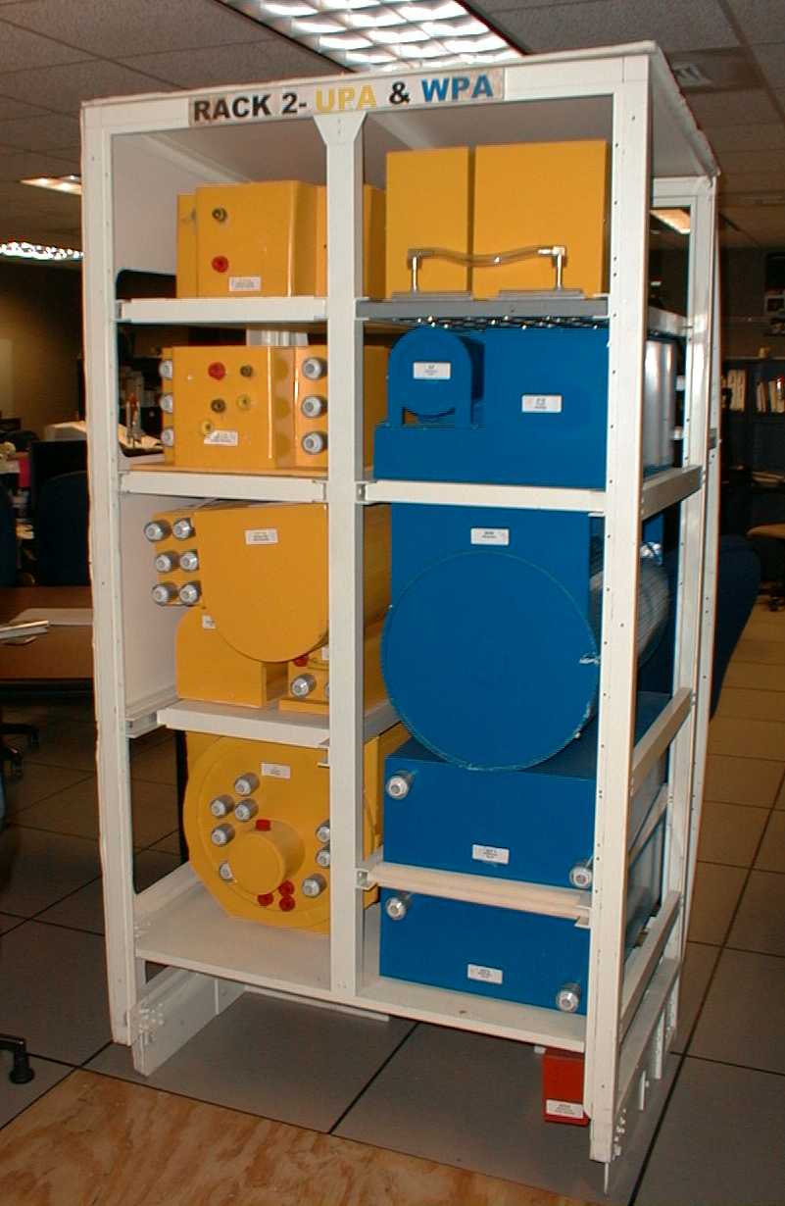 | 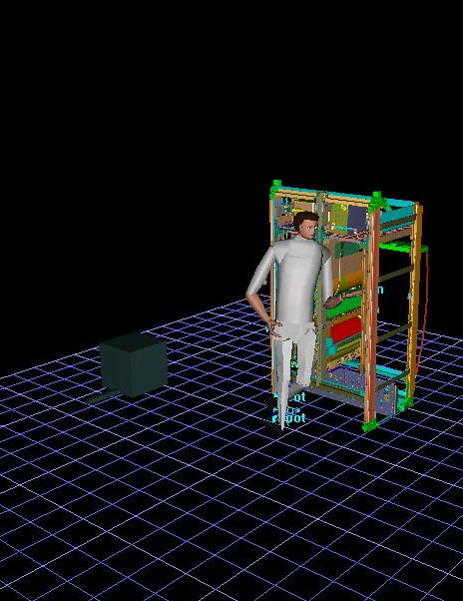
ECLSS WRS Rack 2 | WRS Rack 2 Mockup | Jack Models of Human and UPA in Rack 2
Figure 1. UPA in ECLSS WRS Rack 2

