CISE5020-80 Homework2
Page 35
Problem 2.5
Page 37
Problem 2.18
Page 37
Problem 2.19 a.

Solution:
P35 Problem 2.5
Let the state of a sequential circuit built of h D flip-flops with output designated Q_{h-1}, … Q ₁, Q ₀ and inputs labeled with D_{h-1}, … D ₁, D ₀ be identified with the binary number (Q_{h-1}, … Q ₁, Q ₀)_{two}. For each of the following sequential circuits, defined by the logic equations for D flip-flop input, draw a logic diagram, construct a state table and derive a state diagram. In these questions, a and b are inputs and z is output. In each case, specify whether the circuit represents a Mealy or Moore machine.
a. $D_{1}=a(Q_{1}∨Q_{0})$, $D_{0}=a{\bar{Q}}_{1}∨Q_{0})$,$z=\bar{a}(Q_{1}∨Q_{0})$
b. $D_{1}=\bar{a}b∨{\text{aQ}}_{1}$, $D_{0}=\bar{a}Q_{0}b∨{\text{aQ}}_{1}$, $z=Q_{0}$
c. $D_{2}=\bar{a}⊕Q_{0}⊕Q_{1}$, $D_{1}=Q_{2}$, $D_{0}=Q_{1}$

(1) Circuit Diagram
Answer to a:
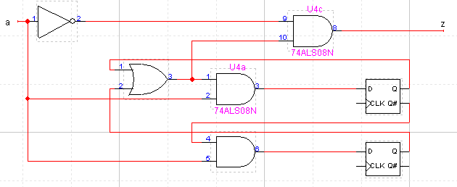
Answer to b:
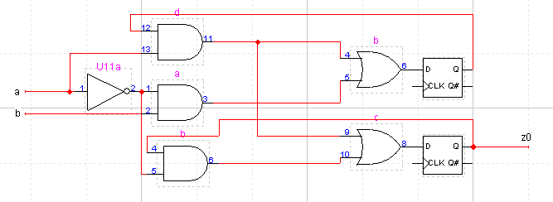

Answer to c:
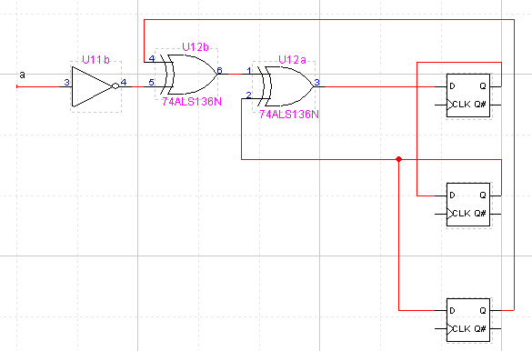

(2) State Table
a.
Current State | Input | Next State | Output
00 | 0 | 00 | 0
00 | 1 | 01 | 0
01 | 0 | 00 | 1
01 | 1 | 11 | 0
10 | 0 | 00 | 1
10 | 1 | 10 | 0
11 | 0 | 00 | 1
11 | 1 | 10 | 0
00
01
10
11
1/0
0/1
0/1
1/0
1/0
0/0
1/0
0/1
State Transition Diagram

b.
Current State | Input | Next State | Output
00 | 00 | 00 | 0
00 | 01 | 10 | 0
00 | 10 | 00 | 0
00 | 11 | 00 | 0
01 | 00 | 01 | 1
01 | 01 | 11 | 1
01 | 10 | 00 | 1
01 | 11 | 00 | 1
10 | 00 | 00 | 0
10 | 01 | 10 | 0
10 | 10 | 11 | 0
10 | 11 | 11 | 0
11 | 00 | 01 | 1
11 | 01 | 11 | 1
11 | 10 | 11 | 1
11 | 11 | 11 | 1
00
01
10
11
10/0,11/1
00/0
10/0
11/0
State Transition Diagram
10/0, 11/0
00/1
01/0
01/0
State Transition Diagram
00/0
01/1
10/1
11/1
00/1
01/1

c.
Current State | Input | Next State
000 | 0 | 100
000 | 1 | 000
001 | 0 | 000
001 | 1 | 100
010 | 0 | 001
010 | 1 | 101
011 | 0 | 101
011 | 1 | 001
100 | 0 | 110
100 | 1 | 010
101 | 0 | 010
101 | 1 | 110
110 | 0 | 011
110 | 1 | 111
111 | 0 | 111
111 | 1 | 011
000
State Transition Diagram
0
1
001
100
010
101
011
110
111
1
0
0
0
1
0
1
1
0
1
1
1
0

Page 37, Problem 2.18
A bit-serial comparator for unsigned binary numbers receives one data input bit from each of two operands x and y, producing the output signals G (x>y thus far) and E (x=y thus far).
a. Design the comparator circuit assuming that data inputs arrive beginning with their most significant bits and that a reset signal is asserted in clock cycle prior to data arrival.
b. Repeat part a for inputs supplied from the least significant end.
Answer to a: (MSB comes first) Initialization signal set G=0, E=1. We need two D-FF to hold G and E.
$$\begin{aligned}D_{G}=G+{\text{Ex}}_{i}{\bar{y}}_{i} \\ D_{E}=E⋅\overline{x_{i}⊕y_{i}}\end{aligned}$$
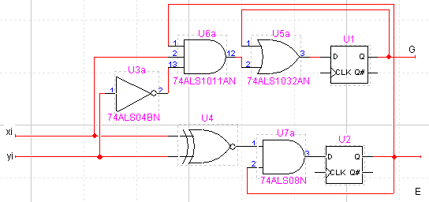
Answer to b: (LSB comes first) Initialization signal set G=0, E=1. We need two D-FF to hold G and E.
$$\begin{aligned}D_{G}=x_{i}{\bar{y}}_{i}+G⋅\overline{x_{i}⊕y_{i}} \\ D_{E}=E⋅\overline{x_{i}⊕y_{i}}\end{aligned}$$
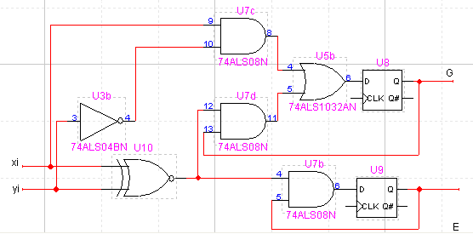
Page 37, Problem 19
We have two register files, each containing 32 register that are 32 bits wide.
- Show how to use these two register files, and additional logic element as needed, to form a register file with 64 registers of width 32 bits.
Answer: