P17 Problem 1.1
- Show that the NOR gate is universal.
- Show that the 2-to-1 multiplexer is universal.
- Is there any other two-input element, besides NAND and NOR, that is universal?

Answer to d. Show how to build AND, OR, and NOT gate from NOR gate.
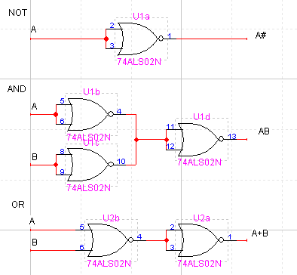
Answer to e. Show how to build AND, OR, and NOT gate from 2-to-1 multiplexer.
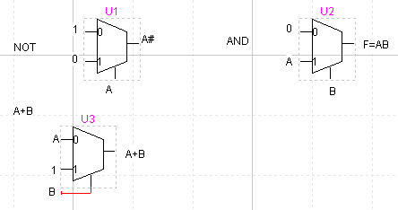
$$F=\bar{B}A+B=\bar{B}A+B+A=A(1+\bar{B})+B=A+B$$
Answer to f. Yes,
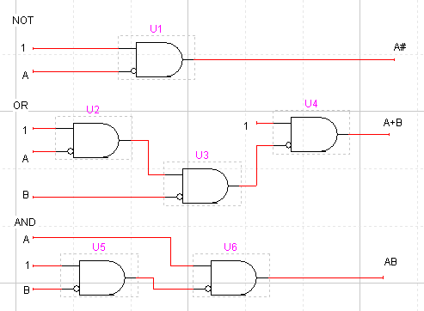

P17 Problem 1.5 BCD-to-7segment decoder
- Inputs are BCD digits; the digits 6, 7, and 9 are displayed with 6, 3, and 6 segments.
Answer:

Input | Output
x3x2x1x0 | e6 | e5 | e4 | e3 | e2 | e1 | e0
0000 | 0 | 1 | 1 | 1 | 1 | 1 | 1
0001 | 0 | 0 | 0 | 0 | 1 | 1 | 0
0010 | 1 | 0 | 1 | 1 | 0 | 1 | 1
0011 | 1 | 0 | 0 | 1 | 1 | 1 | 1
0100 | 1 | 1 | 0 | 0 | 1 | 1 | 0
0101 | 1 | 1 | 0 | 1 | 1 | 0 | 1
0110 | 1 | 1 | 1 | 1 | 1 | 0 | 1
0111 | 0 | 0 | 0 | 1 | 1 | 1 | 1
1000 | 1 | 1 | 1 | 1 | 1 | 1 | 1
1001 | 1 | 1 | 0 | 1 | 1 | 1 | 1

e6 x1x0
 |  | 00 | 01 | 11 | 10
x3x2 | 00 | 0 | 0 | 1 | 1
 | 01 | 1 | 1 | 0 | 1
 | 11 | x | x | x | x
 | 10 | 1 | 1 | x | x
$$e_{6}=x_{3}{\bar{x}}_{1}+x_{2}{\bar{x}}_{1}+{\bar{x}}_{2}x_{1}+x_{1}{\bar{x}}_{0}$$

e5 x1x0
 |  | 00 | 01 | 11 | 10
x3x2 | 00 | 1 | 0 | 0 | 0
 | 01 | 1 | 1 | 0 | 1
 | 11 | x | x | x | x
 | 10 | 1 | 1 | x | x
$$e_{5}=x_{3}{\bar{x}}_{1}+x_{2}{\bar{x}}_{1}+x_{2}{\bar{x}}_{0}+{\bar{x}}_{1}{\bar{x}}_{0}$$

e4 x1x0
 |  | 00 | 01 | 11 | 10
x3x2 | 00 | 1 | 0 | 0 | 1
 | 01 | 0 | 0 | 0 | 1
 | 11 | x | x | x | x
 | 10 | 1 | 0 | x | x
$$e_{4}={\bar{x}}_{2}{\bar{x}}_{0}+x_{1}{\bar{x}}_{0}$$

e3 x1x0
 |  | 00 | 01 | 11 | 10
x3x2 | 00 | 1 | 0 | 1 | 1
 | 01 | 0 | 1 | 0 | 1
 | 11 | x | x | x | x
 | 10 | 1 | 1 | x | x
$$e_{3}=x_{3}+{\bar{x}}_{2}{\bar{x}}_{0}+{\bar{x}}_{2}x_{1}+x_{1}{\bar{x}}_{0}+x_{2}{\bar{x}}_{1}x_{0}$$

e2 x1x0
 |  | 00 | 01 | 11 | 10
x3x2 | 00 | 1 | 1 | 1 | 0
 | 01 | 1 | 1 | 1 | 1
 | 11 | x | x | x | x
 | 10 | 1 | 1 | x | x
$$e_{2}=x_{2}+{\bar{x}}_{1}+x_{0}$$

e1 x1x0
 |  | 00 | 01 | 11 | 10
x3x2 | 00 | 1 | 1 | 1 | 1
 | 01 | 1 | 0 | 1 | 0
 | 11 | x | x | x | x
 | 10 | 1 | 1 | x | x
$$e_{1}=x_{3}+{\bar{x}}_{3}{\bar{x}}_{2}+{\bar{x}}_{1}{\bar{x}}_{0}+x_{1}x_{0}$$

e0 x1x0
 |  | 00 | 01 | 11 | 10
x3x2 | 00 | 1 | 0 | 1 | 1
 | 01 | 0 | 1 | 1 | 1
 | 11 | x | x | x | x
 | 10 | 1 | 1 | x | x
$$e_{0}=x_{3}+x_{1}+x_{2}x_{0}+{\bar{x}}_{2}{\bar{x}}_{0}$$

Circuit diagram:

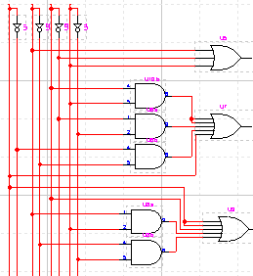
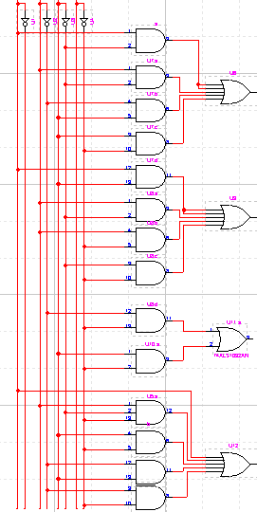
e2

e6
e1

x3x2x1x0
e5
e0

e4

e3

P18 Problem 1.10
Prove that the following pairs of logic expressions are equivalent, first by truth table, and then by means of symbolic manipulation.
Proof:
$$\text{RHS}=\text{xyz}+x\bar{y}\bar{z}+\bar{x}y\bar{z}+\bar{x}\bar{y}z$$
$$=\text{xyz}+\bar{x}\bar{y}z+x\bar{y}\bar{z}+\bar{x}y\bar{z}$$
$$=(\text{xy}+\bar{x}\bar{y})z+(x\bar{y}+\bar{x}y)\bar{z}$$
$$=(\overline{x⊕y})z+(x⊕y)\bar{z}$$
$$=x⊕y⊕z=\text{LHS}$$
Truth table:
Input  xyz | LHS  $$x⊕y⊕z$$ | RHS  $$\text{xyz}+x\bar{y}\bar{z}+\bar{x}y\bar{z}+\bar{x}\bar{y}z$$
000 | 0 | 0
001 | 1 | 1
010 | 1 | 1
011 | 0 | 0
100 | 1 | 1
101 | 0 | 0
110 | 0 | 0
111 | 1 | 1

P18 Problem 1.10 d Proof:
$$\text{LHS}=\text{xz}+w\bar{y}\bar{z}+\text{wx \{}\bar{y}+\bar{w}\text{xy}+\bar{x}y\bar{z}$$
$$=\text{xz}+w\bar{y}\bar{z}+\text{wx \{}\bar{y}(z+\bar{z})+\bar{w}\text{xy}(z+\bar{z})+(w+\bar{w})\bar{x}y\bar{z}$$
$$=\text{xz}+w\bar{y}\bar{z}+\text{wx \{}\bar{y}z+\text{wx \{}\bar{y}\bar{z}+\bar{w}\text{xyz}+\bar{w}\text{xy \{}\bar{z}+w\bar{x}y\bar{z}+\bar{w}\bar{x}y\bar{z}$$
$$=\text{xz}+w\bar{y}\bar{z}+\text{wx \{}\bar{y}z+\text{wx \{}\bar{y}\bar{z}+\bar{w}\text{xyz}+y\bar{z}(\bar{w}x+w\bar{x}+\bar{w}\bar{x})$$
$$=\text{xz}+w\bar{y}\bar{z}+\text{wx \{}\bar{y}z+\text{wx \{}\bar{y}\bar{z}+\bar{w}\text{xyz}+y\bar{z}(\bar{w}(x+\bar{x})+w\bar{x})$$
$$=\text{xz}+w\bar{y}\bar{z}+\text{wx \{}\bar{y}z+\text{wx \{}\bar{y}\bar{z}+\bar{w}\text{xyz}+w\bar{x}y\bar{z}+\bar{w}y\bar{z}$$
$$=\text{xz}+\text{wx \{}\bar{y}z+\bar{w}\text{xyz}+w\bar{y}\bar{z}+\text{wx \{}\bar{y}\bar{z}+w\bar{x}y\bar{z}+\bar{w}y\bar{z}$$
$$=\text{xz}(1+w\bar{y}+\bar{w}y)+w\bar{y}\bar{z}+\text{wx \{}\bar{y}\bar{z}+w\bar{x}y\bar{z}+\bar{w}y\bar{z}$$
$$=\text{xz}+w\bar{y}\bar{z}+\bar{w}y\bar{z}+\text{wx \{}\bar{y}\bar{z}+w\bar{x}y\bar{z}$$
$$=\text{xz}+w\bar{y}\bar{z}+\text{wx \{}\bar{y}+\bar{w}y\bar{z}+\text{wx \{}\bar{y}\bar{z}+w\bar{x}y\bar{z}$$
$$=\text{xz}+w\bar{y}\bar{z}+\text{wx \{}\bar{y}(1+\bar{z})+\bar{w}y\bar{z}+w\bar{x}y\bar{z}$$
$$=\text{xz}+w\bar{y}\bar{z}+\text{wx \{}\bar{y}+\bar{w}y\bar{z}+w\bar{x}y\bar{z}$$
$$=\text{xz}+w\bar{y}\bar{z}+\bar{w}y\bar{z}+w\bar{x}y\bar{z}$$
$$=\text{xz}+w\bar{y}\bar{z}(1+\bar{x})+\bar{w}y\bar{z}+w\bar{x}y\bar{z}$$
$$=\text{xz}+w\bar{y}\bar{z}+w\bar{y}\bar{z}\bar{x}+\bar{w}y\bar{z}+w\bar{x}y\bar{z}$$
$$=\text{xz}+w\bar{y}\bar{z}+w\bar{x}\bar{z}(\bar{y}+\bar{y})+\bar{w}y\bar{z}$$
$$=\text{xz}+w\bar{y}\bar{z}+\bar{w}y\bar{z}+w\bar{x}\bar{z}=\text{RHS}$$
Truth table:
Input  wxyz | LHS | RHS
0000 | 0 | 0
0001 | 0 | 0
0010 | 1 | 1
0011 | 0 | 0
0100 | 0 | 0
0101 | 1 | 1
0110 | 1 | 1
0111 | 1 | 1
1000 | 1 | 1
1001 | 0 | 0
1010 | 1 | 1
1011 | 0 | 0
1100 | 1 | 1
1101 | 1 | 1
1110 | 0 | 0
1111 | 1 | 1

p.18 Problem 1.12
Assume x = (x₂x₁x₀) _{two} and (y₂y₁y₀) _{two} are 3-bit unsigned binary numbers. Write down a logic expression in terms of the six Booleans variables x₂, x₁, x₀, y₂, y₁, and y₀ that assumes the value 1 iff:
- x = y
- x < y
- x ≤ y
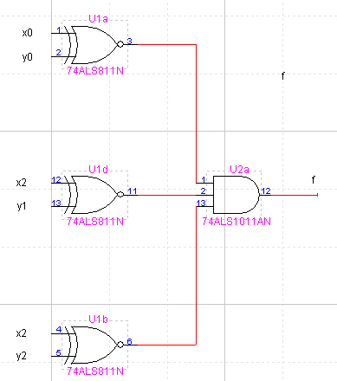
Answer to a:
$$f_{1}=\overline{x_{2}⊕y_{2}}⋅\overline{x_{1}⊕y_{1}}⋅\overline{x_{0}⊕y_{0}}$$

Answer to b:
$$f_{2}=y_{2}{\bar{x}}_{2}+\overline{x_{2}⊕y_{2}}⋅y_{1}{\bar{x}}_{1}+\overline{x_{2}⊕y_{2}}⋅\overline{x_{1}⊕y_{1}}⋅y_{0}{\bar{x}}_{0}$$
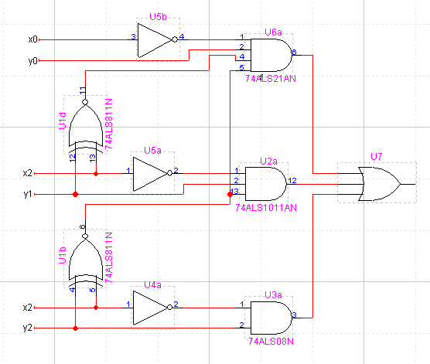

Answer to c:
$$\begin{aligned}f_{3}=f_{1}+f_{2} \\ \overline{x_{2}⊕y_{2}}⋅\overline{x_{1}⊕y_{1}}⋅\overline{x_{0}⊕y_{0}}+y_{2}{\bar{x}}_{2}+\overline{x_{2}⊕y_{2}}⋅y_{1}{\bar{x}}_{1}+\overline{x_{2}⊕y_{2}}⋅\overline{x_{1}⊕y_{1}}⋅y_{0}{\bar{x}}_{0}\end{aligned}$$

