U.S. EPA Environmental Justice View Site
http://epamap14.epa.gov/ejmap/ejmap.aspx
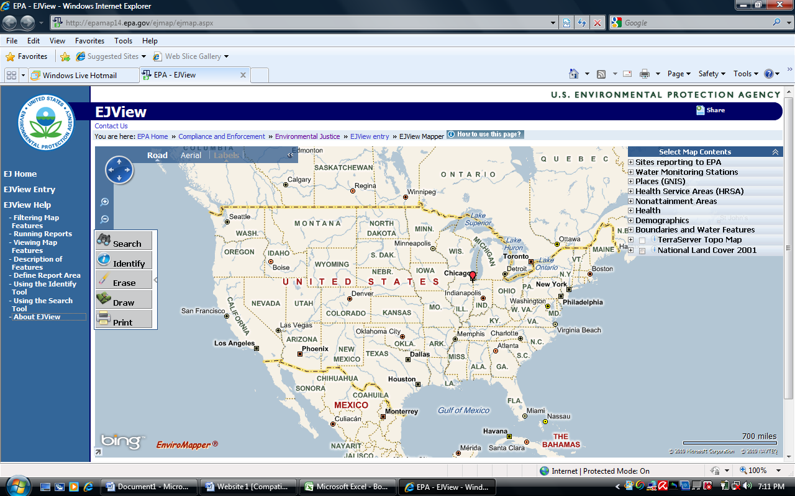
The EJView website is a public web page that gives a geographic view of environmental, health and waste facility information. The website also has a section that describes the government agencies that report to the site, or EPA. The features that are available on this site can easily help an individual identify environmentally high risks areas visually on a map by researching particular areas of concern.

This website is useful for environmental research because of the information that is provided, such as:
- Demographics, statistics and population estimates of a specific geographic area,
- Road and aerial views of maps for the selected research areas,
- A general summary of the selected areas on the map, with an option to receive a report of the selected areas.
HOME

