How to make building name link to Google maps.

GRAPHICS FROM OTHER PAGES
I see a graphic that I’d also like to use on my website. How do I get it and put it on my page? (such as Apply Now button on Academic Programs page)

WHICH IS BETTER?
Read more here.

OR

Read more

BEST PRACTICE FOR CONTACT INFO
For questions, suggestions, additions, etc. pertaining to the CAHNS website, contact Dr. Nick Gawel or Joan Kite.

_________________

EVENTS
- If you’re going to use your flyer that went out over Univ Comm, at least crop off the logo!....and you need to link to more details on the event.
- If it’s easier you can link your flyer to a larger (full-size) flyer so they can read those details….but only do this if you’re going to alter the metadata for the Events page….b/c your image text is not searchable/findable on search engines.

Which is better? BTW, leftnav says “SOARS Scholars Program” --

S.O.A.R.S (Students Opportunities For Advancement In Research Skills)


The current proposed project titled SOARS (Student Opportunities for Advancement in Research Skills) Scholars program will focus on paid opportunities for students to participate in research activities during their junior/senior years in the following STEM fields: Agriculture, Biology, Chemistry, Computer Science, and Engineering. Learning that is supported by active research will improve students’ skill-sets both in theory and practice. Learning and research that is a paid activity will lessen the impact of financial strain and eradicate the need to engage in off-campus employment. The program will concurrently offer structured activities to enhance their knowledge about internships, co-ops, careers and the graduate school experience.
Producing sufficient numbers of graduates who are prepared for STEM occupations has become a national priority in the United States. To attain this goal, some policymakers have targeted reducing STEM attrition in college, arguing that retaining more students in STEM fields in college is a low-cost, fast way to produce the STEM professionals that the…

SOARS Scholars Program

Students Opportunities For Advancement In Research Skills

About the Program
The current proposed project titled SOARS (Student Opportunities for Advancement in Research Skills) Scholars program will focus on paid opportunities for students to participate in research activities during their junior/senior years in the following STEM fields:
- Agriculture,
- Biology,
- Chemistry,
- Computer Science,
- and Engineering.
Learning that is supported by active research will improve students’ skill-sets both in theory and practice. Learning and research that is a paid activity will lessen the impact of financial strain and eradicate the need to engage in off-campus employment. The program will concurrently offer structured activities to enhance their knowledge about:
- internships,
- co-ops,
- careers,
- and the graduate school experience.
Producing sufficient numbers of graduates who are prepared for STEM occupations has become a national priority in the United States. To attain this goal, some policymakers have targeted reducing STEM attrition in college, arguing that retaining more students in STEM fields in college is a low-cost, fast way to produce the STEM professionals that the nation needs (President’s Council of Advisors on Science and Technology [PCAST] 2012).

EDIT TEXT
- If you have phone numbers with only extension, alter to be complete phone number (so people can click on cell phone)

Maps/Directions
Link to map page

TABLES
How to center a table
Add:
margin-left:auto; margin-right:auto;
to styles in table properties

Make REAL words for wrapping purposes (not URLs!)
/_testadmin/accounting/faculty.asps
If have table, won’t behave properly.

New Web Page to Replace Old One
For example, you need to make drastic changes to “contact.pcf”. How do you go about it?
Brand new page named “contact2016.pcf”…..or alter “contact.pcf”?
Moral of story: Don’t publish a new file named “contact2016.aspx”….b/c all your links are to contact.aspx!

Help! The right side of my content is hanging off the side of the page and not viewable!
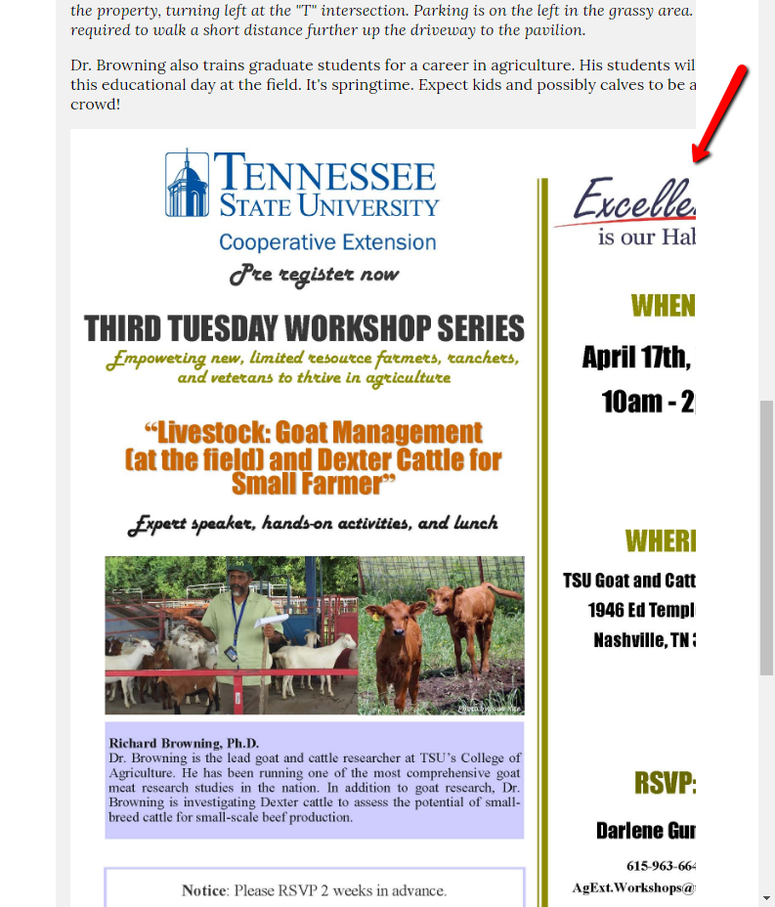

FONT SIZE
You can’t have small font-size b/c small mobile devices won’t be able to read it. The size that is default is by-design.

WRONG USE OF LOGO

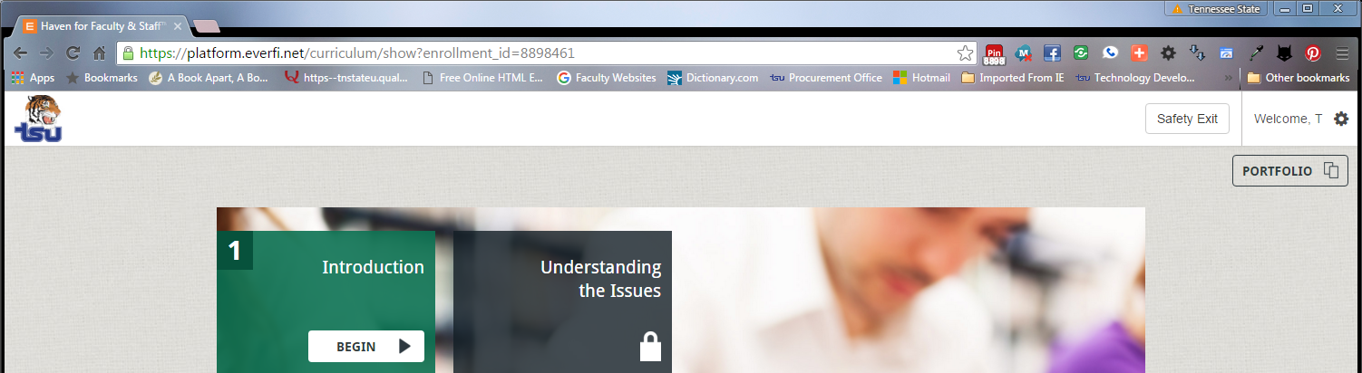

Search for “logos” in search box.

PAGE TITLE – must be relevant to page (not repeat of dept name!)
Don’t put dept name as Page Title. On mobile, your menu will have ALL the same things on it!!!!
Also, the browser tab is an indicator of what page you’re on, so put a specific page title!

http://www.tnstate.edu/hr/benefits-class.aspx

FIX!
http://www.tnstate.edu/_workshop/members.aspx

ADD TO CALENDAR
Make appt in Outlook,
Forward as .ics (calendar file)
Right-click to save to your PC
Upload into your OU Campus directory named “reminders”
(If you don’t have a “reminders” directory, you can very quickly make one:
Just click “New”
And choose “Folder”
Name it “reminders”.
Then, take note of the link of your ics file. It will be:
www.tnstate.edu/YourDeptWebsite/

Make link on web page to this .ics file.

Subtitle – don’t put text there! (and contraction “it’s”….and acronym “Faqs” should be capitalized!)

School of Nursing

The School of of Nursing and it's nursing programs are accredited by the Accreditation Commission on Education in Nursing and are approved by the State Board of Nursing. The BSN Program is currently on hold for Fall 2016. For frequently asked questions, follow the link, BSN Faqs.

Enjoy Helping People?
Become the best possible health care professional you can be, and help meet the growing demand for skilled nursing professionals to serve our changing population. Start on the path to your nursing career at Tennessee State University, where our exceptional faculty members are dedicated to your professional advancement.

TABLES
CELLPADDING IN TABLE
In /_workshop, I put a contact.pcf page that is AEAO/Success Center (they put leading spaces on every line!)
FIX THIS PAGE!

TABLES - sizing
Don’t grab by corner & enlarge. Always use dimensions….or else table will take on fixed width….and not work responsively.

MENTIONING A BUILDING?
Add the link to the Building map. Duh.

Making a link? When do you open in a new window? How do you do it?

LINKING (MAKING YOUR DEPT VIRAL)

Tennessee State University, in collaboration with Fisk University, is hosting the 24th Annual NAAAHP Conference!
The Audacity of Vision: Dare to Dream
Oct. 31 - Nov. 3 at Opryland Hotel!


- Anything on graphic is not searchable.
- If this was text, you could link to the organizations represented!....and be more findable yourselves!

IF DELETE CONTENT FROM CELL/COL, DELETE COL MAYBE
http://www.tnstate.edu/_workshop/tableCol.aspx

MERGE
If you have 2 rows & 2 columns…..and you remove content from one TD cell & make it empty….and that makes you want to spread the content from the other column/cell across both columns (merge cells).

CONTENT TEXTURE
Paragraph – make bullets/texture
http://www.tnstate.edu/_workshop/tableCol.aspx

HOW TO CHANGE METADATA AFTER PAGE EXISTS
Properties

