# TENNESSEE STATE UNIVERSITY WEBSITE SYSTEM & CONTINGENCIES

**TABLE OF CONTENTS**

System Configuration

Disaster Recovery

Backups

Fail-over Site

CMS Administration

## System Configuration

Tennessee State University (TSU) operates the web content management system, OU Campus, purchased and installed from Omniupdate, Inc in 2010. TSU has contracted with Omniupdate for annual system support of this system. TSU IT Department oversees this support contract.

|  |
| --- |
| **SYSTEM INFO**  **Web Server:** \\phlox-s08r2\e$  **Website IP:** 10.52.128.224  **CMS UNIX machine:** althos  **CMS Login Screen:**  [www.tnstate.edu/oucampus](http://www.tnstate.edu/oucampus) OR <https://althos.tnstate.edu/oucampus/login.jsp?user=main&blog=&id=&site=&path>=  **Website:** [www.tnstate.edu](http://www.tnstate.edu) |

The OU Campus system is a dual-machine system setup. The CMS is housed on a UNIX machine (althos). The published website is housed on a Windows-based web server (HUM-web05).

Within the CMS (OU Campus) the TSU employee (web editor) creates their web page. When they press "Publish" within OU Campus to publish their .pcf web page, a .aspx webpage is created on the web server.

The following system diagram demonstrates this system layout:   
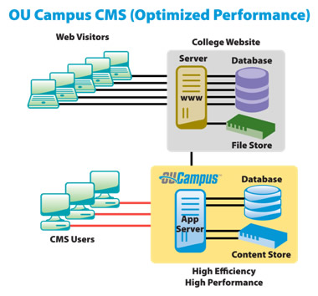

## Disaster Recovery & Continuity Plan (network & servers)

< The fail-over site has never been implemented. See summary documents, though, on discussions and costs. Summary documents are located in “DisasterRecovery” folder in “WebmasterDocumentation”. >

Hardware

Software

Network

## Backup Routine

Both the Althos (CMS) machine & the web server are regularly backed up.

Backups and restoration of Althos are handled by IT Server Admins.

Nightly backups of the web server are handled by CIT Systems/Networking, specifically Systems Administrator, Dwayne Hurst. He uses the Tivoli system to back up the web server as seen on the screenshot further below.

**IT-SYSTEMS CONTACTS**

Ben Coleman (w) 615.963 7696 (cell) 615.708.3638 [ben.coleman@tnstate.edu](mailto:ben.coleman@tnstate.edu)

Dwayne Hurst (w) 615.963.7695 (cell) 615.946.5634 [hurst@tnstate.edu](mailto:hurst@tnstate.edu)

**From:** Hurst, Joseph   
**Sent:** Monday, May 02, 2011 1:39 PM  
**To:** Hurst, Joseph; Jennette, Tracy  
**Subject:** Tivoli backup of phlox-s08r2

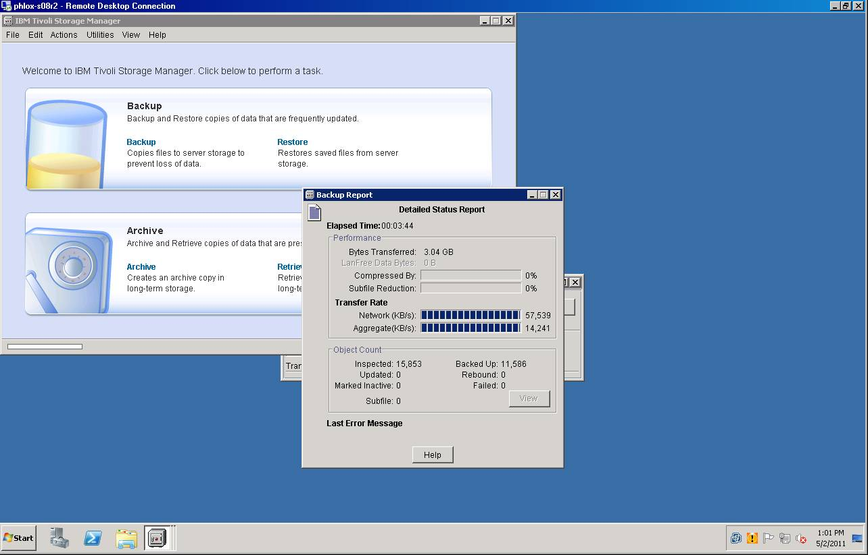

## Fail-over Site

< The fail-over site has never been implemented. See summary documents, though, on discussions and costs. Summary documents are located in “DisasterRecovery” folder in “WebmasterDocumentation”. >

Suggestion: In case of network outage, outsource a cold website.

In case of web server downtime, ____________________.

## System Upgrades

OU Campus receives regular system upgrades. Omniupdate personnel has access to our system for these upgrades. (System access was previously provided by CIT-Systems.)

After each upgrade, Omniupdate restarts our system. However, should any problem occur, our Unix Systems group may need to restart it. Instructions follow:

|  |
| --- |
| **OU CAMPUS CMS SERVER (ON ALTHOS) RE-START INSTRUCTIONS**  In the future, there's three parts that need to be started: Sybase (the database), Tomcat, and the Apache web server.  Sybase can be started by running the following commands:  # su - sybase % cd $SYBASE/$SYBASE_ASE/install % startserver -f ./RUN_MSTAY0  This will generate a lot of output; simply press enter to get another prompt, and exit from the sybase user prompt.  Next, both Tomcat and Apache need to be started:  # /usr/local/omniupdate/tomcat/bin/startup.sh # /usr/local/omniupdate/apache/bin/apachectl start  After that, you should be good to go.  **CHECK IF SYSTEM IS UP**  You can check to see if the system is back up by going to this link & seeing if the OU Campus login screen displays: <https://althos.tnstate.edu/oucampus/login.jsp?user=main&blog=&id=&site=&path>=  **SYSTEM CONTACTS AT OMNIUPDATE**  Email [support@omniupdate.com](mailto:support@omniupdate.com)  FORMER SYS ADMINS  **Brian Tusi**  Software Developer / IT Manager  OmniUpdate, Inc.  800.362.2605 x203  **Christopher Davison** Network Administrator OmniUpdate, Inc. 800.362.2605 x205 |

## CMS Administration

Login Screen: [www.tnstate.edu/oucampus](http://www.tnstate.edu/oucampus)

The primary system administrator of the CMS is CIT Webmaster, Tracy Jennette. No secondary has been appointed. TSU IT Server Administrator (currently Ben Coleman) handles all server administration of the CMS web server and of the TSU public-facing main-website webserver.