Student E-mail (Office 365)

1. Click on “Apps”, and then go to “Settings”

Click



1. Click “Add account”

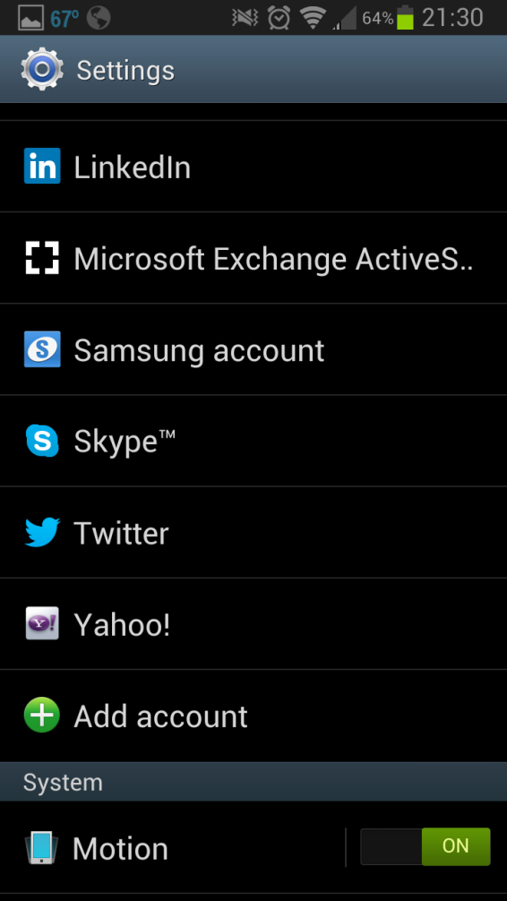

Click

1. Click “Email”

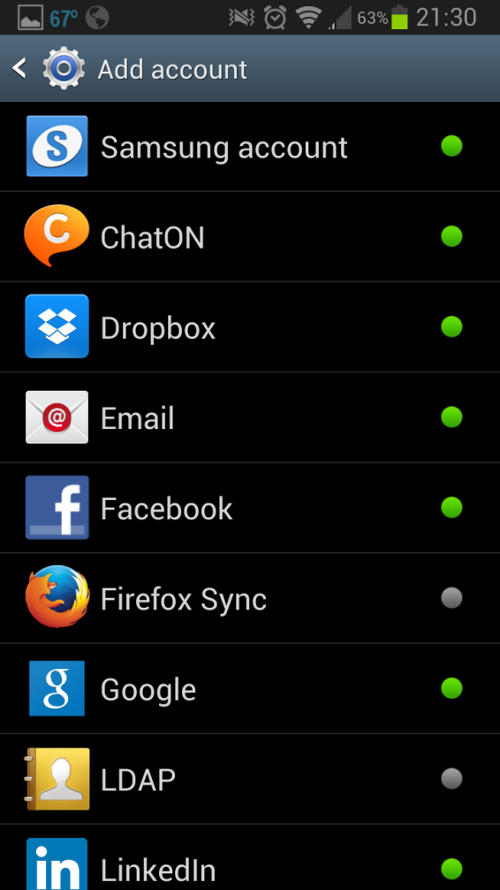

Click

1. Enter your credentials (Same username/password you use for signing into the computer and Elearn)

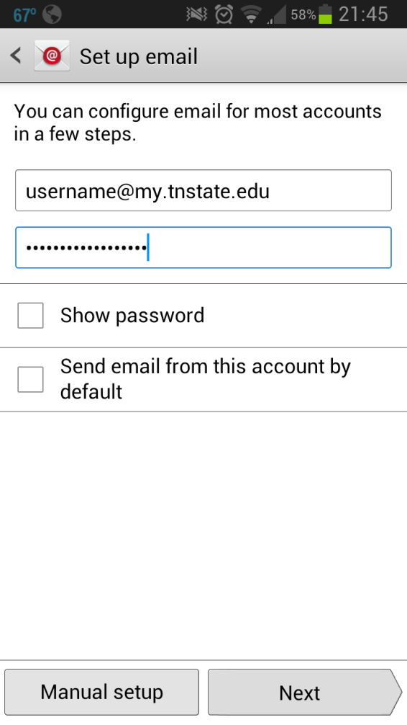

1. Click “IMAP account”

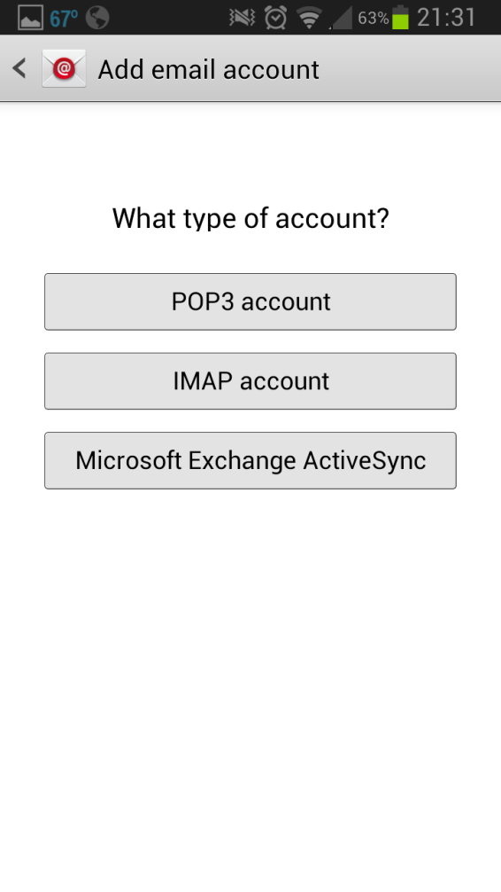

Click

SSL

1. 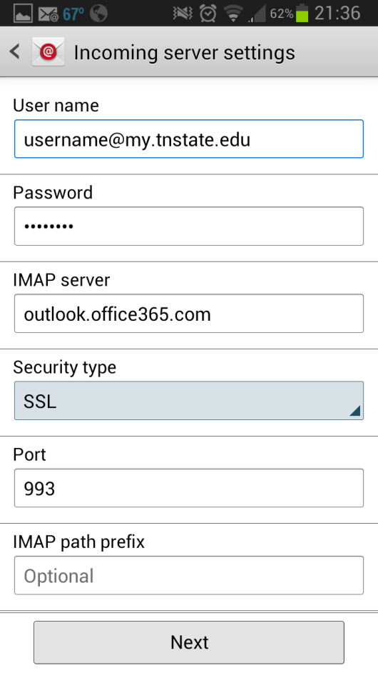IMAP server – “outlook.office365.com”; Change “Security type” to “SSL”; Change Port to “993”
2. You can set your own schedule times

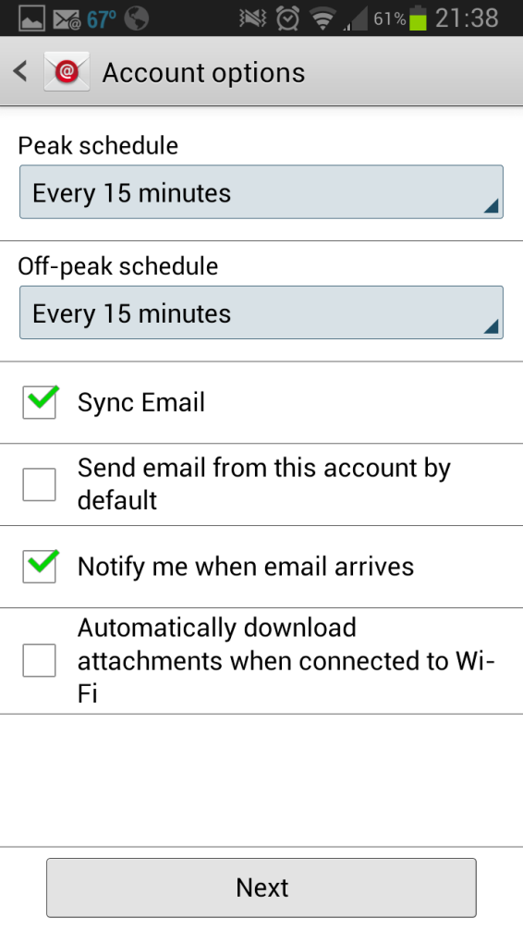

1. 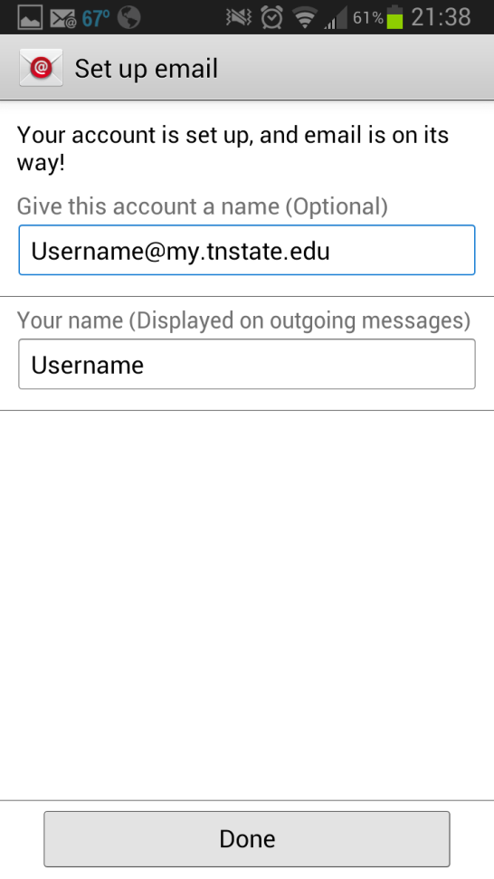Fill in the blanks