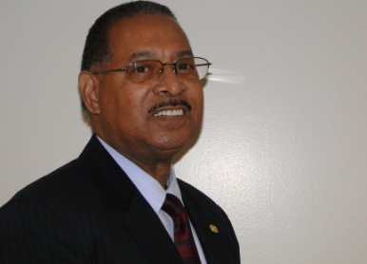
Will Nesby, USDA/1890 Program Liaison
Tennessee State University

USDA/1890 Program Liaison Office at Tennessee State University

The USDA/1890 Program Liaison at Tennessee State University, advises and counsels students on employment opportunities and programs within USDA agencies and provides ongoing evaluative commentary on the quality of the students’ educational and employment experience. Also, the liaison serves as advisor to University officials in the development and implementation of comprehensive recruitment programs designed to encourage students to enroll in courses of study in agriculture or related fields. The position also oversees the implementation of the USDA/1890 Scholars’ application process on TSU’s campus, works directly with USDA agencies to place students in positions under a variety of programs, which include the Student Temporary Employment Program (STEP) and the Student Career Experience Program (SCEP), and assists both students and employing offices resolve issues, which might arise.

Mr. Will Nesby is the current UDSA/1890 Liaison, he may be reached at will_nesby@tnstate.edu or by phone at 615-963-5442.

The USDA/1890 National Scholars Applications are now available online at www.usda.gov/1890program.xml. There are two applications for each category (high school/college), one is the standard application and one is 508 Compliant (specifically for the visually impaired)

Please check out our USDA Internships and Scholarships!

