I am grateful to serve as Interim Provost and Vice President at Tennessee State University an institution with impeccable reputation and rich with accomplishments! Serving in this capacity is humbling and exciting.

We are currently facing challenging opportunities and it is during these times that we can look to and expand on the historic legacy of Tennessee State University.  This legacy is one built on the scholarship, learning and service of great leaders, faculty, staff, and students who created an institution grounded in community and who faced and overcame society’s greatest challenges. As an HBCU we strive to meet the moment and this office is committed to build on the institutions reputation and do the forward looking work needed to assure we excel and prevail as a world class community of scholars!  As COVID-19 challenges us as and as we grapple with issues related to social justice, TSU stands as an integral part of fostering a campus of innovative growth, research, and learning.

Our ongoing entrepreneurial mind set impacts our culture of learning and excellence. Our strong tradition of teaching and compassionate attitude to assure success will continue to encourage our students to secure meaningful careers across the professional spectrum.  Our classrooms integrate theory, research, and practice through the use of traditional and new methods.  Students have the opportunity to learn from our world class faculty and we have the responsibility to enhance our curriculum. The office of the provost brings together academic leadership and resources across the university to enhance academic excellence in teaching, research, creative expression and service.  The office of the provost is committed to student learning, success and lifelong opportunities.

It is an honor and privilege to serve as Provost.  I look forward to working with each of you as we face great opportunities for a successful future.

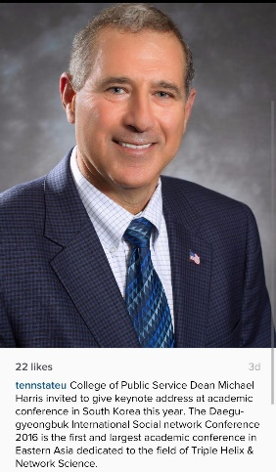

Michael Harris

Provost and Vice President for Academic Affairs

|  |
| --- |
|  |