**Academic Catalogs**

**How to Make Clickable Catalogs**

**MICROSOFT WORD**

These instructions are for use in Microsoft Word when initially creating the Academic Catalog(s). The last instruction, however, involves Adobe PDF settings.

**USE MS WORD’S STYLES FOR ALL HEADINGS**

For all of the headings in the catalog, use Word’s styles for Heading 1, Heading 2, etc. in the “Styles” menu.

For example:

* The main title of the entire document should use Heading 1 (a large heading).
* The main section headings should use Heading 2.
* The subsections within the main sections should use Heading 3.

- [how to use MS Word’s heading styles](https://getproofed.com/writing-tips/styles-and-headings-in-microsoft-word/) –

**MAKE BOOKMARKS AT SECTIONS THROUGHOUT CATALOG**

For example: if you’re linking the words “College of Agriculture” in the Table of Contents to a section further below in the document, first make the heading of the section for College of Agriculture into a bookmark.

- [how to make bookmark in Word](https://support.office.com/en-ie/article/add-or-delete-bookmarks-in-a-word-document-or-outlook-message-f68d781f-0150-4583-a90e-a4009d99c2a0) –

**MAKE TABLE OF CONTENTS INTO LINKS**

For example:

In the Table of Contents, highlight “College of Agriculture” and right-click it

Choose “Hyperlink”

In the hyperlink box (shown below), choose “Place in Document” on the left panel. In the middle pane, find the bookmark (one you previously created) that you want to link to. Click it, and click “OK”.

Voila! You have a clickable item in the Table of Contents.

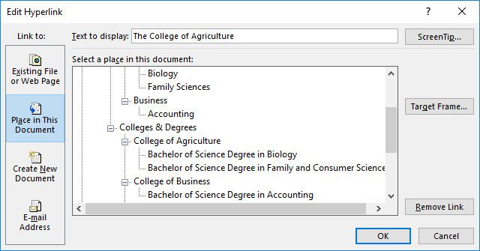

*Do this for all items in the Table of Contents.

**SAVE FILE**

After saving the file as a Word document, also save it like this:

* For “Save as type”, choose “PDF”….and click the “Options” button just below that.
* Check the box for “Create bookmarks using”.
* Check the box for “Headings”.

**ALTER INITIAL VIEW IN THE PDF**

In Adobe Acrobat Professional or DC version --

* Click “File – Properties”
* Click the “Initial View” tab
* For “Navigation tab”, select “Bookmarks Panel and Page”  
  (This will ensure that when a person opens the catalog Adobe’s left-hand side Bookmarks/Table of Contents will be presented immediately and the person can easily and efficiently navigate the document.)

*NOTE: Some versions of Adobe don’t display “Initial View” as an option. So this setting cannot be done.