Teaching Chapter 10
EDUCATIONAL PLANNING & DECISION-MAKING:

Making Wise Choices about Your College Courses and Major

Key Instructional Goal of this Chapter
The primary goal of this chapter is to help students make meaningful connections between their early academic choices and their long-term educational and vocational plans. Studies show that students who do not see a connection between their current academic experiences and their future educational and career goals may be at risk for attrition. Thus, a key objective of this chapter is to enable students make this connection, and make it early, before they conclude that college is irrelevant to their personal and professionals plans. It is for this reason that the chapter is situated early in the textbook.

Key Points to Emphasize When Discussing this Chapter

* Remind students that being undecided or uncertain about their major is not the exception but the norm and, therefore, “normal.” Students typically reach final decisions about a major during their college experience; not before it. As the chapter documents, new students are very uncertain about their choice of major and the relationship between majors and careers. The reality is that most entering college students are undecided, even if they may have declared a major upon entry. First-term students should be assured that early indecisiveness about a major or re-assessment of their originally chosen major is healthy because it often reflects a willingness to explore options before fully committing to a particular educational or career goal.
Point out to your students that it is often better to remain undecided and gain some experience with the college curriculum than it is to make a premature decision just to get the decision “out of the way” or to relieve anxiety about being undecided. Instead of rushing their choice only to discover later that it was not a good choice, students should be encouraged to make their first choice their best choice, i.e., make it a carefully thought-out choice that best reflects who they are and who they want to become.

* Students should also be reminded that the benefits of waiting and not committing prematurely to a major must be balanced against the dangers of remaining undecided for a prolonged period of time; the latter may indicate procrastination, or unwillingness to take the time and effort to learn more about themselves and their options. Students may also need to be reminded that prolonged indecision can lead to late changes in academic plans, which can result in longer time to degree completion because of the need to complete different degree requirements for a new major.

* Point out that self-awareness represents the key first step in the process of deciding on a college major (or any important personal decision). This step provides the foundation for prudent selection of a major; it improves the quality of the decision by enabling students to make a choice that is most compatible with their personal interests, talents, needs, and values. Thus, looking inward and gaining self-knowledge (to “know thyself”) is the critical first step in the decision-making process. Students need to know themselves well before they can be expected to know their major or what career they want to pursue in life.
* In addition to needing self-knowledge for accurate decision making, students should be reminded that good choices and decisions also rest being knowledgeable about the full range of options or alternatives that are available. When this involves choosing a college major, students need to be aware of the variety of subject areas that are options for a major, and they need to know the “infra-structure” of these subject areas, i.e., what particular courses comprise the majors they are considering.

Clarifications & Caveats Regarding this Chapter

Coverage of Learning Styles in Chapter 10
It might be surprising to see the topic of learning styles covered in a chapter on educational planning and decision-making, rather than its usual place in a chapter on learning or study skills. We intentionally included learning styles in this chapter because an individual’s preferred learning style is an important personal characteristic that students should be aware of when making choices about a major. College majors represent different academic disciplines, each of which requires different approaches to learning, thinking, acquiring knowledge, and organizing the knowledge that is acquired. Thus, particular majors tend to emphasize (or require) use of particular learning styles. It is for this reason that students’ self-awareness of their learning style and its compatibility with the learning style used or emphasized by different academic disciplines (majors) was included as an integral part of this chapter on choosing a college major.
We also felt that it was important to cover learning styles and multiple intelligences in close proximity because both relate to ways in which individuals and academic disciplines acquire knowledge. Similar though these concepts may be, there is also a subtle, yet critical difference between them: learning styles refer to different learning preferences, whereas multiple intelligences refer to different learning aptitudes, abilities or talents. We thought it was important to compare and contrast learning styles and multiple intelligences, so that students become aware of the subtle but significant difference between liking or preferring something and having an aptitude or talent for doing it well (or competently). For example, a student may have a preference for majoring in pre-med and becoming a surgeon, but if the student does not have a sufficiently high level of kinesthetic (psychomotor) intelligence, pre-med probably does not represent a good choice.

Campus-to-Campus Variation with Respect to Curricular Terminology & Degree Requirements

As was the case with the content covered in chapter 2, there is variability in how different campuses define their terms with respect to the curriculum. Thus, it will probably be necessary for you to point out this variability out at the outset of this instructional unit and identify the particular language used on your campus. For example, some colleges may use the term “elective” to refer simply to any course that is not required for general education or a major, while other colleges make a sharp distinction between “restricted” and “free” electives. Colleges also vary with respect to use of terms such as “cognate areas,” “required support courses,” and “distribution requirements.”
Furthermore, the number of units required for different degree programs and program components tend to vary from campus to campus. The number of units cited that we cite for general education, college majors and minors, and college graduation are merely approximate “averages.” For instance, the exact total of units your college requires for the Baccalaureate degree may not match the number cited in the text (120 units).

Possible Exercises/Assignments for Chapter 3

Faculty Interview

Step 1: Form small groups of 2-4 students who have interest in the same major. For students who are “totally undecided,” have them identify a possible major they might consider.

Step 2: Ask these student groups to make an appointment with a faculty member in the major field that interests them. Visiting the office of a college professor while in the company of a supportive group of peers should help students feel less apprehensive about this interview process. (Group interviews also demand less time from faculty than individual interviews.)
Listed below is a pool of possible questions that students could choose to ask during a faculty interview. To ensure individual accountability, each group member should be instructed to take responsibility for asking 2-3 questions.

* Faculty-Interview Questions

1. How did you decide on your major? What influenced your initial decision or attracted
you to the major in the first place?

2. When did you decide on your major? Was it your first choice, or did you change to it
from another major? (If you changed your original major, why did you change?)

3. What personal interests, learning styles, or intelligence types do you think would
“match up” well with the academic demands of your major?

4. What particular courses in your major did you find especially enjoyable, exciting, or
stimulating?

5. Were there any unexpected requirements in your major that proved to be particularly
challenging?

6. Would you choose the same major again if you were a college student now?

7. What particular course(s) or co-curricular experience(s) would you recommend
to help me decide if I should like major in your field?

8. What careers are related to your major? What different types of careers does your
major prepare you for?

9. Did you have a minor? If yes, how did it relate to or connect with your major?

10. To pursue a career directly related to your major do you need an advanced degree
(e.g., Master’s or Ph.D.) in the field?

11. Can you recommend any references or resources I could consult to learn about your
major or careers related to it?

Step 3: Have students write a short reflection paper on their interview experience, in
which they answer the following questions:

1. Did you receive information about the major that impressed you—to the point where
you’re now strongly considering it as a major? (If yes, what particularly
impressed you about the major?)

2. Did you receive any information that reduced your interest in the major? (If yes, what
particularly dampened your interest in the major?)

3. What was the most important thing you learned about the major or yourself as a result
of conducting this interview?

MBTI Center-Divide
Steps:
1. Create an open space down the center of your classroom.

2. Have students move either to the left, right, or center of the room, depending on where they score (or think they would score) on each of the four traits measured by the Myers-Briggs Type Indicator (MBTI)—e.g., strong extraversion (far left), strong introversion (far right), intermediate (in the middle).
Students could simply self-assess where they think they would fall along each of its four scales read about the MBTI in the text (p. 86). Otherwise, they could take the full-length inventory on paper, or an abbreviated version of the inventory online (for example, at: personalitypathways.com/type_inventory.html)

3. Often students with similar styles come together in the same area of the room, have them form triads or quartets within that area. While in their small groups, ask them to identify majors in your college catalog or bulletin that they think are the most and least compatible with their personality traits.

4. Repeat steps 1-3 for each pair of traits measured by the MBTI.

LSI Corners-Rotation
Steps:
1. Ask students to move to one of four corners of the room, depending on where they score (or where they think they would score) with respect to the four sectors of the Learning Styles Inventory (LSI).
For example:
Accommodators: Left-Front Corner
Assimilators: Right-Front Corner
Convergers: Left-Back Corner
Divergers: Right-Back Corner.

(Note: The LSI may be purchased at the following website: www.haygroup.com/TL/)

2. Have students break into triads or quartets and use your college catalog to identify major(s) that appeal to their group.

3. Have each group rotate clockwise and merge with an adjacent group that has a different learning style. Ask them to note the learning style of the other group and note any differences between that group’s preferred majors and those preferred by their own group.

4. Have the groups rotate two more times, thereby enabling each group to have an inter-group interaction with three other learning-style groups.

Multiple Intelligences & High School-Learning Experiences

Steps:
1. Ask students what academic subject came easiest to them to in high school, or what type of courses they experienced the most success.

2. Form homogeneous groups of 2-4 students who identify the same subject area in step 1., and ask them to list the skills or talents they think that subject required.

4. Ask the group to identify what type of multiple intelligence most closely matches their list of skills.

Multiple Intelligences & Team Presentations

Steps:
1. Ask students to identify what they think is their most well-developed type of multiple intelligence (MI) from among the eight described in the text (p. 85). Or, ask your students to take an online multiple-intelligence assessment and have them report the intelligence type or area in which they scored highest. (For example, they could take a short version of the MI test at: mitest.com/o7inte~1.htm_)

2. Have students with the same type of MI join together in small groups, and ask them if their group were to make a group presentation that best reflects the skills associated their form of MI, what format would they use (e.g., oral presentation, art work, drama, visual demonstration, etc.).

3. Ask students to take the presentation format they identified in step 2 and apply it to any topic or idea of their choice (e.g., one chapter topic in the text).

4. Ask the groups to make their presentations, or ask a group to volunteer.
If you ask for a volunteer group, it may be interesting to note what type of MI group volunteers to go public with their work and share it with the entire class. For instance, did the interpersonal (social) MI group feel more comfortable making a public presentation than the intrapersonal (self) group?
It might also be revealing to ask different multiple-intelligence groups assess their learning styles to see if certain learning styles tend to cluster together with certain MI types. For example, do the interpersonal (social) intelligence groups tend report being more extroverted than the intrapersonal (self) intelligence groups? If so, this may explain their greater willingness to volunteer to publicly present their work in front of the entire class.

Final Note: This exercise may also be expanded into a group project, whereby small groups of students with the same type of MI decide on what sources of information they would consult and what delivery format they would use to present their project (e.g., written report, panel presentation, collage, exhibit, dramatic skit, or videotape). How teams of students with different MI types decide to research and deliver their group projects might serve as a vivid illustration of their different skills or abilities.

Additional Material for Possible Use in Lectures or Reading Assignments Excised from the First Edition of the Textbook
Factors to Consider When Choosing Your Major or Field of Study

Gaining self-awareness is the critical first step toward making an effective decision about a college major, or any other important decision. You need to know yourself before you can know what choice is best for you. While this may seem obvious, self-awareness and self-discovery are often overlooked aspects of effective educational decision-making. In particular, you should develop awareness of your:
1) interests--what you like doing
2) abilities--what you're good at doing, and
3) values--what you feel good about doing.

When students choose a college major that is compatible with their personal interests, research indicates that they are more likely to remain in college and complete their degree (Leuwerke, et al., 2004).
Myths about the Relationship between Majors and Careers
Good decisions are based on accurate information rather than misconceptions or myths. Effective planning and decision-making about a college major is built on accurate information about the relationship between majors and careers. Unfortunately, numerous misconceptions exist about the relationship between majors and careers that often lead students to make uninformed or unrealistic choices of a college major.
Myth 1: When You Choose Your Major, You’re Choosing Your Career
While some majors lead directly to a particular career, most do not. Majors leading directly to specific careers are called pre-professional or pre-vocational majors, and they include such fields as accounting, engineering, and nursing. However, the vast majority of college majors don't channel you directly down one particular career path; instead, they leave you with a variety of career options. All physics majors don't become physicists, all philosophy majors don't become philosophers, all history majors don't become historians, and all English majors don't become Englishmen (or Englishwomen). The career path of most college graduates is not a straight line that runs directly from their major to their career. The trip from college to career(s) is more like climbing a tree. As illustrated in Figure 3.1, you begin with the tree’s trunk--the foundation of general education (courses required of all college students, whatever their major may be), which grows into separate limbs (different college majors), which in turn, lead to different branches (different career paths or options).

The Relationship between General Education (Liberal Arts), College Majors, & Careers

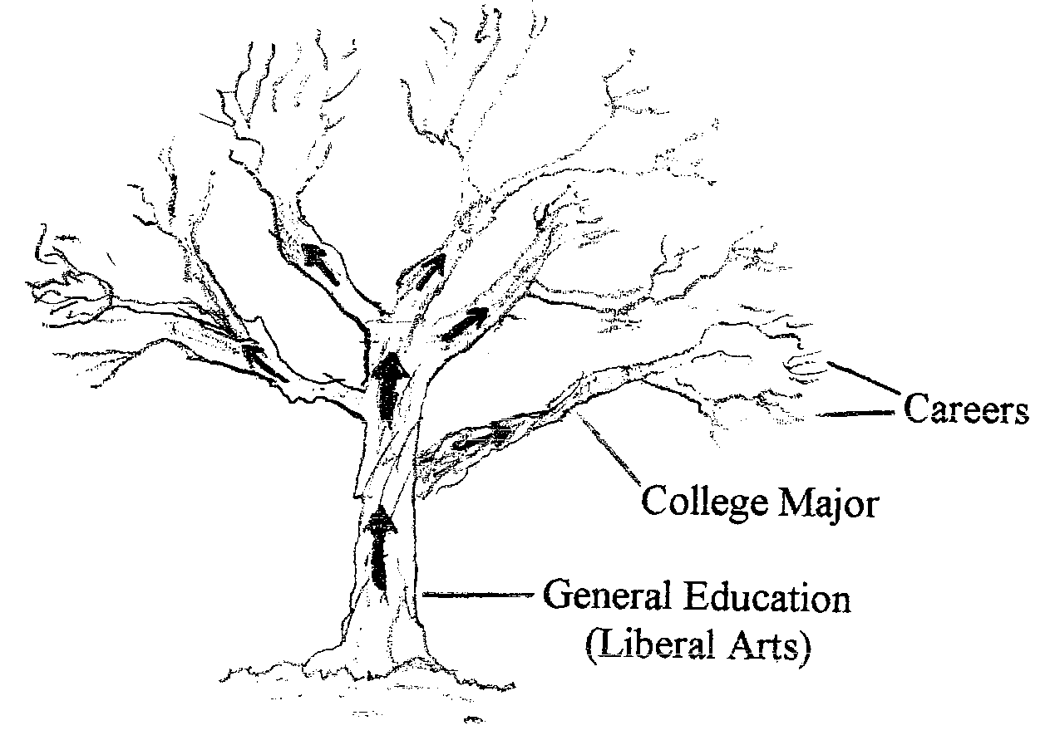

Just as a cluster of branches grow from the same limb, so does a "family" of related careers grow from the same major. For example, an English major typically leads to careers that involve use of the written language (such as editing, journalism, and publishing), while a major in art leads to careers that involve use of visual media (such as illustration, graphic design, and art therapy). The Web site, MyMajors.com, provides useful and free information on groups or families of jobs tend to be related to different majors.
Different majors can also lead to the same career. For instance, many different majors can lead a student to law school and to an eventual career as a lawyer; there really isn't a law or pre-law major. Similarly, pre-med really isn't a major. Although most students interested in going into medicine school after college major in some field in the natural sciences (e.g., biology or chemistry), it's possible for students to go to medical school with majors in other fields, particularly if they take and do well in certain science courses that are emphasized in medical school (e.g., general biology, general chemistry, organic and inorganic chemistry).
Thus, don't presume that your major is your career, or that your major automatically turns into your career field. It's this belief that can result in some students procrastinating about choosing a major--because they think they're making a lifelong decision and fear that if they make the "wrong" choice, they'll be stuck doing something they hate for the rest of their life. The belief that your major becomes your career may also account for the fact that 58% of college graduates major in a pre-professional or pre-vocational field (e.g., nursing, accounting, and engineering) (AAC&U, 2007). These majors have a career that's obviously connected to them, which reassures students (and their family members) that they will have a job after graduation. However, the truth is that although students in pre-vocational majors may be more likely to be hired immediately after graduation, if you track college graduates with other college majors, six months after graduation they too have jobs and aren't any more likely to be unemployed (Pascarella & Terenzini, 2005).

Student Perspective
“Things like picking majors and careers really scare me a lot! I don’t know exactly what I want to do with my life.”
First-year student
Remember: Don't assume that when you choose your college major, you're choosing what you’ll be doing for the remainder of your working life.
Research on college graduates indicates that they change careers numerous times, and the further they continue along their career path, the more likely they are to work in a field that is unrelated to their college major (Millard, 2004). Remember that the general education curriculum is an important and influential part of a college education. It allows students to acquire knowledge in diverse subjects and to development durable, transferable skills (e.g., writing, speaking, organizing) that qualify college graduates for a diversity of careers, regardless of what their particular major happened to be.
The order in which decisions about majors and careers are covered in this book reflects the order that they are likely to be made in your life. For the vast majority of college majors, students first make a decision about their major, and later, they make a decision about their career. Although it is important to think about the relationship between your choice of major and your career choice(s), for most college students these are different choices made at different times. Both choices relate to your future goals, but they involve different timeframes: Choosing your major is a more immediate or short-range goal, whereas choosing your career is an intermediate or long-range goal.
Remember: Deciding on a major and deciding on a career are not identical decisions; they usually are separate decisions made at separate times.
Myth 2: If You Want to Continue Your Education after a Bachelor's Degree, You Must Continue in the Same Field as Your College Major
After college graduation, you have two main options or alternative paths available to you:
1. You can enter a career immediately, or
2. You can continue your education in graduate school or professional school. (See Figure 4. for a visual map of the signposts or stages in the college experience and the basic paths available to you after college graduation.)

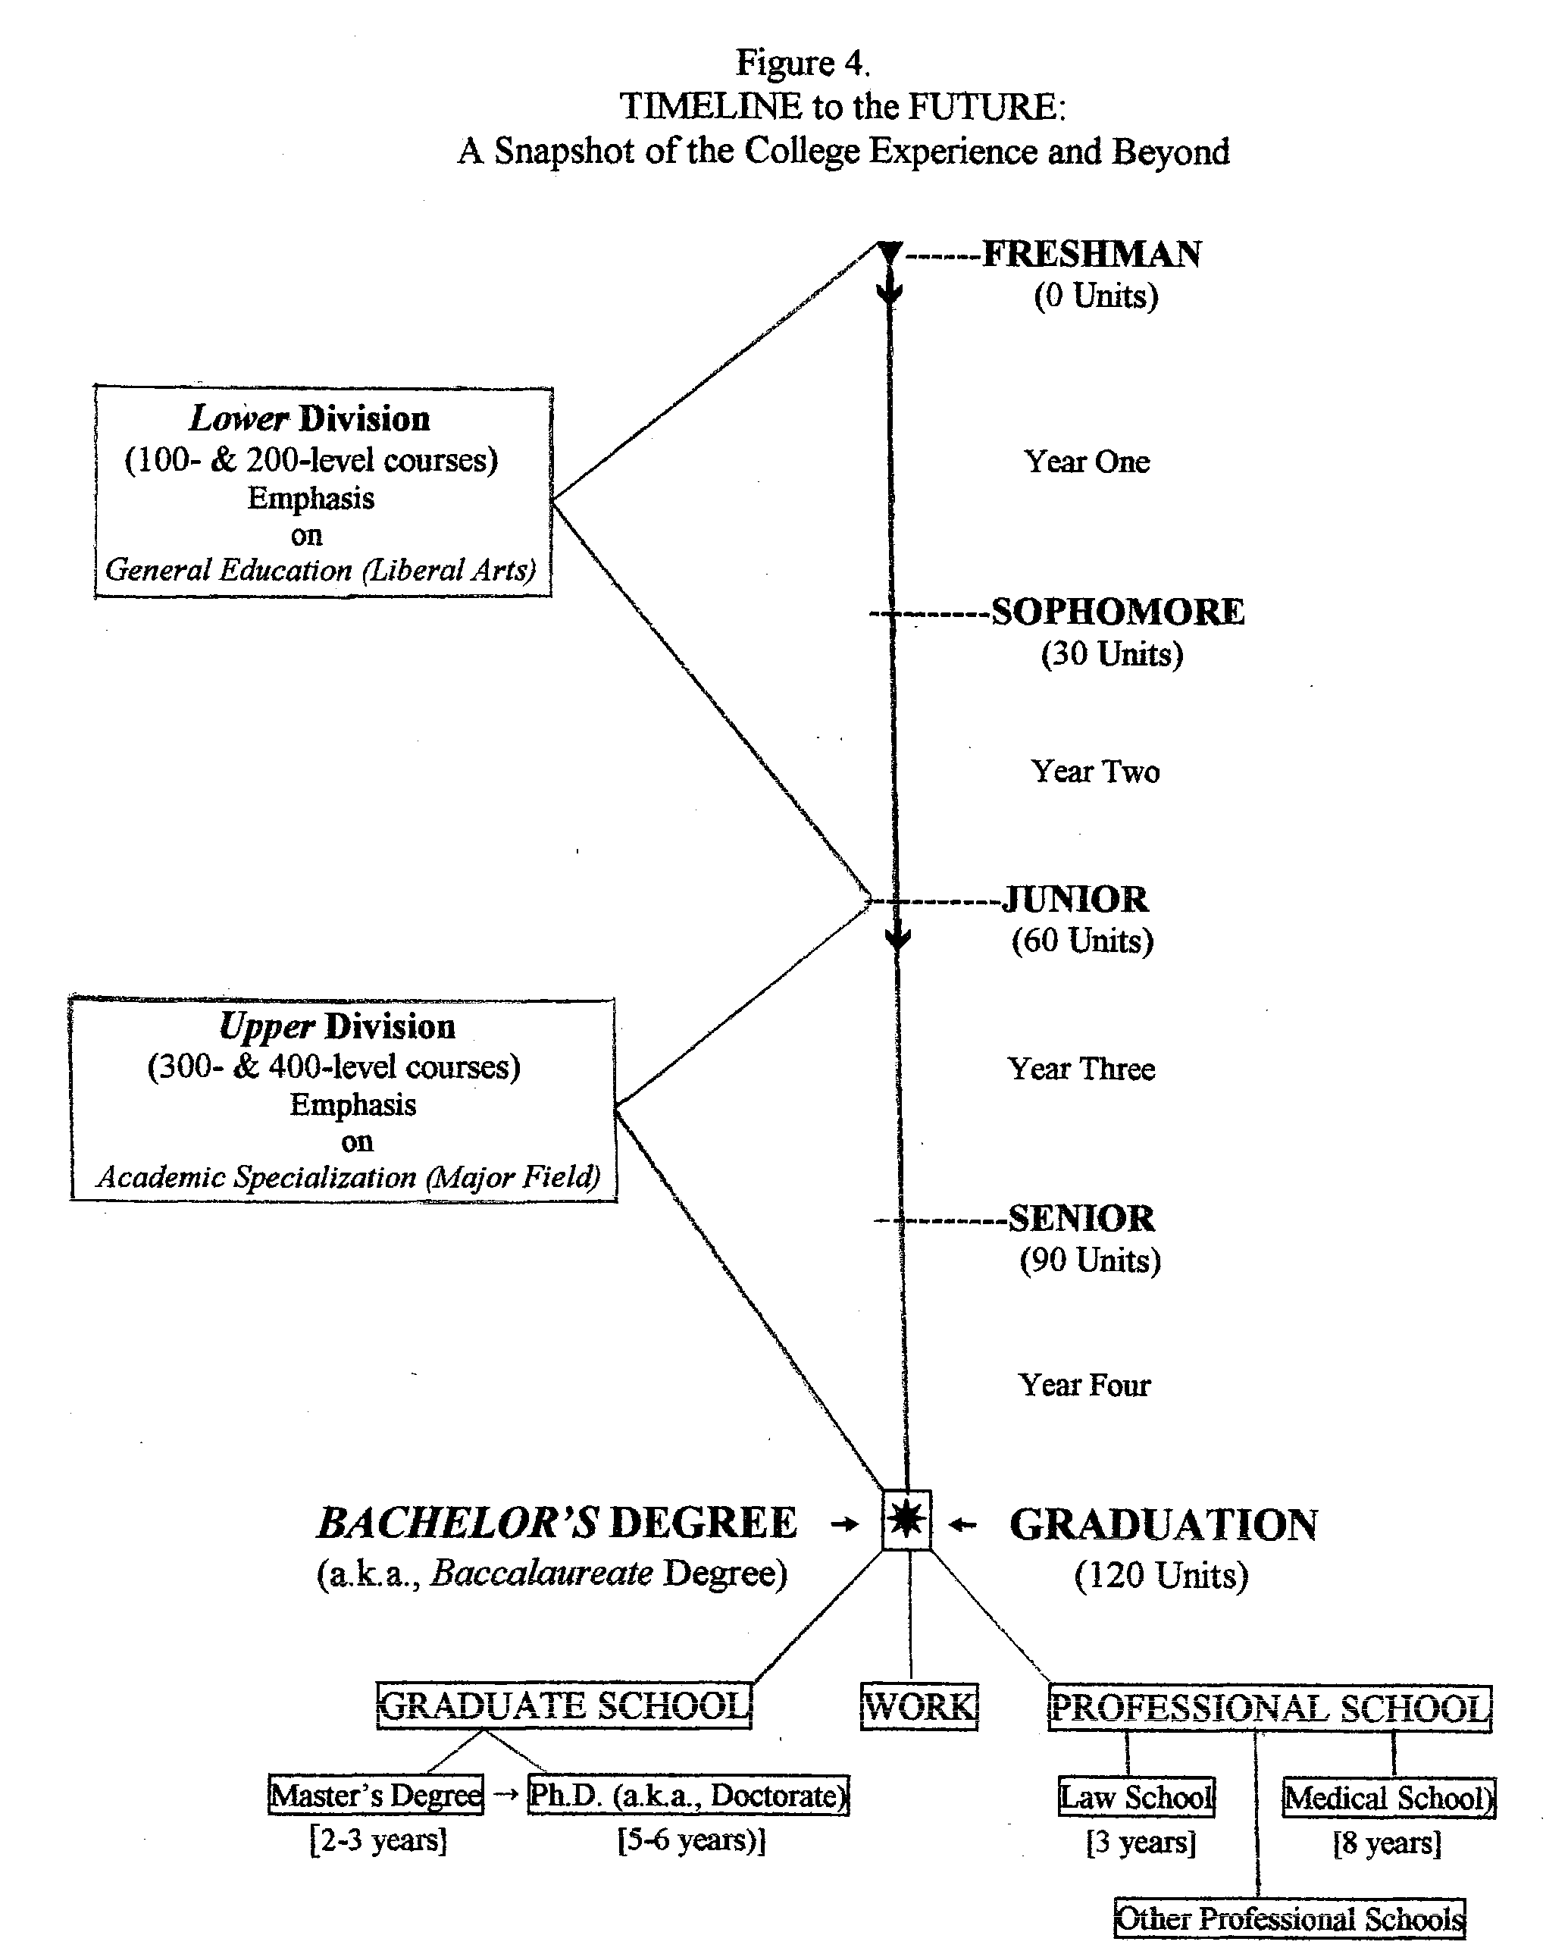
Notes:.
1. The word “freshman” originated in England in 1596, when every college student was a “fresh” (new) “man.” Today, “freshman” is frequently replaced by “first-year student” because this a more gender-neutral term.

- 2. The term “baccalaureate” derives from “Bacchus”—the Greed god of wine and festive celebration, and “laurel”—a wreath made from the laurel plant that ancient Greeks draped around the neck of Olympic champions.

3. The total number of general education units and the total number of units needed to graduate with a bachelor’s degree may vary somewhat from school to school. Also, the total number of units required for a major will vary somewhat from major to major and from school to school.

4. It often takes college students longer than four years to graduate—due to a variety of reasons, such as students working part-time and taking fewer courses per term, (b) needing to repeat courses that were failed or dropped, or (c) making a late change to a different major and needing to fulfill additional requirements for the new major. In some cases, the delay is caused by the college or university failing to provide the needed number of course sections students need for graduation so they have to wait an extra term or year for the needed course to be offered again.

5. Graduate and professional schools are options for continuing to higher levels of education after completion of an undergraduate (college) education.

6. Students going to graduate school on a full-time basis may be able to support themselves financially by working part-time as a teaching assistant (TA) or research assistant (RA).

7. The term “Ph.D.” refers to “Doctor of Philosophy,” respecting for the fact that the first scholars were the ancient Greek philosophers (e.g., Socrates, Plato, and Aristotle). However, a Ph.D. can be earned in many different academic fields (Mathematics, Music, Economics, etc.).

8. It is possible to enroll in some graduate or professional school programs on a part-time basis, while holding a full-time job.

9. Compared to graduate school, professional school involves advanced education in more “applied” professions (e.g., Pharmacy or Dentistry).

Once you complete a bachelor's degree, it's possible to continue your education in a field that's not directly related to your college major. This is particularly true for students who are majoring in pre-professional careers that funnel them directly into a particular career after graduation (Pascarella & Terenzini, 2005). For example, if you major in English, you can still go to graduate school in a subject other than English, or go to law school, or get a master’s degree in business administration. In fact, it's common to find that the majority of graduate students in master’s of business administration (MBA) programs were not business majors in college (Dupuy & Vance, 1996).
Myth 3: You should Major in Business if You Want to Have a Job after Graduation because Most College Graduates Work in Business Settings
Studies show that college graduates with a variety of majors end up working in business settings. For instance, engineering majors are likely to work in accounting, production, and finance. Liberal arts majors are likely to move on to positions in business settings that involve marketing, human resources, or public affairs (Bok, 2006; Useem, 1989).

"Employers are far more interested in the prospect's ability to think and to think clearly, to write and speak well, and how (s)he works with others than in his major or the name of the school (s)he went to. Several college investigating teams found that these were the qualities on which all kinds of employers, government and private, base their decisions"
--Lauren Pope, 1990, p. 213).

Don't restrict your choices of a major to business by believing in the myth that you must major in business to work for a business after graduation. Research shows that in the long run, the career mobility and career advancement of non-business majors in the business world are equal to those attained by business majors (Pascarella & Terenzini, 1991, 2005).

Student Perspective
"They asked me during my interview why I was right for the job and I told them because I can read well, write well and
I can think. They really liked that because those were the skills they were looking for."
--English major hired by a public relations firm (Source: Los Angeles Times, April 4, 2004)
Myth 4: If You Major in a Liberal Arts Field, the Only Career Available to You Is Teaching
Liberal arts majors are not restricted to teaching careers. There are many college graduates with majors in liberal arts fields who have proceeded to, and succeeded in, careers other than teaching. Among these graduates are such notable people as:
l Jill Barad (English major), CEO, Mattel Toys
l Steve Case (political science major), CEO, America Online
l Brian Lamb (speech major), CEO, C-Span
l Willie Brown (liberal studies major), Mayor, San Francisco
(Source: Indiana University, 2004).
In fact, studies show that college graduates with liberal arts majors are just as likely to advance to the highest levels of corporate leadership as graduates majoring in pre-professional fields--for example, business and engineering (Pascarella & Terenzini, 2005). If you are considering a major in a liberal arts field, you should not be dismayed or discouraged by those who may question your choice by asking: "What are you going to do with a degree in that major?"
(A good career-information Web site for liberal arts majors can be found at: www.eace.org/networks/liberalarts.html)
Myth 5: Specialized Skills Are More Important for Career Success than General Skills
You may find that general education (liberal arts) courses are sometimes viewed by students as unnecessary requirements that they have to "get out of the way" before they can "get into what's really important"--their major or academic specialization. However, general education Is career preparation because it develops practical, durable, and transferable skills that supply a strong foundation for success in any profession.
Also, don’t forget that the general skills and qualities developed by the liberal arts serve to increase career advancement (ability to move up the career ladder) and career mobility (ability to move into different career paths. Specific, technical skills may be important for getting into a career, but general educational skills are more important for moving up the career ladder. The courses you take as part of your general education will prepare you for your advanced career positions, not just your first one (Boyer, 1987; Miller, 2003). Furthermore, general professional skills are growing even more important for college graduates entering the workforce in the twenty-first century because the demand for upper-level positions in management and leadership will exceed the supply of workers available to fill these positions (Herman, 2000).
Pause for Reflection
In what ways do you think your general education courses will improve your work performance in the career field you may pursue?

The Liberal Arts Curriculum (General Education) & Career Preparation
One of the primary advantages of taking the wide range of courses that make up the liberal arts curriculum is that they enable you to become more aware of different aspects of yourself, while at the same time, you become more aware of the variety of academic disciplines and subject areas that are available to you as possible majors. Your trip through the liberal arts curriculum will likely result in your discovery of new personal interests and new choices for majors, some of which may be in fields that you didn’t even know existed.
Also, your exposure to a wide range of subjects provides you with the general context that is needed to make an intelligent selection of your specific major and to understand how your particular major fits into the bigger picture. In other words, you need to take a trip through the forest before you can select the right tree. So, look at your trip through the liberal arts curriculum as an exploratory journey in which you are searching to make three key discoveries:
1. Discovering the full range of choices for majors that are available to you,
2. Discovering where your special interests, values, needs, and abilities lie, and
3. Discovering what specialized major best matches your special interests, values, talents, and abilities.
Remember: Finding yourself and your options should take place before you find a major and future career. You don’t build your life around a major and a career; you build a major and career around your life.
Even if you have already decided on a major, you will still need to explore specialized fields within your major to find one that is most compatible with your personal interests, abilities, and values. For instance, if you have decided to major in communications, you will still need to select what particular field or communication media to specialize in, such as visual media, print media, or sound media. Similarly, if you are interested in pursuing a career in law, you will eventually need to decide what branch of law you wish to practice.
So, if you have decided on a major field of study, the liberal arts component of your college experience will help you explore specializations within that field by exposing you to a wide variety of subject areas and by testing your skills and interests in these areas. Furthermore, your exposure to different fields of study in the liberal arts curriculum may result in your discovery of a second field that interests you, which you may decide to pursue as a minor to accompany your major.

