Teaching Chapter 5
STRATEGIC LEARNING, STUDYING AND TEST PREPARATION

Key Instructional Goal of this Chapter
A primary goal of the three previous chapters was to help students see why college is worthwhile and how it is relevant to their future plans. Building on this motivational base, Chapter 4’s primary instructional goal is to help students learn how to learn—strategically and deeply.

Motivating Students for this Chapter

* The importance of learning effectively and efficiently for academic success has always been self-evident; however, its relevance for personal and professional success may be greater today than at any other time in history. Increasing global interdependence and the burgeoning information-technology revolution are creating a greater need for humans to develop transferable learning skills that can be applied in different cultural and occupational contexts. This current climate of global communication and technological change also places a higher premium on workers who have learned how to learn and are able to learn continuously throughout life. Taking a few minutes of class time to point this out to your students can help create positive anticipation set for this unit.

* Explicitly indicate to your students that this unit doesn’t take the traditional “study skills” approach to improving academic performance. First-year students are likely to perceive study skills as something that was already covered in high school study (“been there, done that”). Instead, you will be approaching this topic from the perspective of human learning theory and brain-based (brain-compatible) learning. This approach should trigger greater interest in the topic and make it more stimulating (and challenging) for your students.

* Remind students that this chapter places heavy emphasis on the underlying reason(s) for the recommended learning strategies are effective. Grounding the suggested strategies in solid research on human learning and the human brain should enable students to gain a deeper understanding of why these strategies are effective, which will benefit them conceptually and motivationally.

* Highlight the chapter’s emphasis on the underlying principles of learning that make the recommended learning strategies effective. The intent of this chapter is to equip students with powerful principles they could use to improve their learning across different situations or contexts, both in college and beyond. Encourage your students to see the suggested strategies not simply as college-success “tips,” but more as transferable principles that can be applied to learn any subject or any skill (i.e., they are empowered by learning how to learn, rather than being instructed what to do).

"The habit of active utilization of well-understood principles is the final possession of wisdom."
--Paul Ramsden, Chancellor of Teaching and Learning, University of Sydney (Australia)
* Remind you that the learning and memory strategies discussed here are more than just “study skills” or academic success strategies; they are life success skills or lifelong learning skills that you can and will use throughout the remainder of your personal and professional life. For example, the skills of focusing attention and active listening are not only useful in the classroom, but in social relationships outside of class and throughout life; and note taking itself is a skill that you will continue to use throughout your career (e.g., during professional meetings and committee work).
Furthermore, these lifelong learning skills are probably more important today than at any other time in history because we are now living in an era characterized by rapid technological change and dramatic growth of knowledge. The current information and communication explosion is creating a greater need for people to learn continuously throughout life and a higher demand for working professionals who are skilled learners--who have learned how to learn (Niles & Harris-Bowlsbey, 2002; Herman, 2000).
“In a world that is constantly changing, the most important skill to acquire now is learning how to learn.”
--John Naisbitt, futurist and author of Megatrends: Ten New Directions Transforming Our Lives

Key Points to Make When Covering this Chapter in Class

* Although learning does involve memory, learning and memorizing are not synonymous. Memorizing represents superficial “surface” learning; “deep” meaningful learning doesn’t take place by pounding information into the brain through sheer repetition, but by reflecting on what’s being learned and doing something to, or with it, such as transforming it into different words or identifying examples of it.

* Learning is a sequential, multi-stage process that involves getting information into the brain (attention), keeping it in (storage or retention), and getting it out when we need it (retrieval). It takes all three stages for effective learning to take place and a breakdown at any one of these stages can lower the quality of academic performance. On the other hand, if learning is divided and conquered at each of these key stages, it becomes a more manageable task.

* Learning is a multi-modal process that takes place more effectively and more deeply when multiple sensory modalities are engaged in the process of learning (hearing, seeing, touching, moving, etc.).

* Timing matters—effective learning depends on what’s done (a) before the learning process begins (to ensure attention), (b) during the learning process (to monitor comprehension), and (c) after the learning process (to promote consolidation and long-term retention).

* Self-monitoring (self-checking) for comprehension is essential for deep learning. Highlight the importance of the self-monitoring strategies discussed on pp. 112-113.

Point of Clarification Regarding Information Included in this Chapter

* No specialized method for note-taking and reading is favored because we’ve found that students often have difficulty applying a single method effectively across different academic disciplines and lecturing styles. Furthermore, students sometimes get so preoccupied with adhering to a particular note-taking format that it distracts them from the more important task of listening actively and processing meaningfully the information being conveyed to them during lectures. Nonetheless, given its popularity, the Cornell Method of note-taking and the SQ3R method of reading are included in this chapter.

Exercises/Assignments for Chapter 5

Lecture Note-Taking Exercises

Active Knowledge Sharing
Steps:
1. Before delivering a short lecture, provide students with a list of questions relating to the
subject matter that will be covered (e.g., words to define, people to identify, pretest on factual
information or concepts).

2. Have students pair up to answer the questions as best as they can.

3. Have students mill around the room to find other pairs who may have answers to questions
they’re unable to answer (Silberman, 1996).

Note: This procedure also serves the important purpose of pre-assessing and activating students’ prior knowledge (and latent misconceptions) before the learning process begins.

Cooperative Note-Taking Pairs
Steps:
1. At a designated point during a lecture, stop your presentation and have students form pairs.
2. While in pairs, have partners take turns asking each other questions such as: “What have you
got in your notes thus far?” or, “What are the most important points that have been
presented?” Teammates should attempt to take something from the other’s notes to include in
their own notes (Johnson, Johnson, & Smith, 1995).

Scripted Cooperation
Steps:
1. At a key point during the lecture, have students form pairs and ask one member to assume the
role of summarizer—who attempts to summarize the information the instructor has presented
without looking at his notes, while the other assumes the role of listener—who provides
feedback about its accuracy and completeness.

2. Have partners elaborate on the lecture information by (a) relating it to their life experiences,
(b) relating it to previously learned information, or (c) creating mnemonic devices to
remember it (O’Donnell, 1994).

Note: This structure and the preceding one (“Cooperative Note-Taking Pairs”) serve to intercept the attention loss that takes place when students passively process lecture information for an extended period of time by engaging students in activities that require them to actively process the information they’re receiving.

Closure Note-Taking Pairs
Steps:
1. At the conclusion of a lecture, one partner summarizes her notes for the other—who, in turn,
corrects any mistakes and adds any missing information.

2. Each member should attempt to take something from her partner’s notes and include it in her
own (Johnson, Johnson, & Smith, 1991).

Pair Review
Steps:
1. At the end of a lecture, provide students with a list of topics that have been covered.

2. Have students form pairs and ask them to recall as many things as they can remember about
each topic (Silberman, 1996).

Note: This structure and the preceding one (“Closure Note-Taking Pairs”) serve to summarize and bring closure to the lecture-learning process, thus ensuring that students reflect on and consolidate the information they’ve received.

Team Recall
This procedure helps to highlight for students how teamwork can improve recall for information presented in the classroom and, ultimately, improve their test performance.

Steps:
1. At the start of class, ask students to list on a sheet of paper everything they can remember
about what was covered in the previous class period.

2. Ask students to pair-up with a partner and add any info from their partner’s list that
wasn’t on their own list. (Have them skip space after their own list before adding their
partner’s information so that they can easily distinguish their own ideas from those
contributed by their partner.)

3. In round-robin fashion, ask different pairs of students to share an item from their
combined list and record it on the board.

4. Have the student pairs add all items that appear on the board that were that were not on
the list they created with their partner. (Ask them to skip a space again after the last
entry on their list before adding these items, so that they can easily identify ideas added
to their list that were recalled by other students in class.)

5. Ask students to note how many ideas were recalled by their partner and other students
in class—above and beyond those they recalled individually.

Reading Exercises

Pairs Think – Turn Teach
Steps:
1. Forms teams of four and have them subdivide into two sets of pairs.

2. Each pair learns one-half of an instructional unit or textbook chapter.

3. Each pair turn-teaches its half of the unit to the other pair (Kagan, 1992).

Team Reading
Steps:
1. Prior to class, students complete a reading assignment (e.g., a textbook chapter, or a
portion thereof).

2. Individually, students take a closed-book quiz on the assigned reading.

3. Students take the same quiz as a team, attempting to reach consensus with respect to
the correct answers for all test questions. This “team quiz” is submitted to the instructor and
all teammates receive the same “team score.”

4. Each student’s individual quiz score and team quiz score are counted equally toward
the student’s final course grade (Michaelsen, 1992).

Note: This testing procedure serves two purposes: (a) it holds students responsible for
completing their reading assignments, and (b) it encourages students to work
collaboratively and grapple with the challenge of reaching consensus.

Dyadic Essay Confrontation (DEC)
Steps:
1. In response to an assigned reading, have students work individually outside of class to: (a)
construct an integrative essay question that compares the reading with previously covered
material, and (b) write a model answer to this question.

2. During class time, ask students to: (a) exchange essay questions with another student and write
a spontaneous essay in response to the question they receive, and (b) compare their
spontaneous answer with the model answer, noting similarities and differences (Millis,
Sherman, & Cottell, 1993).

Studying Exercises

Term Teaming
Steps:
1. Form four-member teams and give each team a list of four terms to research, define, and self-
teach. Members of each team are assigned a number—1, 2, 3, or 4, and all students with the
same number are assigned the same term.

2. Students research their individual terms (e.g., by using their textbook and class notes), then the
“number-one” students pair up with the “number-two” students and teach them what they have
learned. The “number-three” students do the same for the “number-four” students.

3. Students reverse roles and students with numbers two and four do the teaching.

4. Partners rotate (e.g., 1 & 3, 2 & 4) and continue to rotate until all four terms have been taught
to all four team members (Dentler, 1994).

Biological Rhythm Timeline
Steps:
1. Ask students to take a moment to think individually about what time of day tends to be their
“peak period,” i.e., when they are most productive mentally.

2. Designate a line across the room (left to right or front to back), representing early morning
(e.g., 7 AM) to late night (e.g., 11 PM), and have students take a position on that line which
corresponds to their period of peak productivity.

3. Form homogenous groups of students with similar peak periods and ask them to exchange e-
mail addresses in the event they would like to form study groups for your class or other classes
they may be currently taking together in their first term.

Cooperative Study Groups
Steps:
1. Ask students to form four-member study groups and register their group with you by
providing their names and student identification numbers. (Groups may release or add a new
member by unanimous vote; however, if group membership falls below four, the group is
considered disbanded until members vote in a replacement).

2. Students who are members of registered study groups receive bonus points for each course
assignment, provided that their group has registered prior to the assignment’s due date. The
bonus is based on an average of all individual grades received by group members, according to
the following formula: If the average grade is A, all members receive three percentage points;
if the average grade is B, they receive two percentage points; if the average grade is C,
they receive one percentage point. If an individual student receives an A on the assignment,
but the group average is C, that student still receives a bonus of one percentage point
(Robinson, cited in Weimer, 1991).
Additional Material Excised from the First Edition of the Text that
May be Used in Lectures or as Reading Assignments

The same learning strategies that enabled you to earn grades of A or B in high school aren’t likely to earn you those same grades in college; studies show that the percentage of students earning As and Bs drops from about 50 percent in high school to about 33 percent in college (Astin, 1993; Sax et al., 2004). Thus, you are likely to experience greater academic challenges in college than you did in high school. To maintain or exceed your level of academic performance in high school, you will need to elevate your performance to a higher level in college. Attaining this higher level of academic performance will not only involve working harder; it will involve working smarter by using strategies supported by solid research on effective learning.

Brain-Based Learning Strategies
Learning is more effective and efficient when it is “brain-based” or “brain-compatible” (Hart, 1983), i.e., when it capitalizes on the brain’s natural learning tendencies (Caine & Caine, 1994). Although we may differ in terms of our learning strengths and styles, we're also members of the same human species and possess a human brain, which works functions similarly in all human beings. Just as our bodily organs, such as our heart and liver, perform specific biological functions, our brain functions as the biological “learning organ” of the body (Zull, 1998). By understanding how the human brain learns, we can capitalize on this knowledge to identify general principles or common themes of learning that work effectively for all humans. These general, brain-compatible principles can be converted into specific strategies that may be used to learn effectively in any subject area to promote your success across the curriculum (Weinstein, 1982).
The Brain Is Biologically Wired to Seek Meaning
Perhaps the most distinctive and most powerful feature of the human brain is that it is biologically wired to seek meaning (Caine & Caine, 1994). The human brain naturally looks for meaning by trying to connect what it's trying to learn to what it already knows.
Personal Experience
When my son was about 3 years old, we were riding in the car together and listening to a song by the Beatles titled, Sergeant Pepper’s Lonely Heart Club Band.” You may be familiar with this tune, but in case you’re not, there is a part in it where the following lyrics are sung repeatedly: “Sergeant Pepper’s Lonely, Sergeant Pepper’s Lonely, Sergeant Pepper’s Lonely . . . .”
When this part of the song was being played, I noticed that my 3-year-old son was singing along. I thought that it was pretty amazing for a boy his age to be able to understand and repeat those lyrics. However, when that part of the song came on again, I noticed that he wasn’t singing “Sergeant Pepper’s Lonely, Sergeant Pepper’s Lonely . . .” etc. Instead, he was singing: “Sausage Pepperoni, Sausage Pepperoni . . .” (which were his two favorite pizza toppings).
So, I guess my son’s brain was doing what it tends to do naturally. It took unfamiliar information (song lyrics) that didn’t make any sense to him and transformed it into a form that was very meaningful to him!
Joe Cuseo
New Knowledge Is Built on Existing Knowledge
Acquiring knowledge isn't a matter of pouring information into the brain, as if it were an empty jar; instead, the brain builds new knowledge onto knowledge it already possesses (Piaget, 1978; Vygotsky, 1978), i.e., by connecting it to information that it has already stored.
Although academic learning in college may require you to memorize information verbatim, your first strategy when studying should be to seek meaning in the information you're learning, or transform it into a form that's meaningful to you--rather than simply settling for surface (shallow) learning through memorization and sheer repetition. Seeking meaning not only results in learning that's deeper, but also results in memory that's more durable--i.e., more likely to remain in your brain for a longer period of time (Craik & Lockhart, 1972; Craik & Tulving, 1975).
Remember: Deep, long-lasting learning requires an active search for meaning via personal reflection, rather than passive memorizing via mindless repetition.
Since our brains naturally seek meaning, when you learn by searching for meaning, it makes the process of learning more stimulating and more motivating than learning by memorizing and repeating--which can quickly become very monotonous, mindless, and boring. In fact, interviews with students show that those who use a deep, meaning-oriented approach to learning, they're more to report experiencing more personal satisfaction and interest in what they're learning than students who learn through surface-level memorization (Biggs, 1987; Marton, et al., 1997; Marton & Saljo, 1984).
Stages in the Learning and Memory Process
Learning deeply, and retaining what you’ve learned, is a process that involves three key stages:
1. getting information into your brain (perception),
2. keeping it there (storage), and
3. getting to it when you need it (retrieval).
You can consider these stages of human learning and memory to be similar to the way information is processed by a computer: (a) information first gets typed onto the screen, (b) the information is kept or stored by saving it in a memory file, and (c) the information is found by calling up or retrieving that file when it's needed.
Here's a more detailed look at each of these three key stages in the learning-memory process and relate them to learning in college.
Stage 1. Perception: Receiving Information from the Senses and Sending It to the Brain
This is the first step in the learning process because we must first attend to and receive information in order to get it into our brain--where it's registered or perceived. All information from the outside world gets to the brain through our senses (e.g., sight and sound), but it will only reach and get registered in our brain if we pay attention to it.
Contrary to popular belief, not all information that reaches our senses is received and registered in our brain (Rose, 1993). Although information may reach our eyes and ears, if we are not paying close enough attention to it, it will not register in our brain and we will not perceive it. Have you ever had the experience of driving right past an exit that you were supposed to take? Your eyes were fully open and the exit sign was in your field of vision when you passed it, but because you weren't paying close enough attention to it, it didn't register in your brain and you never perceived it.
Only information that we pay attention to gets registered by our conscious brain because the lower, subconscious part of our brain works as an attention filter by selectively letting in or keeping sensory information from reaching the upper parts of the brain--where it is consciously perceived. (See the following figure).
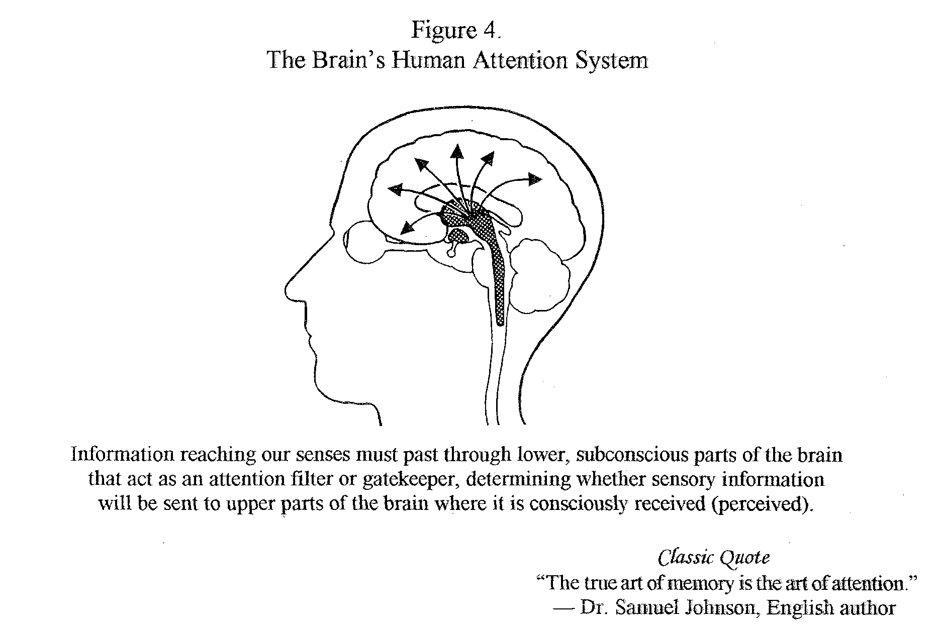

Pause for Reflection
People often forget the name of someone immediately after being introduced. What do you think causes this memory failure?

In fact, one of the major reasons why we forget is because we weren't paying close enough attention to what we needed to remember in the first place; as a result, the information never reaches and registers in our brain. For example, forgetting where we put our keys or where we parked our car are classic examples of inattention or "absentmindedness." We forget these sorts of things because our brain never received the information in the first place; our mind literally was "absent" (not "really there") and fully focusing attention on where we put or keys or parked our car.
As these examples illustrate, attention is a critical prerequisite for learning and memory to take place.
Remember: If there’s no attention, there can be no retention.
In college, there are two key sensory channels or routes through which you will typically receive information: (a) hearing--listening to lectures, and (b) seeing--reading information from textbooks.
For learning to occur through either of these routes, the critical first step is to attend to and make note of the information received. Simply stated, you cannot learn and retain information that you've never attended to and attained in the first place.

Personal Experience
My son Michael is notorious for wanting to do everything that we ask his younger sister to do, and very little of what we ask him to do. A classic example is when we send him to any room to retrieve any object. My wife and I now measure how long it will take him to bring the wanted item back to us. (However, if we're in a hurry, we usually get it ourselves.) This is how it usually goes. "Michael, please go into the master bathroom and get the nail clippers." Michael, who will be seven at the time of this publication, walks slowly toward the bathroom. In a few minutes, he'll walk back into the room where we are, carrying some object he has started to construct (perhaps he'll grow up to be an engineer). When we ask him for the clippers, he'll say: "Oh, I forgot." In reality, he was not paying attention to our request, and it never registered in his brain. However, if we asked Maya (our daughter) to retrieve the item, Michael bowls her over to retrieve it. He listens well when Maya's name is called. The plan in our household now is to ask Maya for everything and let her actually get it when Michael is not around.
--Aaron Thompson, Professor of Sociology
"We remember what we understand; we understand what we pay attention to; we pay attention to what we want."
--Edmund Bolles, Remembering & Forgetting: An Inquiry into the Nature of Memory
Stage 2. Storage: Keeping Information in the Brain
If information passes through our attention filter and is consciously perceived by our brain, it enters into one of the following memory systems:
* short-term memory--where it lasts for only a few seconds; or
* working memory--where you can consciously hold it in your mind and work on it for an extended period of time.
Have you ever walked into a room to do or get something, but once you got there, you had no idea why you were there? This experience illustrates the difference between short-term and working memory. What happened is that you had an idea in your short-term memory about something you were going to do or get in that room, but you then began thinking about something else after you had this thought, and by the time you got to the room, the thought had faded from your working memory. If you had kept that thought in your working memory, you would have been able to hold onto it and would have remembered why you went into the room after you got there.
To get information to stay in the brain for more than a short period of time, it has to be transferred from working memory, which is a temporary memory system, and into a different memory system known as long-term memory. Similar to a computer, we can get information onto the screen (short-term memory) and work on it (working memory), but if we want our computer to save the information we've worked on, we have to store it in the computer's long-term memory system.
The part of the brain that enables you to transfer memories from short-term to longer-term memory is known as the hippocampus (Squire, 1992) (See Figure 5 below). If the hippocampus is permanently damaged, an individual cannot store long-term memories. Or, if the hippocampus is temporarily slowed down by alcohol or marijuana, it can interfere with memory storage (for example, cause memory "blackouts" to be experienced by someone for events that occurred during a night of excessive drinking).
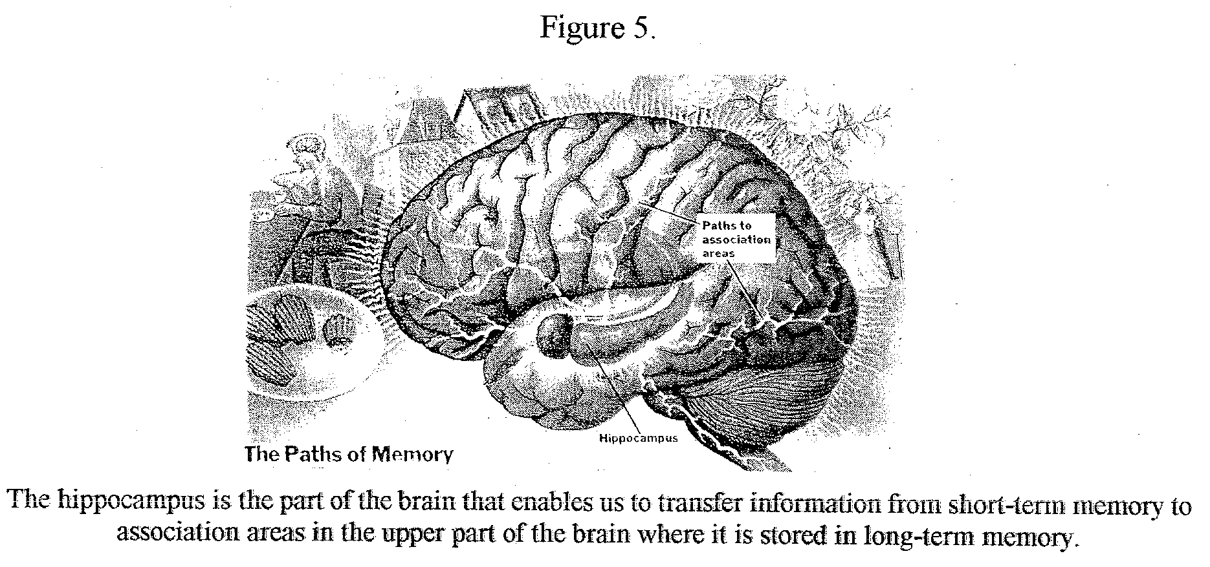

The process of storing information in long-term memory is referred to as coding, and the information that's stored is referred to as a memory trace--a physical or biological trace of the memory in the brain. (Note: The term memory trace is consistent with the word learning--which derives from the root word meaning "footprint" or "track.")
Relating all this to college learning, when you're studying, you are trying to register a memory trace by transferring information from working memory to encode it in long-term storage so that you can recall it at test time. How well the information you've studied will stick in your brain depends on how effectively or deeply you learned it--the deeper the learning, the stronger its memory trace.
The following strategies will help you to learn more deeply and better retain information that you're studying:
* connect or relate the information to something you already know;
* organize it into some classification system;
* take it in through multiple sensory modalities--e.g., see it, hear it, draw it, and feel it; and
* practice it at different times.
Pause for Reflection
It's common to hear students say, "I knew it when I studied it, but I forgot it on the test."

What do you think causes this common occurrence?
How might students study differently to prevent this from happening?
Stage 3. Retrieval: Finding Information that’s Been Stored in the Brain and Bringing It Back to Conscious Awareness
Getting information into the brain and getting it to stay there are the first two critical stages in the learning-memory process. The final stage requires is finding the stored memory and bringing it back to mind. To use a computer analogy, when your computer retrieves a file, it searches through the stored files, finds the particular file you need, and then brings it back to the screen in front of you. When taking a test, you're relying on the retrieval stage of memory to bring back to mind what you've studied before the test. Thus, the first stage of memory involves attending information in lectures and readings; the second stage involves studying (storing that information in your brain); and, the final stage involves retrieving that information at test time.
Evidence for the importance of the retrieval stage of memory comes from what researchers call the "tip of the tongue" phenomenon (Brown & McNeill, 1966). You've probably said to yourself: "Oh, I've got it (the memory) on the tip of my tongue." For example, you're taking an exam, you studied the material well, and you know the information that's being asked for in the test question; however, you just can't quite get it to come back to you. After the test is over, the information may suddenly come back to you when it's too late to use it! This demonstrates the memory trace was in your brain the entire time; you just were just temporarily unable to access and retrieve it.
Pause for Reflection
For each of the three stages that make up the learning and memory process, how would you rate yourself in terms of your ability or past performance?
1. Attention to information presented in class and in reading assignments
(strong, average, or weak?)
2. Studying--preparing for exams and getting information to "store" in your brain
(strong, average, or weak?)
3. Test-taking--retrieving information that you've studied at test time and getting it down on paper (strong, average, or weak?)

Attention in the College Classroom
Be aware that we may sometimes give others and ourselves the impression that we're actively listening because it is the polite thing to do; however, we may just be listening passively, partially, or not at all. For instance, when we're being introduced to someone for the first time, we may appear to be politely listening and paying attention to the person's name; however, we may not be listening carefully at all because we're thinking about what to say next or worrying about the type of impression we're making. When we run into that same person again five minutes later, we're embarrassed to learn that we've forgotten the person's name--which indicates that we weren't really listening and paying attention when we first heard it.
One aspect of effective listening in the classroom is to pay attention to whether you're really paying attention. Often the best way to do so is to check your own body language. Listed in the box below are some key nonverbal signals that often provide a good indication of whether or not you're listening actively and attending closely to what your instructor is saying in class.
Making a conscious effort to focus your attention in the classroom is particularly important during the first year of college because class sizes for introductory courses are often larger than other college courses or courses you had in high school. When class size grows larger, individuals begin to feel more anonymous, which may reduce their sense of personal responsibility and level of active involvement. In large-class settings, it becomes especially important to fight off both external distractions and the tendency for your mind to wander, resulting in "attention drift."
………………………………………………………………………………………………………………………
Nonverbal Behavior Associated with Attention in the College Classroom

Listed below are nonverbal signals that indicate you’re paying close attention during lectures:
1. Your body is oriented directly toward the instructor, so that your shoulders line up squarely with the instructor’s shoulders (as opposed to one shoulder facing the instructor and your other shoulder facing away—sometimes referred as giving a person” the cold shoulder”).
2. Your body is upright or tilting slightly forward (rather than leaning back--which may mean you are “kicking back” and “zoning out”).
3. You make occasional eye contact with the instructor, rather than making no eye contact at all (e.g., looking out the window) or continually staring/gazing at the instructor like you’re in a mesmerized trance. Studies show that when a person makes periodic eye contact and then looks away for a moment to the left or right (referred to as “lateral eye movements” or “LEMS”); this indicates that the person is really listening to and thinking about what is being said (Glenberg, Schroeder, & Robertson, 1998).
4. Your head nods periodically and slowly--not continuously and rapidly, because the latter usually means that the listener wants the speaker to hurry up and finish.
There's another advantage of being attentive in class: You send a clear message to your instructor that you're a motivated, conscientious, and courteous student. This can influence your instructor's perception and evaluation of your academic performance. If you're on the border between two grades at the end of the term, you may get the benefit of the doubt. In contrast, inattentive or discourteous behavior in the classroom is likely to have the opposite effect on your instructor's perception and evaluation of you, and may lower your grade.
------------------------------------------------------------------------------------------------------------------------------
The Question that Instructors Most Hate to Hear after a Student Misses Class:
"Did I miss anything important in class today?"

Responses from Tom Wayman, Professor of Creative Writing, University of Calgary.
Nothing. When we realized you weren't here we sat with our hands folded on our desks in silence, for the full two hours.
Everything. I gave an exam worth 40 percent of the grade for this term and assigned some reading due today on which I'm about to hand out a quiz worth 50 percent.
Nothing. None of the content of this course has value or meaning. Take as many days off as you like: Any activities we undertake as a class I assure you will not matter either to you or me and are without purpose.
Everything. A few minutes after we began last time, a shaft of light descended and an angel or other heavenly being appeared and revealed to us what each woman or man must do to attain divine wisdom in this life and the hereafter. This is the last time the class will meet before we disperse to bring this good news to all people on earth . . .
And you weren't there.
------------------------------------------------------------------------------------------------------------------------------

