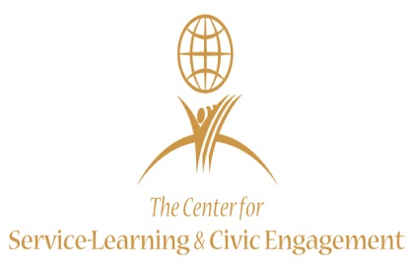
“Be Ready Summer Enrichment Camp 2018”

REGISTRATION: HOLLAND HALL ROOM 106
WEDNESDAY MAY 9TH & WEDNESDAY MAY 16TH
6:00 P.M.-8:00 P.M

. Overview
.
The Be Ready Summer Camp Program is a summer enrichment program sponsored by Boys & Girls Clubs of Middle Tennessee Club and hosted by TSU’s Center for Service Learning & Civic Engagement. We are committed to providing teens Ages 15-18* in grades 10-12 with exposure to activities that emphasize healthy lifestyles, good character, citizenship, community service, post-secondary education and striving for academic success.

Summer Camp Session: June 4, 2018 - July 27, 2018

Times: 9:00am-5:00pm Daily
* Early care will be available from 7:00am-8:30am at Andrew Jackson/Preston Taylor/Franklin and Fairview Boys & Girls Clubs.

Summer Camp Supervisors:

Boys & Girls Club Contact:
Ms. Breah Cunningham bcunningham@bgcmt.org P: 629-200-1062
TSU Contact:
Mrs. Shirley Nix-Davis snixdavi@tnstate.edu P: 615-963-5383

How to Register:

Come on one of the above dates to the TSU location, or pick up an application at TSU’s Center for Service Learning & Civic Engagement in Holland Hall, Suite 306 and return to a location below.

Please complete a Boys & Girls Clubs of Middle Tennessee Application at the following locations:

Andrew Jackson Boys & Girls Club Preston Taylor Boys & Girls Club
916 16th Avenue North 915 38th Avenue North
Nashville, TN 37208 Nashville, TN 37209
(p) 615.320.5106 (p) 615.341.3909

Fairview Boys & Girls Club Franklin Boys & Girls Club
1814 Fairview Blvd. 129 Fowlkes Street, Suite 1000
Fairview, TN 37062 Franklin, TN 37065
(p) 615.799.1880 (p) 615.794.4800

