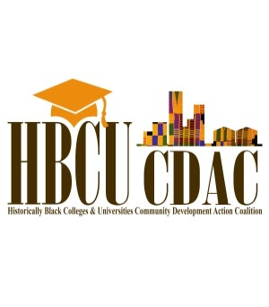
PROPOSAL NARRATIVE FORMAT
Proposals must be in agreement with the requirements of the RFP and submitted in Times New Roman 12 point font, double spaced, and not exceed five (5) pages.
Describe and outline: focus area(s), organizational capacity, goals and objectives, project activities and sites, partnerships, community engagement, orientation and training activities, reflection activities, reporting and project evaluation, project management, and budget narrative.
Narrative Worksheet
The following narrative worksheet is to be completed prior to submitting the online application. Please complete the application in its entirety and save it as a separate file that will be uploaded in the online application.
Describe and outline service project activities, partnerships, community engagement, volunteer orientation, training and management activities, reflection activities, and project evaluation.
Describe and outline: focus area(s), organizational capacity, goals and objectives, project activities and sites, partnerships, community engagement, orientation and training activities, reflection activities, reporting and project evaluation, project management, and budget narrative.

SUBMITTAL INFORMATION: Submit no later than: October 31, 2016 at 5:00 p.m. CDT.
2017 HBCU MINIGRANT PROPOSAL FORMAT:
Please make sure your proposal is in the following order.
- FOCUS AREA(S):

- ORGANIZATIONAL CAPACITY:

- GOALS AND OBJECTIVES:

- PROJECT ACTIVITIES AND SITES:

- PARTNERS/PARTNERSHIPS:

- COMMUNITY ENGAGEMENT:

- VOLUNTEER RECRUITMENT, ORIENTATION, TRAINING, MANAGEMENT:

- REFLECTION ACTIVITIES:

- REPORTING AND PROJECT EVALUATION:

- PROJECT MANAGEMENT:

- BUDGET (See Budget Form and Justification)

