Homepage Content Items
How to Update

Calendar Listing
Video
Weather/Crisis Message
Slideshow

CALENDAR LISTING
This involves updating a table of information...that will get handled by the system to display it in calendar form on the homepage.
HOW TO UPDATE:
- Visit: https://omniupdate.tnstate.edu/11/#oucampus/main/main/previewedit/%2Findex.pcf
- Scroll down on the page, looking for the Calendar listing.
- Click the small green edit button for the Calendar listing.
- Then, edit the table…following the standards below.

STANDARDS TO FOLLOW FOR DATA ENTRY
- Keep all months as 3-letters
- Keep event title as short as possible
- No more than 4 events are possible to be listed properly, so be sure not to add more than 4.

Save the page and publish it.

FEATURED VIDEO
**NOTE: Be sure to do the one nuance noted below when embedding a video.
HOW TO UPDATE:
- Visit: https://omniupdate.tnstate.edu/11/#oucampus/main/main/previewedit/%2Findex.pcf
- Scroll down to where the video is…and click the small green edit button in order to edit the video slot.
- Click the video to highlight it.
- Then, in the menu, click the media button as shown below.

- In the “Source” field, paste the link/URL for the new video
- Click the “Embed” tab on the left
- Scroll down to the bottom of the code.
- Between the greater-than sign (>) and the less-than-sign (<), enter two slashes…as shown below.
- Click “Save”.
- Save the page to preview it. If all is well, publish the page.

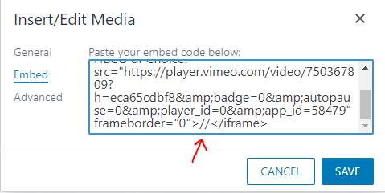

SLIDESHOW

FIRST, NOTE THIS:
You need these 5 pieces of information in order to add a new slide to the TSU Homepage:

HOW TO ADD A SLIDE TO THE SLIDESHOW
First, the original image should be made into 4 images of the following sizes, named according to the naming standard mentioned below:
3840 x 1440px Extra Large
1920 x 720px Large
1440 x 810px Medium
640 x 360px Small

Naming-standard (must contain no spaces & follow naming standard below)
Picturename_xl.jpg
Picturename_lrg.jpg
Picturename_med.jpg
Picturename_sml.jpg

Next, upload the 4 images to this location: https://omniupdate.tnstate.edu/11/#oucampus/main/main/browse/production/images/slideshow

Next, update the homepage slideshow:
Visit: https://omniupdate.tnstate.edu/11/#oucampus/main/main/previewedit/%2Findex.pcf
Click the small green edit button for the slideshow (if you don’t see it, advance the slides until you see it appear in the upper left of the slideshow)
Then, edit the table…following the standards below.

This is strictly a data table. So you place clean data into it and it gets handled by the web system to display it properly onto the web page.
TAKE NOTE of the gold items below…because your data MUST follow these particulars in order for the slideshow to work properly.

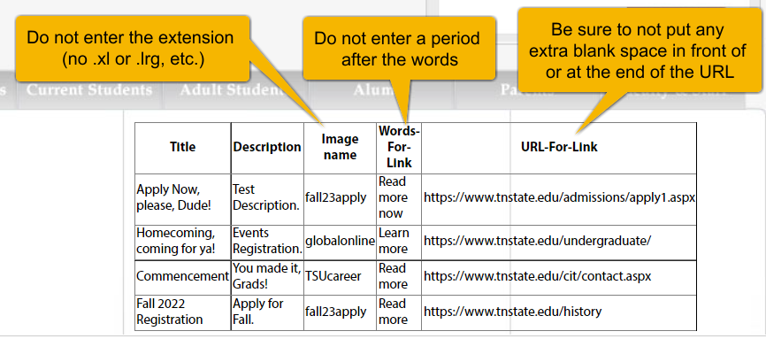

HOW TO DELETE A SLIDE
- First, remove the information for it from the Homepage slideshow data-table. Visit: https://omniupdate.tnstate.edu/11/#oucampus/main/main/previewedit/%2Findex.pcf.
- Choose to edit the slideshow area (by clicking the small green button).
- Remove the row (by right-clicking the row and choosing: Row Delete Row
- Save & publish the page
- Then, visit the folder that contains the images for the old slide: https://omniupdate.tnstate.edu/11/#oucampus/main/main/browse/production/images/slideshow . Click the box beside each image that you want to delete….and click “Delete” up near the top. You’ll then have to enter “delete” to confirm your deletion.

WEATHER/CRISIS MESSAGE
- Visit the TSU homepage – www.tnstate.edu …and at the bottom of the homepage, click “Last Modified” to login to OU Campus.
(Use your normal TSU network login-ID and password.)
- Click the first small green edit button entitled "Edit Announcements".
- Copy one of the messages below or enter your own:
Standard Messages:
  - CLOSED:
Due to inclement weather, Tennessee State University will be CLOSED on DayOfWeek, Month Day. Essential employees are expected to report to work. All classes are cancelled. Please continue to check the TSU homepage and social media for updates.
  - OPENING LATE:
Due to inclement weather, Tennessee State University will open at 00:00am (2 hrs late) on DayOfWeek, Month Day. Please continue to check the TSU homepage and social media for updates.
  - OPEN AS NORMAL:
Tennessee State University will be OPEN on DayOfWeek, Month Day. Please continue to check the TSU homepage and social media for updates.
- Maybe, change its color to red and center it. (This is the message that will appear at the top of the TSU homepage to alert web users)
- Save your edits (top left – diskette icon)
- Publish your page (big green Publish button)
- Click “Publish” one additional time in box that appears.
- Voila! It should now be live. Check it! -- www.tnstate.edu .

