How to Connect to TSU Wireless Network

To access the TSU Wireless Network, you must provide your MyTSU username and password. Guests on our campus can register their email and phone number to receive 24-7 wireless access. If you need any assistance please contact the Helpdesk @ 615-963-7777.

Step 1: Select and connect the TSU wireless network. Your internet browser will automatically open to our captive portal. Select whether you are a TSU Faculty/Staff or TSU Student. For guests you will have to enter your personal email address and phone number to receive 24hrs wireless access.
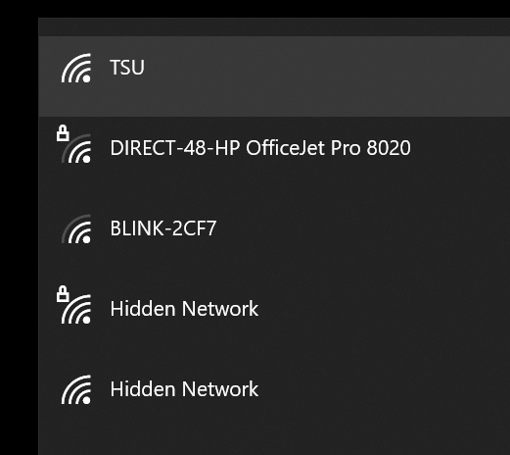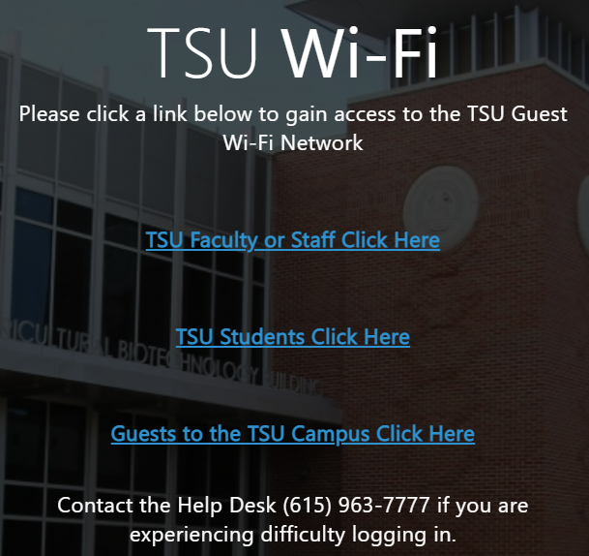
Choose 1
Step 2: Enter your MyTSU username and password. Your username is the portion of your TSU email before the @ symbol. Ex: the username for jdoe123@my.tnstate.edu is jdoe123. Once you accept terms of use and click login you will have access to the TSU wireless network.
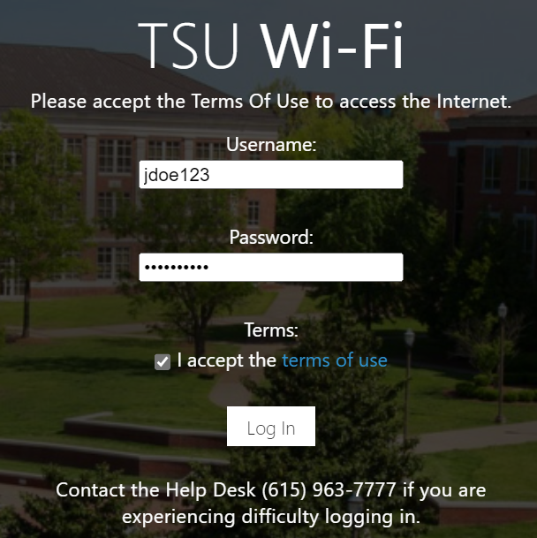
Click Here

