How to split the phone display into two columns

- Non-split screen

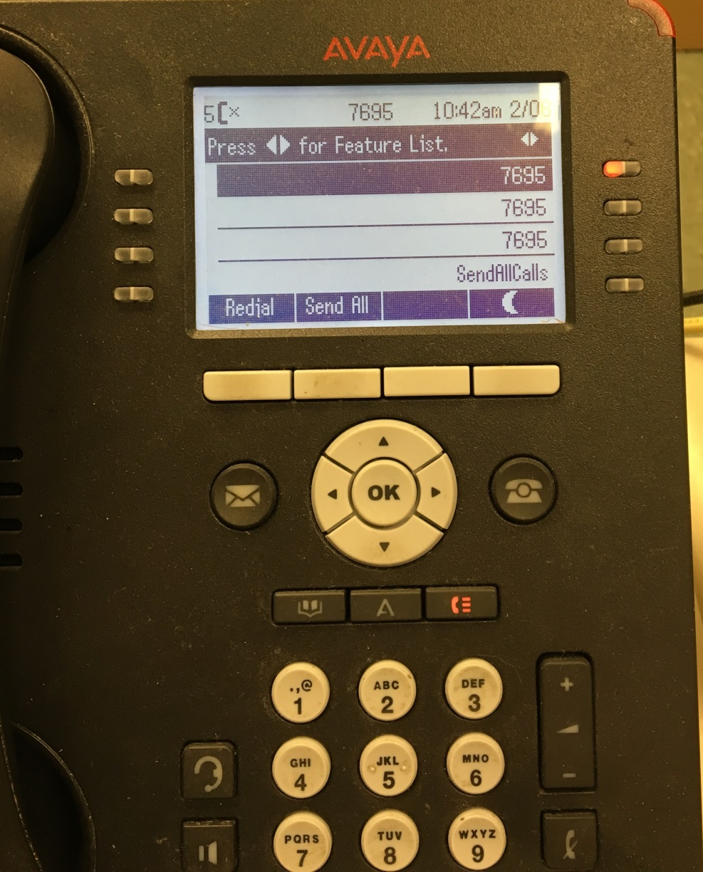

- Press the setup button shown below

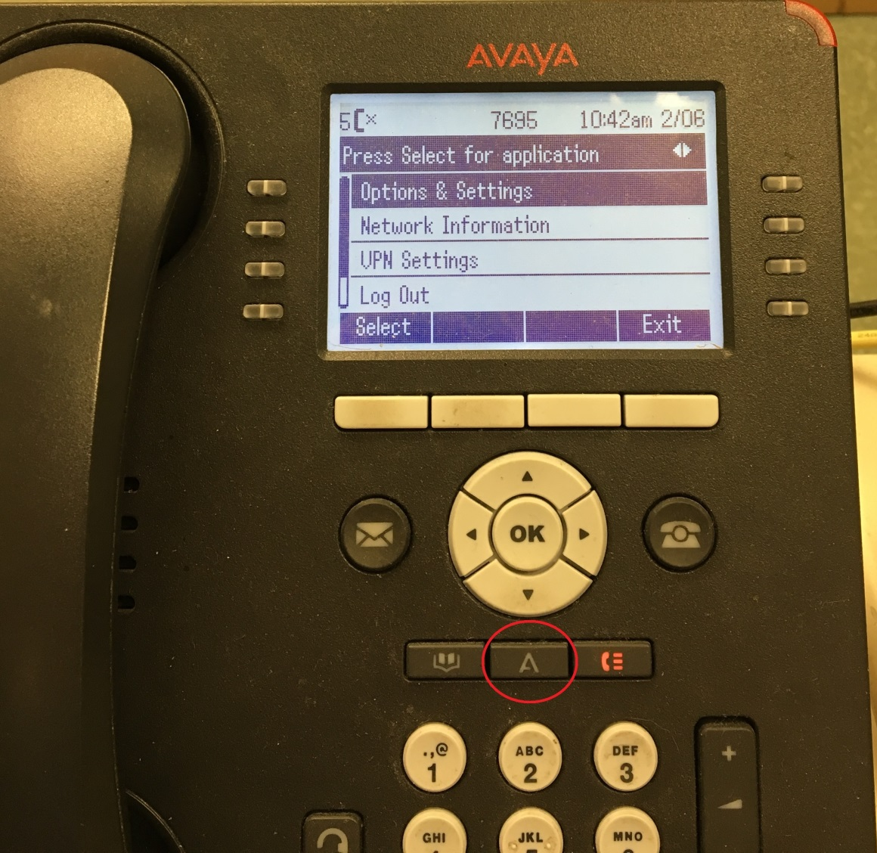

- Then press the OK button – it will take you to the screen shown below

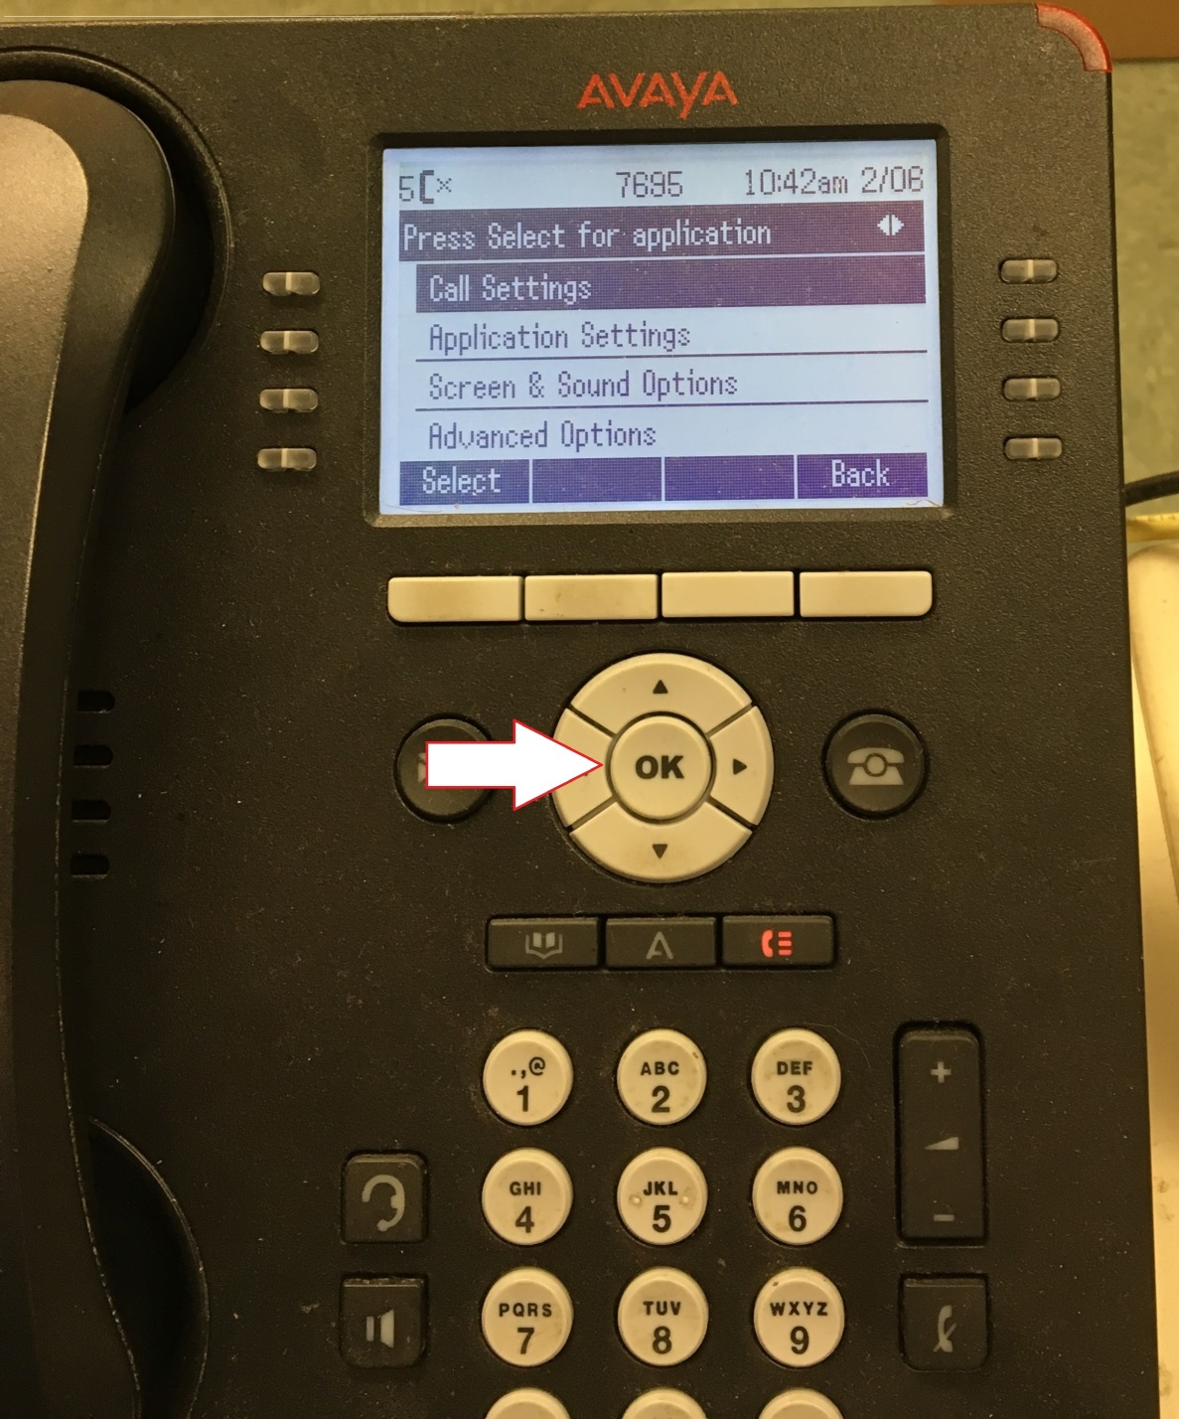

- Arrow down to “Screen and Sound Options” and press OK button

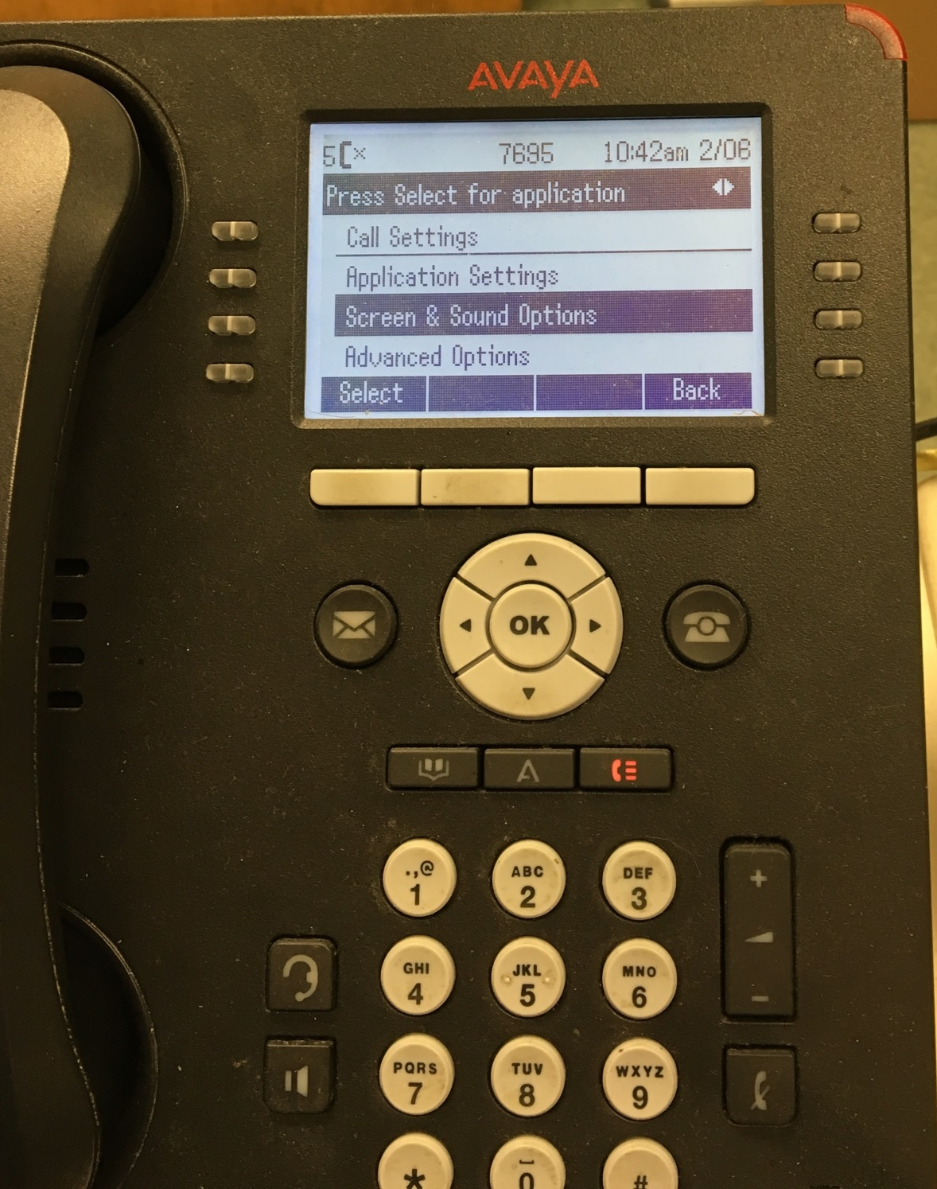

- You will go to the screen shown below

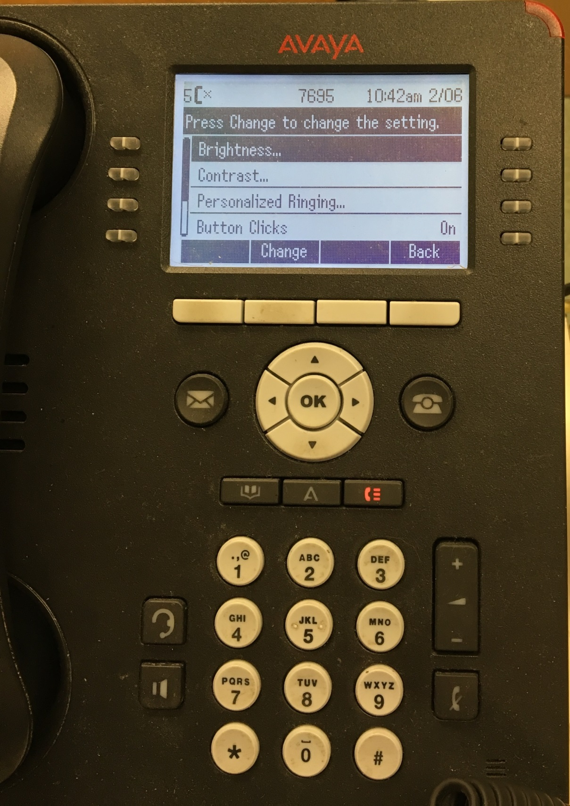

- Arrow down to “Phone Screen Width” and press the white button beneath “Change”

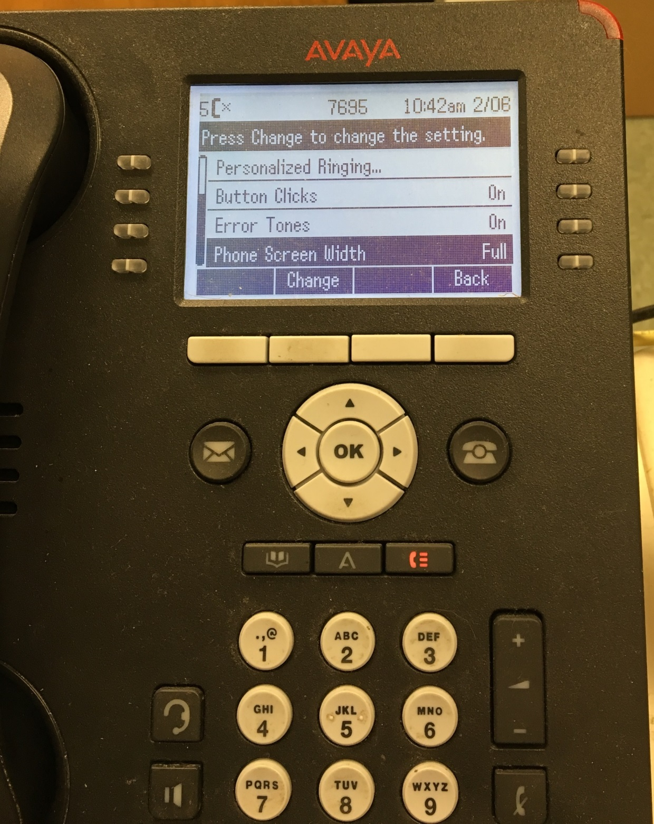

- Press the button beneath “Save”

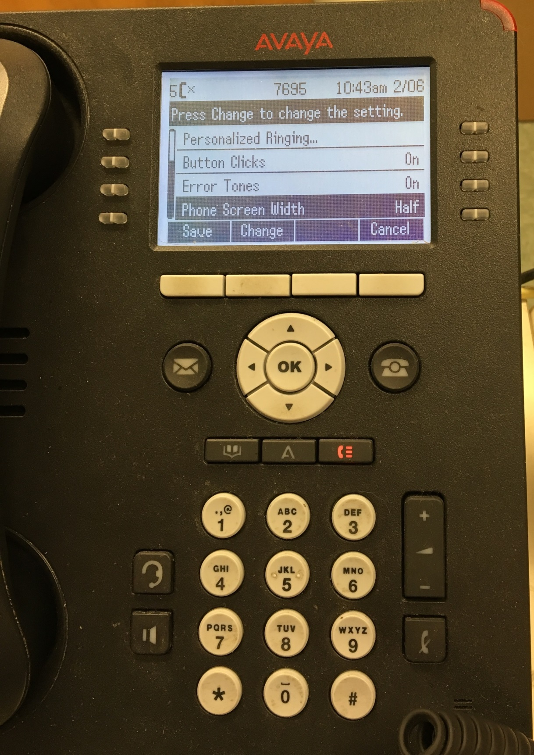

- Press the “Back” button – then the “Exit” button. Your screen should then be split as shown below.
