Press the Setup button – it will take you to the screen shown below. With “Options & Settings” highlighted press the “Select” button or the OK button.

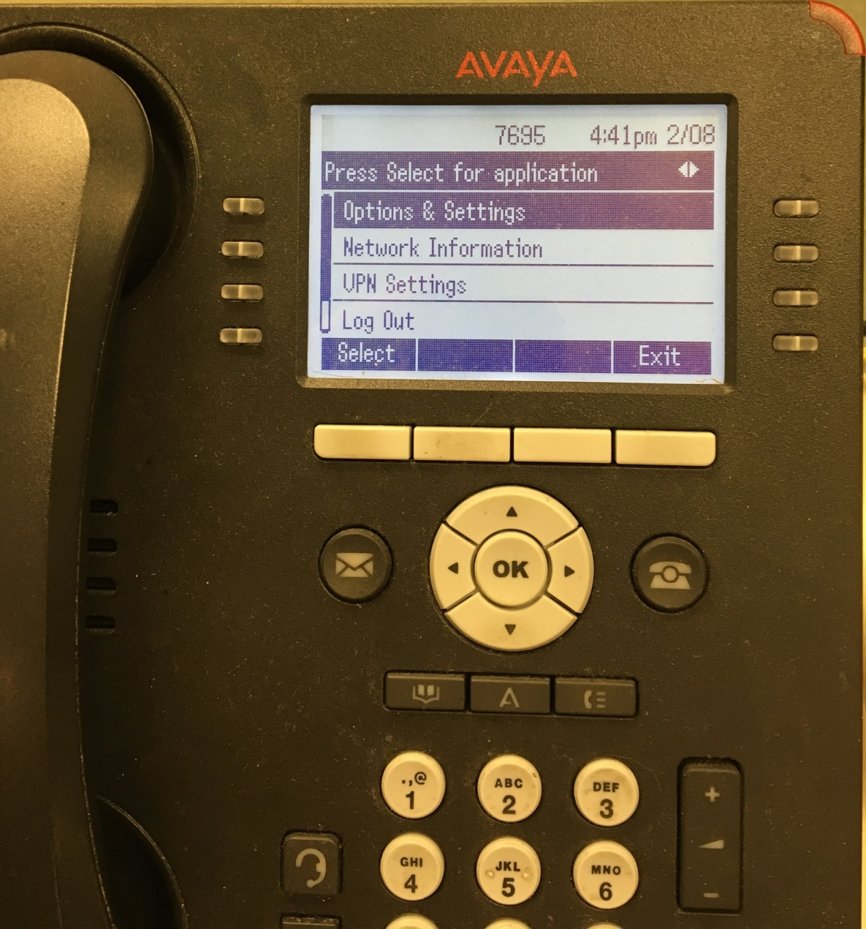

Arrow down to “Screen & Sound Options” and press the white Select button -or- press the OK button

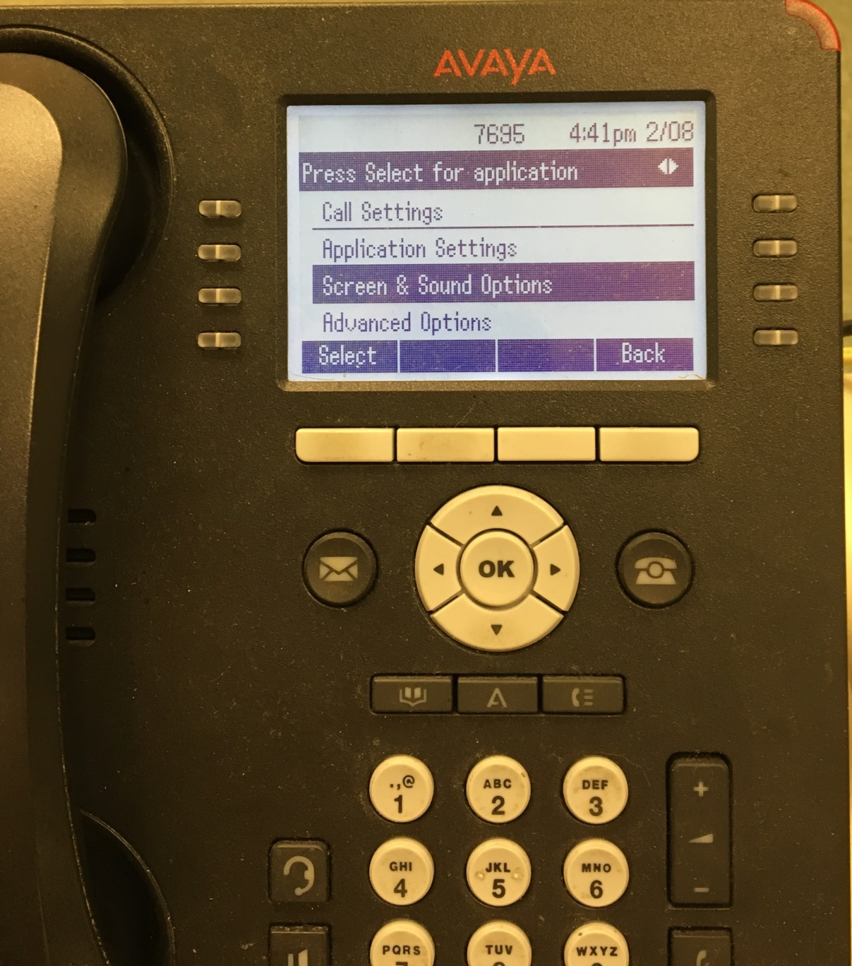

This will take you to this screen – arrow down to “Personalized Ringing” and press the white Change button
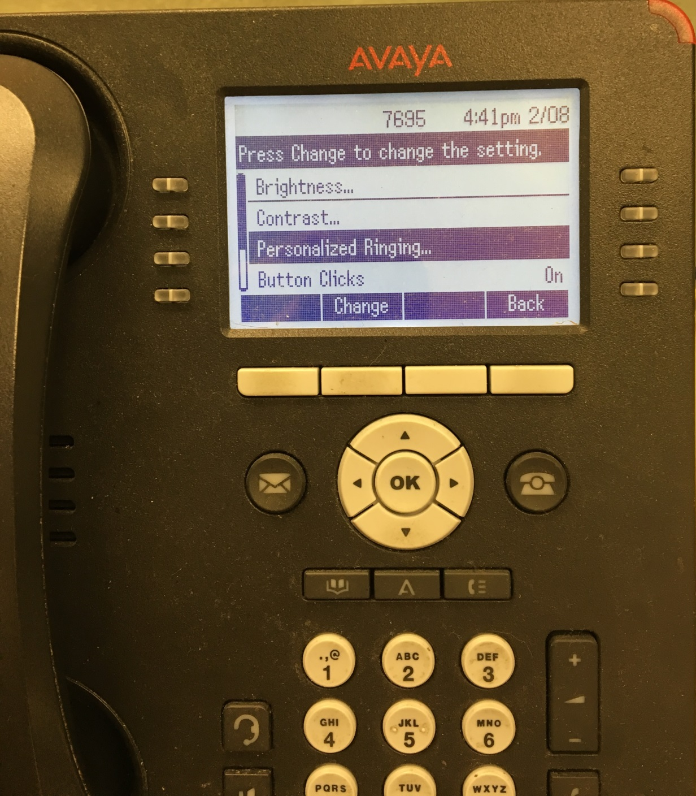

This will take you to the screen shown below which shows the different ringtone choices. Arrow down through the different tones to listen to the available choices. Also, press the “Classic” button to access a different list of ringtones (these are more modern ring tones).

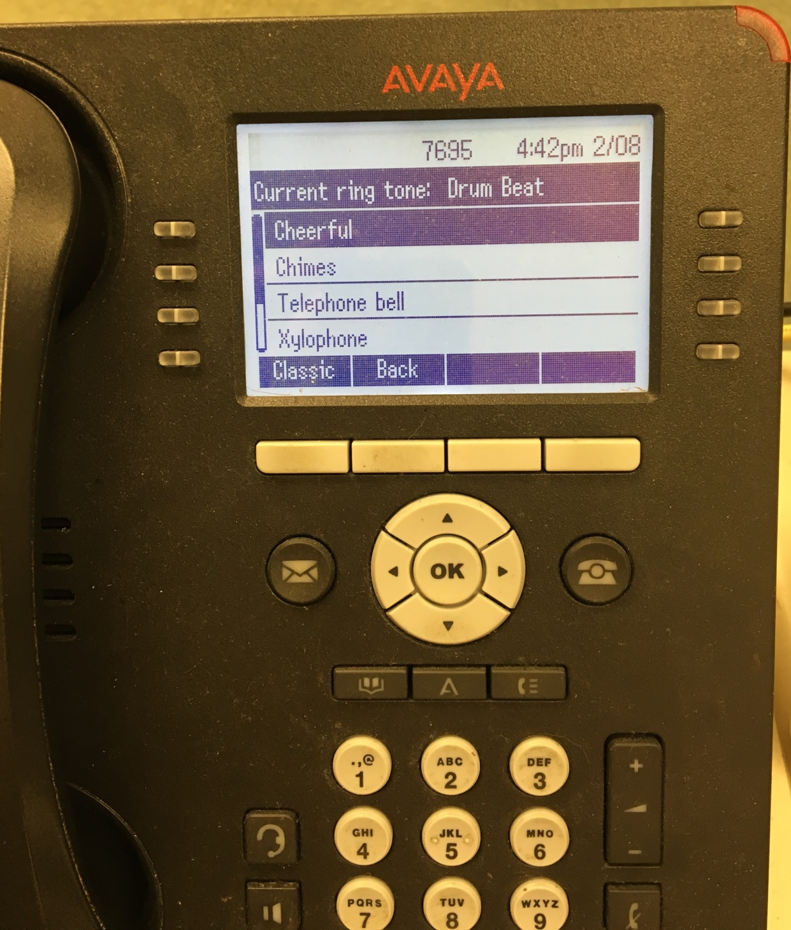

These are the “modern” ring tone choices. Press the “Rich” button to go back to the original list of ringtones.

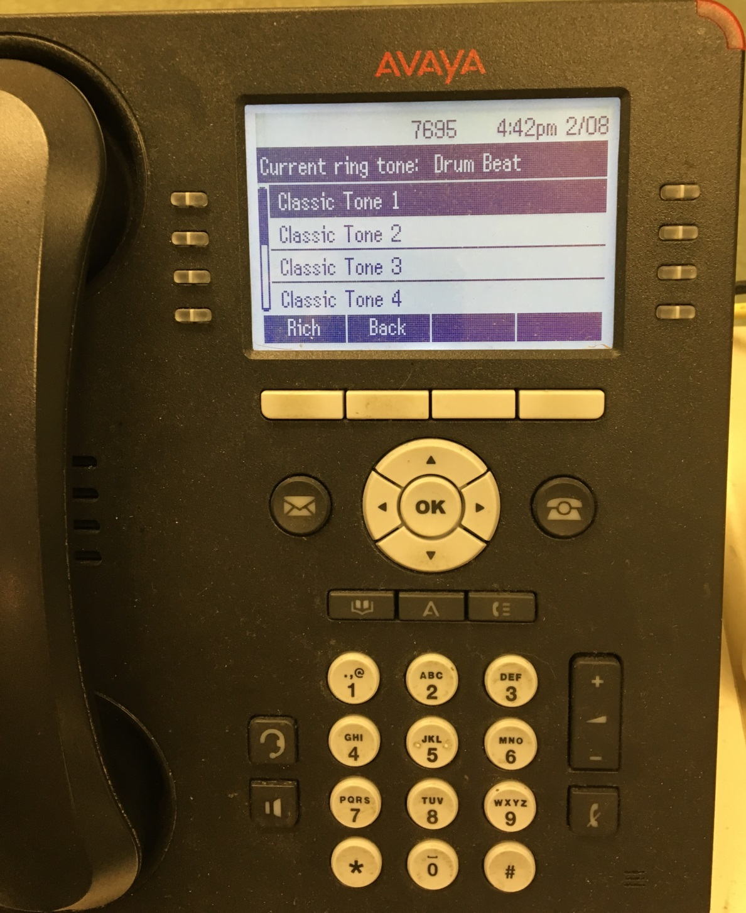

After highlighting the ringtone you want press the “Save” button, then the “Back” button, the “Back” button again, and finally the “Exit” button.

