Avaya 9608G voip phone
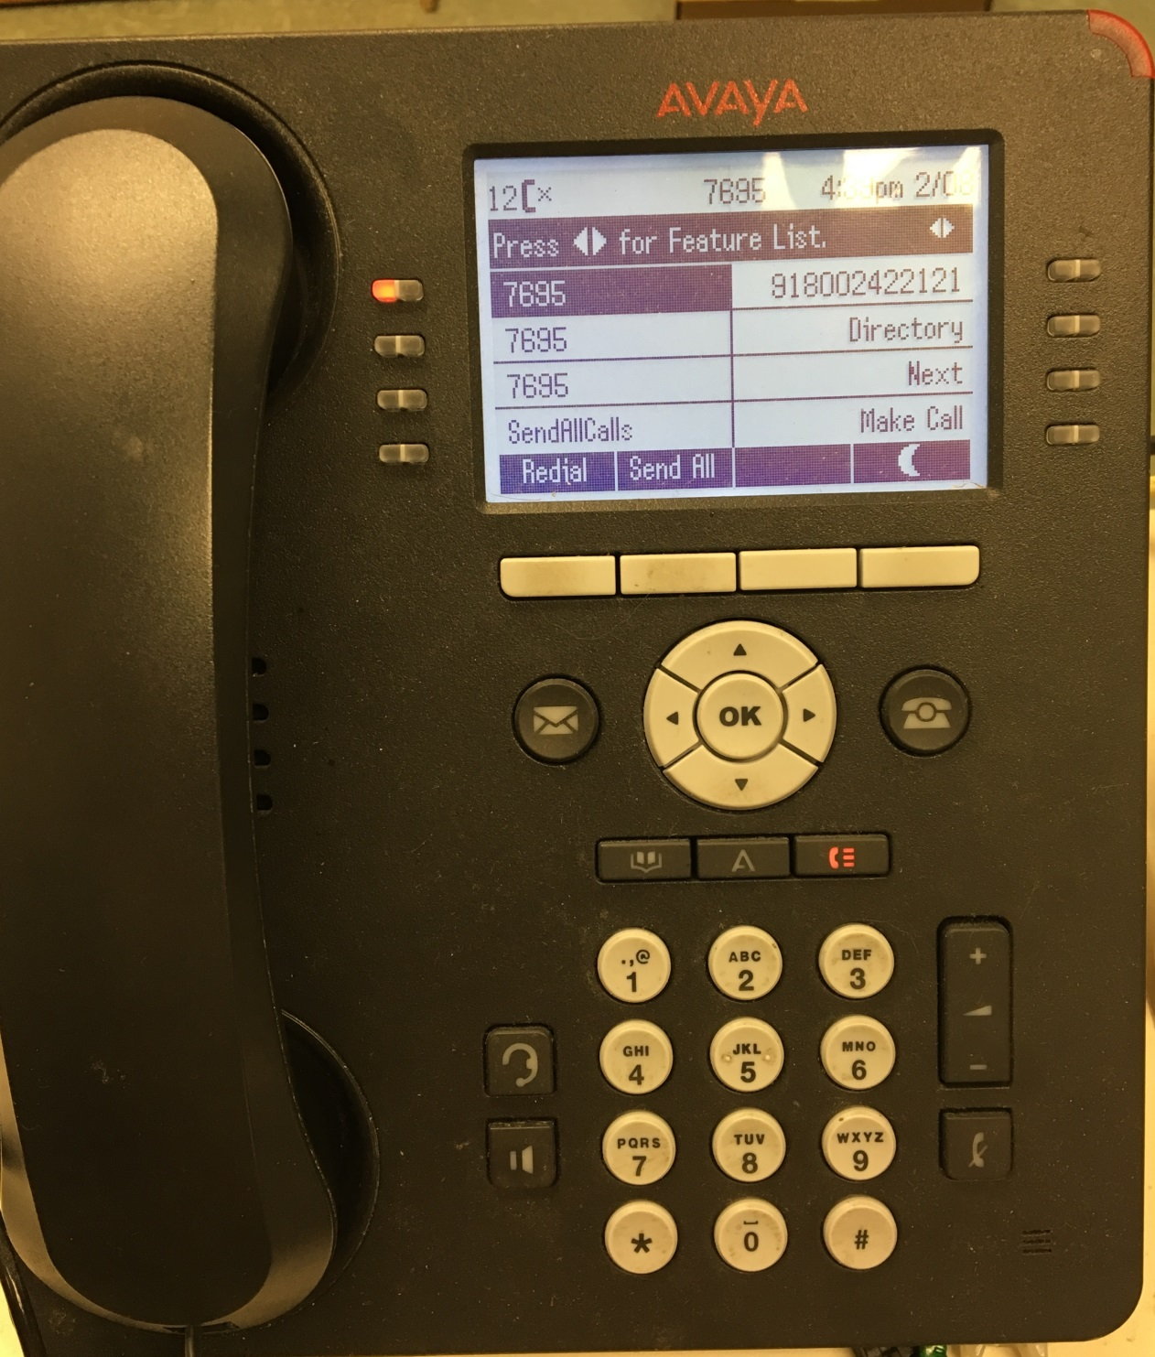

Screen informational fields and corresponding selection buttons. There are four info fields along the bottom of your display. These fields will display choices depending on the situation. To activate one of the choices simply press the corresponding white button.

Home Button – this button will take you to the “home” screen shown below. No matter what screen you are at if you press this button it will bring you back to the “home” screen.

Voice mail button – press this button to access your voice mail (it will be red if you have messages waiting). After pressing the button the Audix VM system will ask you to enter your extension followed by the # key. It will then prompt for you password followed by the # key.

Call History button – press this button display your call history information.
Click this link for more detailed information.

Setup button – this button takes you into menus to change various features of the phone.
Click this link for more detailed information.

Address Book button – press this button to access your address book. NOTE – this address book is separate from your contacts list in e-mail and does not interact with it.
Click this link for more detailed information.

Headphone set button – this button is used for headset if needed. Most current headsets do not require this button to activate the headset.
Please contact Ms. Sheila Brown (963-7611 or sbrown37@tnstate.edu) for current information on compatible headsets for the Avaya 9608G phone.

Speaker phone button – this button will allow to use the phone in hands free/speaker phone mode.

Mute button – turn off your handset or speaker phones ability to communicate. Use for privacy.

Volume button – controls the volume

Screen selection buttons – these four buttons on either side of the screen correspond to the field shown on the screen. The choices shown in the screen fields vary depending on the situation.

