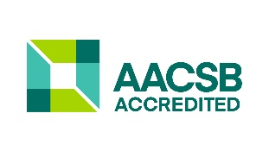



**The Supply Chain Management** concentration is designed to prepare students for a career in Supply Chain Management, having the management and technological skills required for positions in the Supply Chain Environment. The program also provides students with an understanding of the strategic and operational nature of Supply Chain Management.

Using on-line classes in addition to regular day and evening classes, the concentration also addresses the needs of non-traditional students.

Supply Chain Management is the broad range of activities required to plan, control and execute a product's flow, from acquiring raw materials and production through distribution to the final customer, in the most streamlined and cost-effective way possible.

**Career Options in SCM**

Graduates may be involved in Procurement Contract Negotiations and Management (national and international), Supplier Quality Evaluation, B2B Purchasing, Warehousing, ERP, Inventory Management, Transportation, Packaging and International Logistics. As a supply chain manager, the entire supply chain operation from inception to final customer distribution is involved.

**Corporate Sponsored Scholarships and Internships** of our Supply Chain Management students come from firms which include:

* Amazon
* Asurion
* Boeing
* Community Health Systems
* Cummins Filtration
* Dell, Inc.
* GEODIS
* HCA
* Lexmark International
* Schneider Electric
* TechnipFMC
* Tractor Supply Company
* Wells Fargo



**What our degree program emphasizes?**

Our BBA degree with a concentration in supply chain management (SCM) emphasizes the four important areas of:

* **Sourcing** (global strategic procurement, supply contract negotiation)
* **Supply** (production, quality management and service operations)
* **Delivery**(logistics, demand fulfillment), and
* **E-business/information systems** (critical enabler of supply chain efficiencies and responsiveness).

**Our program is unique**

* A unique program that combines e-Business technology with Supply Management into one concentration.
* The concentration was reviewed by the nation’s highly regarded ‘Institute for Supply Management (ISM)’, which highly recommended it to be a model throughout the US.

**Scholarships**

A number of corporate-sponsored scholarships are available for students who are supply chain management majors with strong academic and leadership backgrounds.

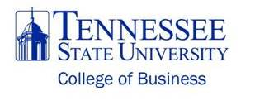



***Supply Chain Management***



**DEPARTMENT OF**

**BUSINESS ADMINISTRATION**

[www.tnstate.edu/busadmin](http://www.tnstate.edu/busadmin)

Bachelor of Business Administration (BBA) degree with a concentration in Supply Chain Management is offered in the Department of Business Administration at the College of Business of the Tennessee State University (TSU).

The College of Business is fully accredited by the Association to Advance Collegiate Schools of Business (AACSB-International).

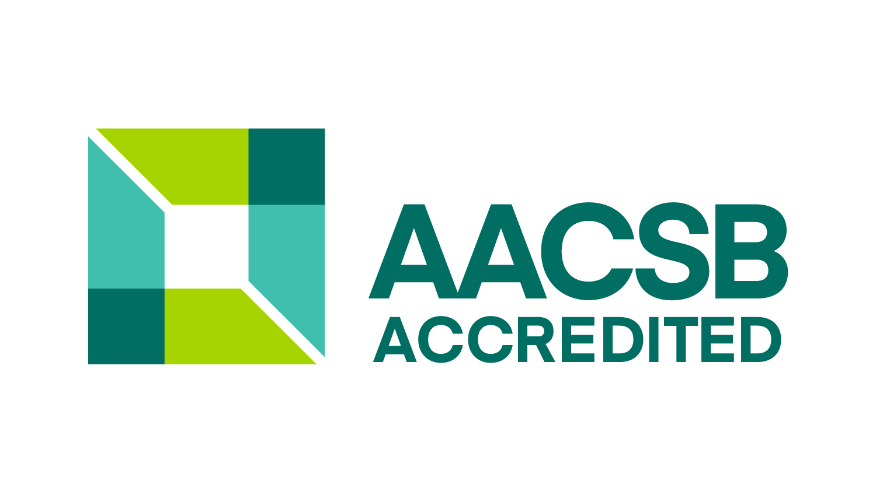

**Curriculum**

Bachelor of Business Administration (BBA) degree with the concentration in E-Business and Supply Chain Management program consists of four sets of courses:   
1. General education courses (42 Hours);   
2. Business core courses (48 Hours);   
3. Supply Chain Management (30 Hours).

**Business Core Courses**

Lower Division

MGMT 1010: Intro to Bus. & Economics

ECON 2010: Principles of Economics I

ECON 2020: Principles of Economics II

ACCT 2010: Principles of Accounting I  
ACCT 2020: Principles of Accounting II

ECON 2040: Statistical Analysis I

BISI 2150: Microcomputer Applications

Upper Division  
BISE 3150: Business Communications

BISI 3230: Business Information Systems

BLAW 3000: Legal Environment of Business  
FINA 3300: Business Finance  
ECON 3050: Quantitative Methods

MGMT 3010: Management and Org. Behavior

MGMT 3020: Operations Management  
MKTG 3010: Basic Marketing  
MGMT 4500: Business Strategy and Policy E-Business /

**Supply Chain Management Courses**

MGMT 2050: Introduction to SCM

MGMT 3040: Bus. Decision Modeling & Analysis

MGMT 4020: Quality Management

MGMT 4250: Leadership

MGMT 4600: Supply Chain Strategy

MKTG 4300: Procurement

MKTG 4400: Logistics

BISI 4150: Database Systems

Business Elective (3)

*Choose 1 course from*

MGMT 3550: Enterprise Resource Planning (ERP)

BISI 4550: Project Management

The College of Business faculty members at TSU are all doctorate degree qualified, holding Ph.D.’s from well-known institutions such as Case Western Reserve University, Northwestern University, Michigan State University, the University of Arkansas, the University of Texas, Rutgers University, and Clemson University.

You can contact our department:

|  |  |
| --- | --- |
| Walk-in: | Suite K-433 |
| E-mail: | scm@tnstate.edu |
| Telephone: | (615) 963-7123 |
| Fax: | (615) 963-7139 |
| Mail: | Tennessee State University College of Business Business Administration 330 10th Ave. N., Suite K Nashville, Tenn. 37203-3401 |

**For more information, please visit:**

<http://www.tnstate.edu/businessadmin/>

Tennessee State University was established in 1912 in Nashville, Tennessee. The University is a comprehensive urban state institution consisting of eight Colleges and Schools.

The College of Business is among the largest academic units on campus, with approximately 1000 undergraduate and graduate students.

.