**Tennessee State University**

**Board of Trustees**



**Finance and**

**Budget**

**Committee**

**Report**

**TENNESSEE STATE UNIVERSITY BOARD OF TRUSTEES**

**FINANCE AND BUDGET COMMITTEE MEETING AGENDA**

|  |  |
| --- | --- |
| 11 a.m. CST  Thursday, June 13, 2019 | Tennessee State University – Main Campus McWherter Administration Building,  President’s Conference Room  3500 John A. Merritt Blvd. Nashville, TN 37209 |

ORDER OF BUSINESS

1. Call to Order
2. Roll Call/Declaration of a Quorum
3. Approval of the February 21, 2019, Finance and Budget Committee Meeting Minutes
4. Approval of Fiscal Year 2019-20 Tuition and Mandatory Fee Increase of 2.19 percent
5. Approval of Institutional Budgets
6. Approval of the Institution’s Fiscal Year 2019-20 Compensation Plan
7. Report on Composite Financial Index
8. President’s Financial Report
9. Approval of Revised Accounts Receivable Policy
10. Approval of Capital Construction Plan
11. Update on Enrollment, Marketing and Student Recruitment Plan

**Tennessee State University**

**Board of Trustees**



**Approval of the**

**February 21, 2019,**

**Finance and Budget Committee**

**Meeting Minutes**

TENNESSEE STATE UNIVERSITY

BOARD OF TRUSTEES

ACTION ITEM

|  |  |
| --- | --- |
| DATE: | June 13, 2019 |
| ITEM: | Approval of the February 21, 2019, Finance and Budget Committee Meeting Minutes  Fiscal Year 2019-20 Audit Plan |
| RECOMMENDED ACTION: | Approval |
| PRESENTED BY: | Chair of Finance and Budget Committee, Trustee Stephen Corbeil |

The document reflecting the minutes from the February 21, 2019, Finance and Budget Committee meeting is included in the June 13, 2019, Board materials.

MOTION: To approve the minutes from the Board of Trustees’ February 21, 2019, Finance and Budget Committee meeting, as contained in the Board materials for the Board’s June 13, 2019, meeting.

**Tennessee State University Board of Trustees**

**Finance and Budget Committee Meeting.**

**February 21, 2019**

**Tennessee State University. 3500 John A. Merritt Blvd. Nashville, Tennessee 37209**

**McWherter Administration Building**

**President’s Conference Room**

**MINUTES**

**Committee Members Present:** Stephen Corbeil and Bill Freeman.

**Other Board Members Present**: Joseph W. Walker, III, Dr. Deborah Cole, Pam Martin, Obie McKenzie, Dr. Edith Peterson Mitchell, Dr. Ali Sekmen, and Braxton Simpson.

**University Staff Present**: President Glenda Glover; Mr. Laurence Pendleton, General Counsel and Board Secretary; Dr. Curtis Johnson, Chief of Staff; Dr. John Cade, Vice President for Enrollment; Terrence Izzard, Assistant Vice President of Recruitment; Horace Chase, Vice President for Business and Finance; Bradley White, Assistant Vice President for Business and Finance; Dr. Alisa Mosley, Interim Vice President for Academic Affairs.

**Guests Present:** Lauren Collier, the Higher Education Commission.

1. **CALL TO ORDER**

Trustee Corbeil called the meeting to order at 11:39 a.m. on February 21, 2019.

1. **ROLL CALL/DECLARATION OF A QUORUM**

Board Secretary Pendleton called the roll at the committee chair’s request. Trustee Corbeil and Trustee Freemen were present. Secretary Pendleton announced the presence of a quorum.

1. **APPROVAL OF NOVEMBER 15, 2018, COMMITTEE MEETING MINUTES**

Trustee Corbeil proceeded to the approval of the November 15, 2018, Finance and Budget Committee meeting minutes, as included in the February 21, 2019, board materials. Trustee Corbeil moved to approve the minutes. Trustee Freeman seconded the motion, which carried unanimously.

1. **Approval of February 4, 2019, Finance and Budget Committee Meeting Minutes**

Trustee Corbeil proceeded to the approval of the February 4, 2019, Finance and Budget Committee meeting minutes, as included in the February 21, 2019, board materials. Trustee Corbeil moved to approve the minutes. Trustee Freeman seconded the motion, which carried unanimously.

1. **Report on February 4, 2019, Finance and Budget Committee meeting with the Foundation Board**

Trustee Corbeil provided a report to the committee and attendees on the joint meeting of the Finance and Budget committee of the Board of Trustees (BOT) and the TSU Foundation board. Trustee Corbeil reported that the meeting was called at the request of Trustee Lewis. The purpose of the meeting was to start a dialogue between the BOT and the Foundation board about additional avenues through which to raise scholarship funds for TSU students.

Trustee Corbeil noted that insufficient scholarship funds affected recruitment and retention of students. Dwayne Tucker, chair of the TSU Foundation board, shared an overview of the foundation’s organization and mission. In summary, Mr. Tucker advised that the foundation has limited funds available for scholarships because much of the money managed by the foundation is restricted and cannot be used for scholarships.

The attendees shared plans and strategies for fundraising and collaboration. Independent alumni associations were also discussed. The parties determined that the best liaison between the TSU BOT and the foundation board is the Finance and Budget Committee of the BOT.

Trustee Freeman commented that he supported Trustee Corbeil’s summary of the joint meeting. He also noted that the BOT members in attendance left with a better understanding of the nature of the foundation’s operations and restrictions.

Trustee Corbeil stated that one of the issues that the attendees identified during the meeting was that the BOT must formulate an articulable and specific request for support. For example, the board should be prepared to ask for $5M over the next five years for funding designated for scholarships.

Trustee Cole noted that the majority of the funds held by the foundation came from the state with many restrictions. She agreed that the board needs to improve fundraising.

Trustee Corbeil specified that the institution needs a campaign to raise unrestricted funds.

Trustee Mitchell asked if there were any firm plans because none were reflected in the minutes of the meeting.

Trustee Corbeil answered that the next step was to create a strategic fundraising plan.

1. **Approval of the Student Fee Payment and Enrollment Policy**

Trustee Corbeil proceeded to the approval of the Student Fee Payment and Enrollment Policy, as included in the February 21, 2019, board materials. Trustee Corbeil commented that the policy was in place when the institution was governed by the Tennessee Board of Regents. He noted that the policy was adopted as a TSU policy when the institution severed from the TBR under the FOCUS act. Trustee Corbeil informed the committee that the policy was being modified to be more friendly to TSU students in recognition of their unique needs.

Vice President Chase commented that key changes of the policy extend the time from fourteen days to twenty-one days by which students must satisfy all outstanding debts and obligations to the institution to avoid being purged from enrollment. The policy also allows students to remain enrolled when their outstanding debt is $200 or less.

Trustee Corbeil moved to recommend to the full board, the approval of the student fee payment and enrollment policy, as contained in the materials for the February 21, 2019, board meeting materials. Trustee Freeman seconded the motion, which carried unanimously.

1. **Approval of the Deferred Payment Plan Policy**

Trustee Corbeil asked President Glover to provide information on the deferred payment plan policy. President Glover asked Vice President Chase to provide an overview of the policy.

Vice President Chase stated that the purpose of this policy is to implement, clarify, and ensure the consistent administration of the deferred fee payment program at Tennessee State University.

He noted that the TSU Deferred Payment Plan policy revises the TSU policy governing the same policy area, which was adopted when the institution severed from the Tennessee Board of Regents under the FOCUS act.

A deferred payment plan is available for regular academic semesters (fall and spring) and for students who are in good financial standing. All financial aid awarded to a student is applied before the deferred payment plan is utilized. There are two deferred payment plan options. One option is for students with balances above $2,000. In this option, the student pays a $50 service fee, a fifty percent down payment of the balance, and three equal installments due prior to the end of the semester. The second option is for students with balances of $2,000 or less. The second option is the same as the first except there is no down payment required.

Trustee Corbeil moved to approve the deferred payment plan policy, as contained in the materials for the February 21, 2019, board meeting. Trustee Freeman seconded the motion, which carried unanimously.

1. **Update on Enrollment, Marketing, and Student Recruitment Plan**

Trustee Corbeil asked President Glover to present an update on the enrollment, marketing, and student recruitment plan. President Glover referred the committee to the report of recruitment, enrollment, and retention on page 110G of the board materials for the February 21, 2019, board meeting. President Glover noted that the current total head count for the spring 2019 semester is 6,537, the fall 2019 semester head count is projected to be 8,013, and the fall 2020 semester head count is projected to be 8,253.

President Glover asked Terrance Izzard to present the update on the strategic plan. Mr. Izzard commented that the plan was developed by a multifaceted committee of twenty-five members who are deans, faculty, staff, administrators, and students. The TSU Recruitment Committee is charged with assisting with developing a plan that will increase enrollment by identifying the challenges that have caused declines, and to formulate strategies to address them. It is chaired by Dr. Curtis Johnson, Chief of Staff. The committee has two co-chairs, Mr. Terrence Izzard and Dr. Sharon Peters. The committee members have identified a number of key strategies to stabilize and increase enrollment.

Undergraduate Strategies:

1. Strategic Outreach

2. Strategic Marketing

3. Strategic Communications

4. Technological Infrastructure Enhancements and Capital Improvements

5. Strategic Funding for Scholarship

Graduate Strategy:

1. Strategic Marketing and Recruitment for the Graduate School

Mr. Izzard noted that meetings have been held with the school districts for Clarksville, Montgomery County, and Shelby County. He reported that over 140 students attended and thirty students applied on site. Mr. Izzard reported that 231 high school visits have been made to date under the Tiger Days program.

President Glover asked Dr. Mosley to report on the Knowledge Academy.

Dr. Alisa Mosley reported that the institution asked for permission to offer dual enrollment in psychology. She noted that the institution hopes to extend the program to English and music. Dr. Mosley commented that meetings have been held between the institution’s administration and the administration of Pearl Cohn, Whites Creek, Strafford, and MLK high schools.

President Glover noted that students in the dual enrollment programs will contribute to the institution’s head count and full time enrollment numbers.

Mr. Izzard commented that TSU held recruitment days in Shelby County and plans to hold similar events in Atlanta, GA, Birmingham, AL, Chattanooga, TN, and Clarkesville, TN. He also noted that mailers were sent out and that a digital, call, and text campaign has also been planned.

Trustee Corbeil asked how many students were enrolled as a result of the recruitment programs. He noted the importance of metrics to evaluate and validate the effectiveness of each strategy. Mr. Izzard responded that he did not have specific numbers with him.

Mr. Izzard reported that the institution plans to hire another recruiter and that it has created a Transfer Tuesday initiative, which is an open house program that focuses on the needs of transfer students, non-traditional students, and distance learners. He also noted that Dr. Johnson is working with TEMA, the Tennessee Emergency Management Agency, to certify emergency managers.

Mr. Izzard reported that social media is being leveraged as part of the strategic marketing plan. 225 social media posts have been made, advertisements of special places on campus have been posted, a virtual campus visit platform, You Visit has been added, and Naviance Career Readiness Solutions is being implemented.

President Glover noted that hits on the social media platform showed promise, but that the institution has seen a reduction in activity correlated to Mr. Izzard’s time away from the institution due to an injury.

Trustee Cole noted that customer service is required to recruit and retain students. She recounted that in her personal experience, the customer training is not effective.

Trustee Mitchell stated that the Mr. Izzard’s presentation was wonderful and that she was enthusiastic about the plan. She asked if there was an element that addresses the unique needs of military affiliated persons. She inquired whether the institution has a plan to facilitate the transfer of credits to TSU. She asked if the institution has evaluated setting up classed on local military bases.

Dr. Mosley answered that THEC awarded TSU a grant to offer courses and convert credits earned from military experience with the aim to reduce institutional barriers and facilitate the transition from the military into higher education.

Dr. Cade added that the institution is evaluating ways to collect data from veteran’s DD214 paperwork to maximize credit awarded for military service. Dr. Cade also noted that programs for military students are being established on the Avon Williams site.

Trustee Mitchell stated that those are wonderful strategies and she reported that the University of Maryland has marketing programs focused on the needs of veterans.

Dr. Mosley added that the institution participated in six events to recruit veterans.

Trustee Corbeil noted that the board should be able to measure the success of the programs and initiatives by doing year-to-year comparisons. He asked if the recruitment and retention projections shown on page 110G were attainable.

Dr. Cade commented that he believed the goals were attainable. Dr. Mosley commented that each college has a recruitment goal and projection plan.

Trustee Cole asked for clarification on the enrollment numbers. She asked if the budget is based on head count and whether full-time, part-time, graduate, and undergraduate students enrollment is used to develop the budget.

Dr. Cade noted that applications were down three percent and that admissions were down six percent over the previous year.

Trustee Freeman commended the recruitment plan.

Trustee Corbeil commented that the committee had just had a tough but necessary discussion. He thanked President Glover and her team for the update.

Trustee Sekmen asked to speak. He commented that he obtained the enrollment numbers from 2012 to the present. He then asked for the true reason for enrollment decline. He stated that he and other faculty analyzed the enrollment trends and offered to send copies of his analysis to the board. He noted that in fall 2015, the head count was 9167, in fall 2016, the head count was 8816, and that enrollment declined 13% over 3 years. He juxtaposed TSU’s enrollment with MTSU’s enrollment over the same period. He noted that while TSU’s enrollment declined 13%, MTSU experienced a 3.92% decline. Trustee Sekmen continued that he found that from spring 2015 to fall 2019, TSU’s enrollment declined 22.32%, while MTSU’s enrollment declined 7.4%. Trustee Sekmen stated that his belief is that the issue is not recruitment or admissions, but retention of students. He noted that the increase in admissions standards accounts for attrition of approximately 250 students. He noted that TSU’s peer institutions are performing better. He commended the plan as comprehensive, but also opined that it is not innovative.

President Glover responded that the administration has maintained that the issue for TSU students is insufficient funds. She noted that 900 students were not admitted regardless of what Trustee Sekmen’s numbers show. She commented that the institution is working hard with community colleges to increase enrollment, with funding sources to obtain additional scholarship funding, and with students on retention. President Glover asserted that she will terminate any faculty on the spot for cause for telling students not to return to TSU.

Trustee Corbeil interjected that the institution needs to “block and tackle,” and do what will be effective to correct the attrition.

Trustee McKenzie asked if the cost of implementing the recruitment plan had been projected. He asked that the committee and the administration take another look at the budget to verify that the cost has been accounted for.

Trustee Corbeil asked Vice President Chase to evaluate the budget and verify that the cost of the plan has been included.

Trustee Sekmen added that graduate enrollment has declined over the last six years and undergraduate enrollment has declined over the last four years. He noted that the plan is extensive, but it only covers the basics.

Dr. Mosley noted that the faculty spoke about allocating Title III funds to support graduate students in STEM and education programs.

President Glover informed the attendees that the graduate school has a separate plan.

Trustee Sekmen commented that an anonymous letter was sent to the faculty senate acknowledging the cost reduction plan aimed to reduce the budget by $15.3M, but that those cuts will be insufficient. Trustee Sekmen recounted that the letter from President Glover to the institution dated November 12, 2018, promised not to cut faculty. He also recounted that in a previous BOT Finance and Budget committee meeting, Trustee Corbeil eluded to the possibility that the $15.3M cuts to the FY 2018-19 budget might be insufficient. Trustee Sekmen noted that faculty position announcements are typically advertised in October for August start dates, but that layoffs at this point in the fiscal year will result in a year of unemployment of any faculty laid off. Trustee Sekmen then asked if the board could commit to no faculty layoffs for 2019-2020. Chairman Walker stated yes. President Glover clarified that tenured and tenured track faculty are protected, but that adjunct faculty and staff have not assurances. Chairman Walker confirmed that the board will support the President’s plan to protect tenured and tenured track faculty and that the board will make an announcement.

Trustee Sekmen asked that the board and administration acknowledge the trends in a realistic way, plan ahead, and adjust now.

Trustee Corbeil asked President Glover for a measure of confidence in the enrollment projections.

Vice President Chase answered that Simpson Consulting Group had been retained to evaluate the efficiency of the institution and to develop a recommendation to “right-size” the organization based on costs and the revenue.

Trustee Cole noted that this is a new plan and that its effectiveness cannot be measured retroactively.

Vice President Chase commented that the Business and Finance department discovered that $15.3M had to be cut from the budget. It required drastic steps to restore the institution to fiscal balance without using reserves. He noted that we have spent 14% less as compared to last year by not filling some positions. He assured the committee that Sibson has done this type of exercise for other institutions and that they have established benchmarks. Sibson has met with one hundred staff, cabinet members, and administration council members. He reported that Sibson has completed 95% of the scheduled interviews after which Simpson will compile a report. He noted that the institution will adjust its strategy once the report is in.

Trustee Cole asked if Sibson is an efficiencies firm. She asked if the institution is hoping to find new revenue streams as well as cutting expenses and advised that Sibson’s recommendations should save or generate enough money to cover the cost of the firm’s work.

Vice President Chase agreed, but warned that the institution has to agree to take some of the recommendations.

Trustee Cole asked if the board would receive a copy of Sibson’s report. Secretary Pendleton and President Glover commented on the drafting process and that she will be determining the distribution of the report.

Trustee Mitchell noted that the recommendations that the institution follows must align with the mission, vision, and direction of the institution.

Trustee Corbeil thanked President Glover and her team.

1. **Report on TSU’s Severance from the Tennessee Board of Regents on Capital Management Function**

Trustee Corbeil asked President Glover for the report on the institution’s severance from the TBR on the capital management function. Vice President Chase stated that the institution plans to seek approval to sever from the TBR on the capital management function by July 1, 2020, but that the institution is currently unprepared to make the request. Two key positions must be filled before the institution is ready. He noted that the institution could request approval from THEC before 2020, but the effective date of severance would likely remain the same.

Trustee Corbeil thanked President Glover and her team for the report.

1. **Adjourn**

Trustee Corbeil moved to adjourn the meeting at 1:09 p.m. Trustee Freeman seconded the motion, which carried unanimously.

**Tennessee State University**

**Board of Trustees**



**Approval of the**

**Fiscal Year 2019-20**

**Tuition and**

**Mandatory Fee Increase of 2.19 Percent**

TENNESSEE STATE UNIVERSITY

BOARD OF TRUSTEES

ACTION ITEM

|  |  |
| --- | --- |
| DATE: | June 13, 2019 |
| ITEM: | Approval of the Fiscal Year 2019-20  Tuition and Mandatory Fees |
| RECOMMENDED ACTION: | Approval |
| PRESENTED BY: | Chair of Finance and Budget Committee, Trustee Stephen Corbeil |

The purpose of this agenda item is to request approval for the proposed FY2019-2020 mandatory fee increase of 2.19 percent.

**Background Information:** TSU Guideline B-060 (*Fees, Charges, Refunds, and Fee Adjustments*) requires the approval of the Board for all mandatory institutional fees and charges, unless specific exceptions are provided. Mandatory fee recommendations are presented to the Board one time per year for: (1) ***maintenance*** fees and out-of-state tuition and (2) all ***other*** mandatory fees.

“***Maintenance***” is a fee assessed to students based on the number of credit hours for which they are registered and is commonly thought of as tuition, although for fee purposes “tuition” is separately defined and assessed as a premium paid by out-of-state students.

“***Other***” represents various other fees related to student activities, athletics, specialized courses, certain services, etc. Maintenance/tuition recommendations will generally be considered at the regular June meeting of the Board. All other mandatory fees may be presented at the regular March or June meeting of the Board. If changes to both sets of fees are presented at the same board meeting, it will be the June meeting, when the annual operating budget is also considered.

Pursuant to the FOCUS Act, the Tennessee Higher Education Commission establishes fee increase ranges. For FY 2019-20, THEC set the range for maintenance plus other mandatory fees, excluding out-of-state tuition, at 0% to 2.5%. TSU is proposing an increase of 2.19% for its tuition and mandatory fee increase.

The President of the university is responsible for the enforcement and collection of all fees and charges. Fees and charges that specifically do not require Board approval must receive formal approval by the President or a designee.

Pursuant to the Tuition Transparency and Accountability Act (Tuition Act), and Board Policy 006 (Board Consideration of Increases in Tuition and Mandatory Fees), TSU is required to post the proposed tuition and mandatory fee increase to the Board website at least fifteen days prior to the Board meeting to allow for comment. TSU has complied with this requirement.

In addition, pursuant to the Tuition Act and Board Policy 006, the Board shall consider the following factors in considering tuition and mandatory fee increase recommendations:

a. Level of State support

b. Total cost of attendance

c. Efforts to mitigate the financial effect on students

d. THEC mandatory tuition and fee ranges

e. Inflationary costs

f. Tuition and fee levels at peer institutions and competing institutions

g. Student Demand

h. Other factors pertinent to the cost of the University’s operations and programs of study

**Proposed Implementation Date:** Fall Term 2019

**Item Details**: See attachment.

MOTION: To approve the Fiscal Year 2019-20 Tuition and Mandatory Fee Increase of 2.19 percent, as contained in the Board materials for the Board’s June 13, 2019, meeting.

**TUITION AND MANDATORY FEE INCREASE**

**AGENDA ITEM FOR BOARD OF TRUSTEES JUNE 13, 2019, MEETING**

Pursuant to the Tennessee Tuition Transparency and Accountability Act, T.C.A. § 49-7-1603, the Tennessee State University Board of Trustees is providing public notice of the proposed tuition and mandatory fee increase for the 2019-2020 academic year. The tuition and fee increase will be considered by the Board at its June 13, 2019, Board meeting.

1. The combined total proposed tuition and mandatory fee increase for academic year 2019-2020 is **2.19%**. The breakdown of the increase is as follows:

a. Undergraduate maintenance proposed fee (tuition) increase of 1.82%

i. Base 12 hours proposed to increase from $274 per hour to $279 per hour

ii. Over base hours proposed to increase from $54 per hour to $55 per hour

b. Student Athletic Fee proposed fee increase of $25 per student per semester. This fee is included in the Program Services Fee which will go from $554 to $579 per semester, resulting in a 4.52% increase in mandatory fees.

c. The 2.19% combined increase is derived from the proposed total tuition and mandatory fees that would be assessed for a student taking fifteen (15) credit hours in FY19-20 compared to FY18-19.

2. Revenue derived from the tuition and mandatory fee increase will be used primarily as follows:

a. Undergraduate maintenance

i. Further enhance our student support services such as tutors, student advisement and coaching.

ii. Fund increase in scholarship cost

iii. Address inflation based on Higher Education Price Index (HEPI)

iv. Fund recruitment and retention efforts

b. Student Athletic Fee

i. Helps ensure compliance with Title IX requirements

ii. Helps to offset the increased costs of team travel and other athletic operating costs mandated by third parties

3. Tennessee State University makes every effort to mitigate the effect of the increase on students:

a. Undergraduate maintenance

i. Tennessee State University’s undergraduate maintenance fee is one of the lowest among public universities in Tennessee.

ii. The proposed 1.82% Undergraduate Maintenance increase is within THEC’s established tuition range for academic year 2019-2020.

b. Student Athletic Fee

i. It is the lowest of all public LGIs in the state

ii. Closer aligns Tennessee State University’s fee with other state institutions

4. Factors the Board will Consider When Setting Tuition and Mandatory Fee Increases

a. Level of State support

b. Total cost of attendance

c. Efforts to mitigate the financial effect on students

d. THEC mandatory tuition and fee ranges

e. Inflationary costs

f. Tuition and fee levels at peer institutions and competing institutions

g. Student Demand

h. Other factors pertinent to the cost of the University’s operations and programs of study

**Tennessee State University**

**Board of Trustees**



**Approval of**

**Institutional**

**Budgets**

TENNESSEE STATE UNIVERSITY

BOARD OF TRUSTEES

ACTION ITEM

|  |  |
| --- | --- |
| DATE: | June 13, 2019 |
| ITEM: | Approval of Institutional Budgets |
| RECOMMENDED ACTION: | Approval |
| PRESENTED BY: | Chair of Finance and Budget Committee, Trustee Stephen Corbeil |

TSU Policy 4:01:00:00 (*Budget Control*) recognizes budgeting as the process whereby the plans of the University are translated into an itemized, authorized, and systematic plan of operation, expressed in dollars, for a given period. This policy also recognizes that a budget is a plan and that circumstances may necessitate revisions or changes to the original plan from time to time. To that end, the University submits three detailed budgets for approval each fiscal year.

Under Board policy, the original budget for each fiscal year is known as the *Proposed Budget* and is prepared in the spring of each year. This budget is based on the level of state funds recommended in the Governor’s proposed budget as well as early estimates of factors such as enrollment growth or decline, research activities, and availability of federal funds. The *Proposed Budget* is normally submitted to the Board for approval at the Summer Board meeting. The *October Revised Budget* is prepared in the fall of each year and is normally submitted to the Board for approval at the Winter Board meeting.

The final budget submitted for each fiscal year is the *Estimated Budget.* It includes final adjustments to the current year budget and is the budget against which final year-end actual amounts are compared. It is prepared, submitted, and considered by the Board at the same time as the *Proposed Budget* for the upcoming fiscal year.

The budget model is being reconstructed to become more conservative in revenue projections and budget. In addition, expenses are being reviewed thoroughly in effort to be strategic, efficient and accountable while remaining within in the confines of the University’s recurring resources. A more strategic process is necessary to assure there are minimum disruptions to student success and the level of services the University provides. The University has partnered with Sibson Consulting Company and currently awaits their final report. However, the University is proceeding with two phases of a Three-Year Budget Planning process. This Three-Year Fiscal Improvement Plan will incorporate fiscal year ending 2020 with a conservative tuition revenue projection based on the past three year enrollment trend; a 2.19% fee increase; a slight increase in state appropriations; a reduction to expenditures by eliminating some vacant positions; and the use of some prior revenues to balance the budget.

Additionally, during the fiscal year ending 2020, will be implementing additional cost cutting measures, including the possible implementation of a Voluntary Separation Incentive Plan. However, under this measure, the financial benefit will not be truly recognized until a period of time (e.g. 6 or 12 months) after the employee has separated. Year one also includes a strategic review by the university’s division heads making recommendations to restructure their divisions to assure they are effective and efficient for recurring revenues. This process will begin in May 2019.

Year two, FYE 2021 will continue with a conservative revenue projection; reduction of expenses due to voluntary separation incentive program; reduction of expenses due to reorganization of divisions; and thus a budget with recurring revenues exceeding recurring expenses and return a portion of the prior revenues used FYE 2020.

Year three, FYE 2022 will complete the return of prior year revenues used in FYE 2020.

This approach will allow the university administrators to continue to serving our students during FYE 2020 and focus on a long-range plan involving the University’s structure with use of resources that we can sustain.

The purpose of this agenda item is to consider for approval both the *Estimated Budget* for Fiscal Year 2018-19 and the *Proposed Budget* for Fiscal Year 2019-20.

**Proposed Implementation Date**: July 1, 2019

**Item Details**: See attachment.

**MOTION: To approve Tennessee State University’s Estimated Budgetfor Fiscal Year 2018-19 and the Proposed Budgetfor Fiscal Year 2019-20, as contained in the Board materials for the Board’s June 13, 2019, meeting.**

**TENNESSEE STATE UNIVERSITY**

SUMMARY OF UNRESTRICTED FUNDS

EXPENDITURES AND TRANSFERS

JULY BUDGET 2019-20



**TENNESSEE STATE UNIVERSITY**

SUMMARY OF UNRESTRICTED CURRENT FUNDS

REVENUES

JULY BUDGET 2019-20



**TENNESSEE STATE UNIVERSITY**

SUMMARY OF UNRESTRICTED FUNDS

EXPENDITURES AND TRANSFERS

JULY BUDGET 2019-20



**TENNESSEE STATE UNIVERSITY**

SUMMARY OF UNRESTRICTED CURRENT FUNDS

JULY BUDGET 2019-20



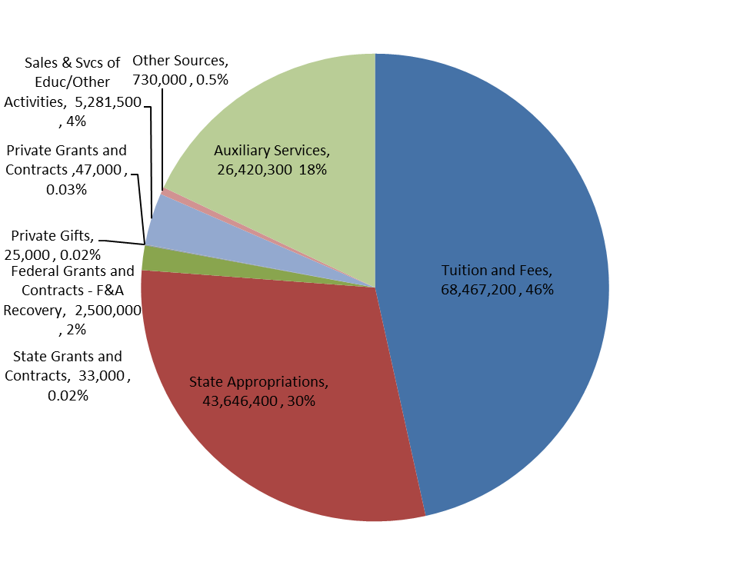

**TENNESSEE STATE UNIVERSITY**

SUMMARY OF UNRESTRICTED CURRENT FUNDS

JULY BUDGET 2019-20



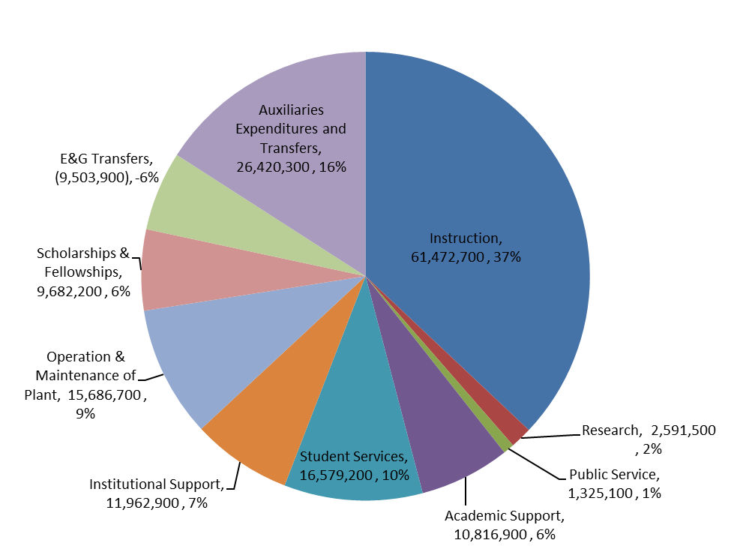

**TENNESSEE STATE UNIVERSITY**

SUMMARY OF UNRESTRICTED CURRENT FUNDS

JULY BUDGET 2019-20

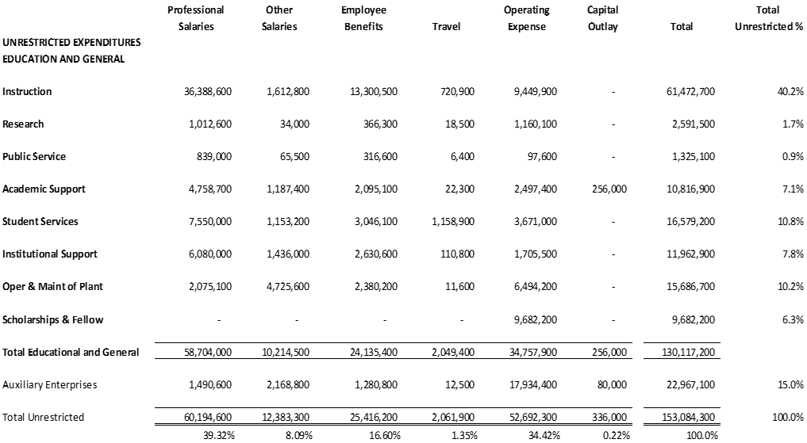

**TSU MCMINNVILLE CENTER**

SUMMARY OF UNRESTRICTED CURRENT FUNDS

JULY BUDGET 2019-20



**TSU MCMINNVILLE CENTER**

SUMMARY OF UNRESTRICTED CURRENT FUNDS

JULY BUDGET 2019-20



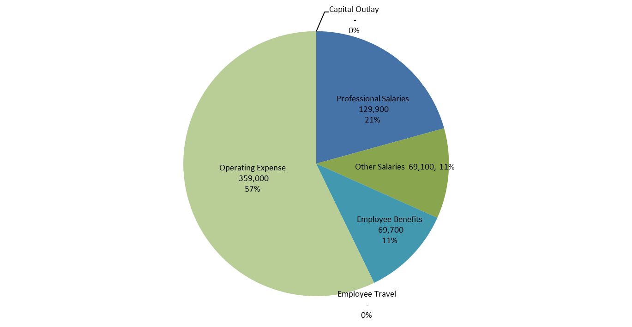

**TSU INSTITUTE OF AGRICULTURAL & ENVIRONMENTAL RESEARCH**

SUMMARY OF UNRESTRICTED CURRENT FUNDS

JULY BUDGET 2019-20



**TSU INSTITUTE OF AGRICULTURAL & ENVIRONMENTAL RESEARCH**

SUMMARY OF UNRESTRICTED CURRENT FUNDS

JULY BUDGET 2019-20



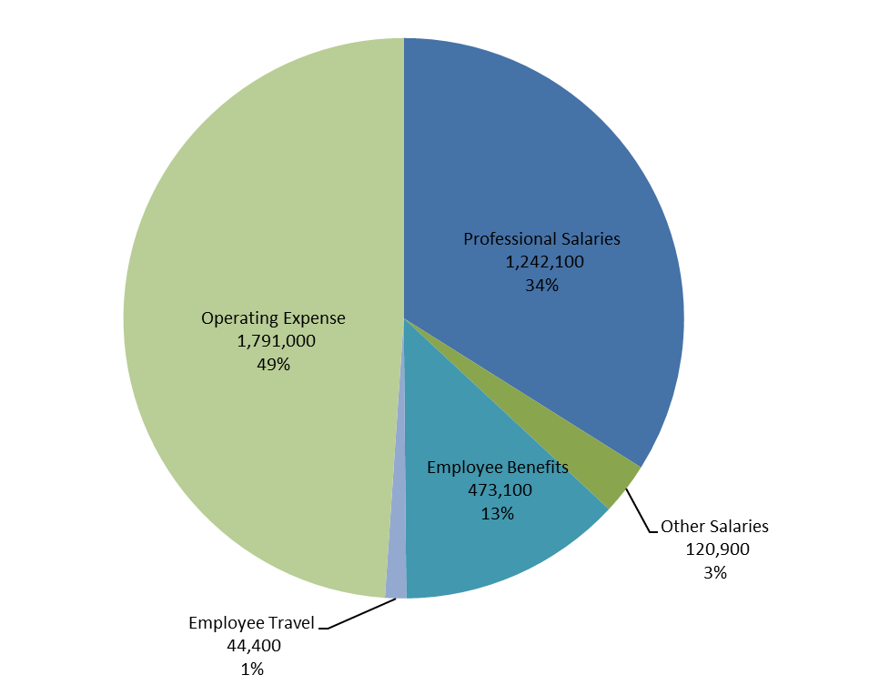

**TSU CCOPERATIVE EXTENSION**

SUMMARY OF UNRESTRICTED CURRENT FUNDS

JULY BUDGET 2019-20



**TSU CCOPERATIVE EXTENSION**

SUMMARY OF UNRESTRICTED CURRENT FUNDS

JULY BUDGET 2019-20



**TSU FORESTRY**

SUMMARY OF UNRESTRICTED CURRENT FUNDS

JULY BUDGET 2019-20



**TSU FORESTRY**

SUMMARY OF UNRESTRICTED CURRENT FUNDS

JULY BUDGET 2019-20



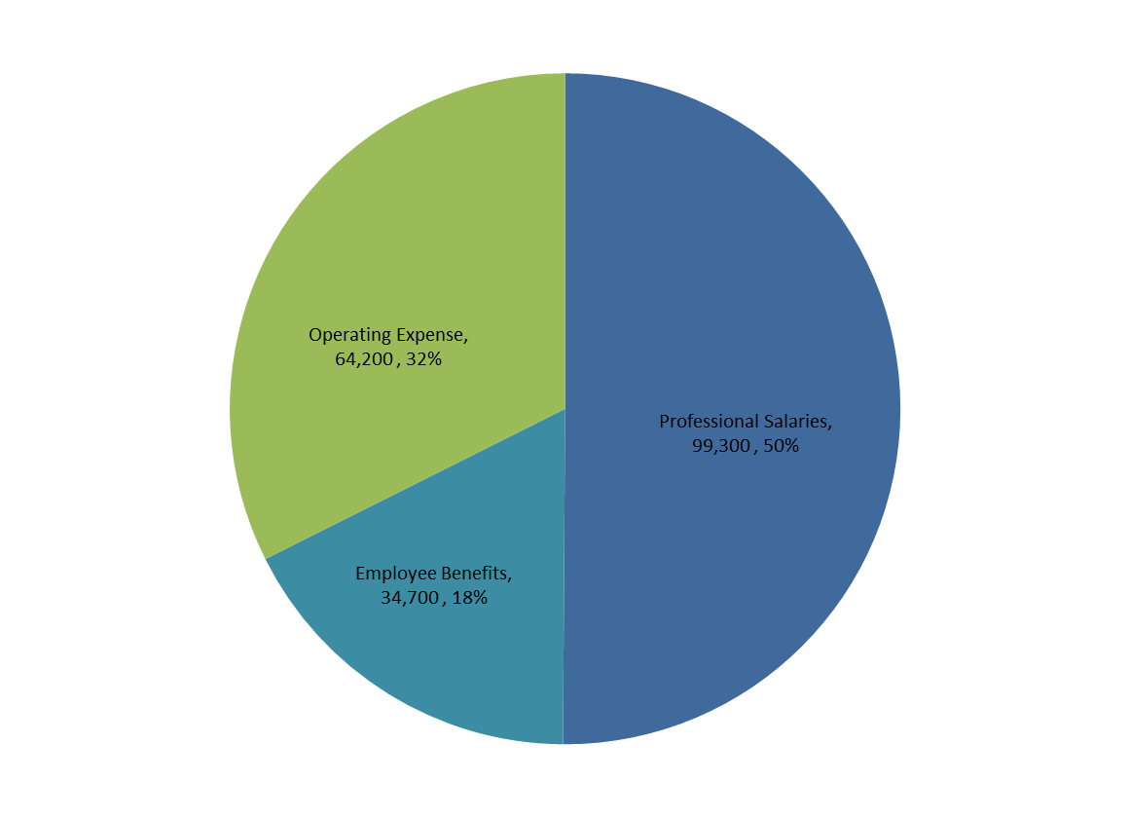

**Tennessee State University**

**Board of Trustees**



**Approval of the**

**Institution’s Fiscal**

**Year 2019-20**

**Compensation Plan**

TENNESSEE STATE UNIVERSITY

BOARD OF TRUSTEES

ACTION ITEM

|  |  |
| --- | --- |
| DATE: | June 13, 2019 |
| ITEM: | Approval of the Institution’s  Fiscal Year 2019-20 Compensation Plan |
| RECOMMENDED ACTION: | Approval |
| PRESENTED BY: | Chair of Finance and Budget Committee, Trustee Stephen Corbeil |

The purpose of this agenda item is to consider approval of the University’s compensation plan for Fiscal Year 2019-2020.

TSU Policy (formerly TBR Guideline) P-043 (*Compensation Guideline*) sets a University goal of providing all employees with compensation consistent with market, subject to satisfactory job performance and budget availability. The following strategies, in any combination, may be used to distribute a pool of funds designated for compensation adjustments:

* Compensation Plan: The University may provide salary adjustments: (1) consistent with its Board-approved plan; and/or (2) that address changes in market salaries as prescribed in the plan, if the plan has already been fully funded; and/or (3) that address specific equity issues and reclassifications consistent with the plan.
* Cost of Living Adjustment (COLA): The University may provide a COLA and may establish a minimum payment.

* Faculty Promotion: The University may fund faculty promotions consistent with its approved compensation plan.
* One-Time Payment: The University may provide one-time payments up to $1,000.
* Merit Increases: The University may provide an increase based on the job performance of employees.
* Funding Additional Positions: The University may create new positions based on institutional needs.
* Other: The University may adjust the pay scales of various groups, such as adjuncts, graduate assistants, etc.

The salary pool for Fiscal Year 2019-20 is ­­­2%, consistent with the total allocated for regular State of Tennessee higher education employees. No additional amount or percentage is proposed. Unless otherwise provided, these increases do not apply to adjunct faculty, temporary employees, graduate assistants, student workers, or employees on terminal leave status. Eligible employees are classified as “regular” or “post-retirement service,” unless a distribution includes those in the above-referenced “other” category. All eligible employees on the payroll prior to the proposed implementation dates below are eligible for these increases, regardless of the funding source (i.e., unrestricted, restricted, E&G, or auxiliary) or effort percent (although some categories may be prorated for employees on a part-time status).

Pursuant to the FOCUS Act, the Board’s Bylaws and Delegation of Authority to the President Policy, and TSU policy, the Board must approve institutional compensation plans.

**Proposed Implementation Dates:** Salary increases will be effective July 1, 2019, for fiscal-year employees; August 1, 2019, for modified-year employees; and September 1, 2019 (the beginning pay cycle), for nine-month faculty.

See Attachment.

MOTION: To approve the Institution’s Fiscal Year 2019-20 Compensation Plan, which provides a 2% across the board increase for faculty and staff, as contained in the Board materials for the Board’s June 13, 2019, meeting.

**FY-2020 COMPENSATION PLAN/SALARY INCREASE PROPOSAL**

It is the legislative intent to provide a pool of funds equivalent to a 2% across the board salary increase for higher education employee salary increases effective July 1, 2019, at a level determined by each governing board. For Tennessee State University, this equates to approximately $1,300,000.

These funds are proposed to be distributed as follows:

**FACULTY**

Faculty will receive a 2% across-the-board increase.

**STAFF**

Staff will receive a 2% across-the board increase.

Salary increases will be effective July 1, 2019, for fiscal-year employees; August 1, 2019, for modified-year employees; and September 1, 2019 (the beginning pay cycle), for nine-month faculty.

Excluded from salary increases are graduate assistants, adjunct employees, temporary workers, and student workers.

TENNESSEE STATE UNIVERSITY

BOARD OF TRUSTEES

INFORMATION ITEM

|  |  |
| --- | --- |
| DATE: | June 13, 2019 |
| ITEM: | Finance and Budget Committee Report on Composite Financial Index |
| RECOMMENDED ACTION: | None |
| PRESENTED BY: | Chair of Finance and Budget Committee, Trustee Stephen Corbeil |

The return on net assets ratio measures total economic return during the fiscal year. This measure is similar to the return on equity ratio used in examining for profit concerns and answers the questions, “Are they better off financially than they were a year ago” and “Does financial asset performance support the strategic direction of the institution?”  While investments in plant, a capital campaign, or a poor stock market can all create year-to-year volatility in this measure, the trend over time should be positive.

The net operating revenues ratio indicates an operating surplus or deficit in the given fiscal year. A positive ratio indicates that the institution experienced an operating surplus for the year. This ratio is similar to a profit margin and answers the questions, “Did they balance operating expenses with available revenue” and “Do the operating results indicate that the institution is living within available resources?”  Depreciation expense is included to reflect the use of physical assets in measuring operating performance.

The primary reserve ratio measures financial strength and flexibility by comparing expendable net assets to total expenses. This measure answers the question, “How long can the institution survive without additional net assets generated by operating revenue?”

The viability ratio measures the financial health of the institution by comparing total expendable net assets to total current and non-current liabilities. This ratio is similar to a coverage ratio used in the private sector to indicate the ability of an organization to cover its long term debt from readily available resources and answers the questions, “How much of their debt can the institution pay off with existing resources” and “Is debt managed strategically to advance the institution's mission”.

After their calculation, these four ratios are combined to deliver a single measure of the overall financial health of the institution. By blending these four core financial ratios into one metric, a more balanced view of the institution’s finances is provided since weakness in one measure can be offset by strength in another. Additionally, measuring the index over time provides a glimpse as to the progress institutions are making toward achieving financial goals.

**Item Details**: See attachment.

**Tennessee State University**

**Board of Trustees**



**President’s Financial Report**

TENNESSEE STATE UNIVERSITY

BOARD OF TRUSTEES

DISCUSSION ITEM

|  |  |
| --- | --- |
| DATE: | June 13, 2019 |
| ITEM: | President’s Financial Report |
| RECOMMENDED ACTION: | None |
| PRESENTED BY: | Chair of Finance and Budget Committee, Trustee Stephen Corbeil |

1. **Update on Intent to Sever from Tennessee Board of Regents on Capital project planning and management**

**Background Information:**

Under the FOCUS Act, effective April 13, 2017, the six locally-governed institutions (LGIs) that were formerly a part of the Tennessee Board of Regents severed from that system in all areas except three: (1) procurement; (2) capital project planning and management; and (3) data systems.

**PROCUREMENT**

At the November 16, 2017 Board of Trustees Meeting the Tennessee State University Board of Trustees granted the President authority to sign an *Intent to Sever* form, to notify THEC of the university’s plan to sever from TBR procurement effective July 1, 2018. The procurement and contracts offices worked diligently to meet all THEC requirements and conditions for independence, and severance was approved by the Commission meeting effective July 1, 2018.

**CAPITAL**

Two leadership positions in facilities and capital planning job descriptions have been revised. The positions previously were outlined to be Assistant VP positions and are being converted to Executive Director of Facilities Management and Executive Director for Capital Projects and Planning. Both positions have been advertised, interviews are currently being scheduled, and a plan to hire within the next few weeks. VP for Business and Finance is in consultation with THEC staff; and TSU facilities staff has been participating in the appropriate capital severance training. The materials required for severance consideration is approximately 90 percent complete. The severance team has attended in person or via web streaming all training that has been offered by THEC. Staff has attended SBC & ESC pre agenda phone calls and pre agenda staff meeting when TSU had an item on the agenda. The areas of responsibility matrix for capital projects has been completed. The organizational chart and key staff bios in Capital Project Management is 95% complete. The documentation for the areas of proficiency for Capital Project Management is complete. The required Capital Project Business process flow charts are 98% complete. The creation and population of the TSU Planning Webpage (Beta Version) is ongoing. Currently only available to TSU severance team. The webpage will be complete and ready to go live prior to severance.

**DATA**

No LGI has yet started the process of severing from TBR in the area of data systems, and no instructions have been given to begin or execute this process. Therefore, no severance date for Tennessee State University has been planned or established.

The purpose of this agenda item is to present as an informational update on severance from TBR in the areas of procurement, capital, and data.

1. **Update on External Organizational and Operational Review**

In order to gain the benefits of an independent perspective about the quality, efficiency and effectiveness of its current operations and organizational structures, the University engaged the external higher education consulting firm, Sibson Consulting. Sibson was assigned to do the following:

* Assess the quality and effectiveness of current University operations and identify opportunities for improvement
* Assess current staffing levels and compare those against peer institutions and national standards
* Assess current service levels and identify opportunities for improvement
* Identify opportunities to reduce current operating expenses
* Identify opportunities to generate new or additional revenues
* Develop a set of recommendations that support and advance all of the above tasks

To perform its review, Sibson engaged in the following activities:

* Conducted one-on-one interviews with over 80 individuals, including those within the President’s Cabinet, Administrative Council, Faculty Senate Leadership (who obtained and shared additional input from faculty), and additional staff across the University
* Reviewed student engagement climate survey data to gather student perspectives
* Reviewed numerous documents and information, organizational charts, policies, procedures, processes documents, job descriptions, and workforce data
* Conducted best practice research, including peer institutions
* Compared staffing metrics at peer institutions as identified by Tennessee State University, including Tennessee institutions, THEC institutions, and HBCUs

To finalize its assignment, Sibson Consulting is in the process of completing the following activities:

* Assembling benchmarking data, and other relevant information
* Developing a list of themes and findings gathered from data analysis and interviews
* Identifying organizational and structural issues that may be impacting current operations
* Identifying options and ideas for addressing operational inefficiencies and other opportunities to reduce operating expenses and increase revenues
* Developing meaningful revenue generation ideas
* Developing a report with recommendations that address key issues, operational efficiency issues, and institutional needs and opportunities, with a target completion date of June 21, 2019.

**Tennessee State University**

**Board of Trustees**



**Approval of the**

**Revised Accounts Receivable Policy**

TENNESSEE STATE UNIVERSITY

BOARD OF TRUSTEES

ACTION ITEM

|  |  |
| --- | --- |
| DATE: | June 13, 2019 |
| ITEM: | Approval of the Institution’s  Revised Accounts Receivable Policy |
| RECOMMENDED ACTION: | Approval |
| PRESENTED BY: | Chair of Finance and Budget Committee, Trustee Stephen Corbeil |

The purpose of this agenda item is to consider approval of the University’s revised Accounts Receivable Policy.

The purpose of this policy is to establish the process regarding collection of accounts receivable at Tennessee State University. This policy applies to the collection of all accounts and notes receivable by Tennessee State University. The policy addresses billing, delinquent accounts, employee receivables, recovery of overpayment to employees, collection agencies and write-offs.

The university has previously operated under essentially the same policy under the direction of the Tennessee Board of Regents. However, the TBR policy states that each institution should have its own policy. Tennessee State University is seeking approval to adopt a revised collection of accounts receivable policy and adhere to it.

The purpose of this agenda item is to consider for approval of the Collection of Accounts Receivables Policy.

**Proposed Implementation Date**: July 1, 2019

**Item Details**: See attachment

**Collection of Accounts Receivable**

**Guideline Area**

Business and Finance Policy

**Purpose**

The purpose of this policy is to establish the process regarding collection of accounts receivable at Tennessee State University (TSU or University)

**Definitions**

* Disposable earnings - means that part of the earnings of an individual remaining after the deduction from those earnings of any amounts required by law to be withheld.

**Policy**

1. **General**
   1. This policy applies to the collection of all accounts and notes receivable by Tennessee State University. The University shall, to the maximum extent practicable, require payment in advance for all services and goods to avoid the creation of receivables.
      1. TSU Policy on the Payment of Fees. Requires (with limited exceptions) that all assessed fees be paid in advance by a student before he or she is considered enrolled for any academic term.
      2. Types of Receivables. Accounts and notes receivable may be generated from programs and activities including but not limited to:
         1. Student loan programs;
         2. Traffic and parking fines;
         3. Library fines;
         4. Bad checks;
         5. Contracts;
         6. Property rental;
         7. Damage, loss, or liability to the institution by others; and
         8. Financial aid adjustments.
      3. Security Deposits. The University is authorized to require any person to post a deposit or security bond, or provide appropriate insurance to offset potential obligations to the institution arising from programs or activities.
      4. Statute of Limitations. Pursuant to T.C.A. § 28-1-113, there is no time limit on the University’s authority to collect receivables unless otherwise expressly provided by statute.
2. **General Collection Procedures**
   1. Billing. Collection efforts should begin no later than thirty days after the obligation has been incurred or other fixed due date.
      1. The University may negotiate alternative payment arrangements with debtors when such arrangements offer the best prospect of collecting the debt.
      2. An account becomes delinquent based on payment criteria established by the University for the type of debt involved. For example, debts from students may not be classified as delinquent until a student fails to enroll in a subsequent fall or spring semester where the provisions of the "Record Holds" in II.D. below would apply.
   2. Delinquent Accounts. A minimum of three billings or letters of contact shall be sent by the University at thirty-day intervals once an account becomes delinquent.
      1. For debts greater than $100, the third letter should indicate that the account will be referred to a collection agency if payment is not made within a specified date.
      2. Sending letters by certified mail is optional.
   3. Defaulted Accounts. Accounts are classified as defaulted when the University’s established collection efforts for the type of debt have failed to produce payment.
      1. Receivables of $100 or more shall be referred to a collection agency if the University’s collection efforts are unsuccessful.
      2. The accounts should be submitted to the agency within a reasonable time after the final collection letter is sent if the debtor has not responded.
      3. Referral of accounts under $100 to a collection agency is not required.
         1. No additional collection efforts are required for receivables under $100 except as provided for under the Record Holds (Section II.D) and Employee Receivables (Section III.).
         2. See Section IX. for write/off procedures.
   4. Record Holds. Pursuant to T.C.A. § 49-9-108, diplomas, transcripts, certificates of credit or grade reports will not be issued until the student involved has satisfied all debts or obligations owed to the university.
      1. This statutory limitation shall not apply to debts or obligations:
         1. Of less than twenty-five dollars ($25.00) that are more than ten (10) years old.
         2. Evidenced by notes or other written contracts providing for future payment, such as, but not limited to, loans authorized under federal or state education or student assistance acts.
      2. An amount owed under the University’s installment payment plan for enrollment fees which is not yet due shall not cause a hold to be applied. A notice stating specific amount due should be sent to each student prior to completion of registration.
   5. Enrollment and Outstanding Debts or Obligations. A student must pay any past due debts and obligations incurred in prior academic terms before being permitted to register at the University unless the debt is less than $100 or an acknowledgement of debt/promise to pay agreement for the prior debt or obligation has been executed
      1. Additionally, all known debts and obligations incurred during the current term must be paid prior to a student being allowed to pre-register for any future terms. The University will continue to withhold diplomas, transcripts, certificates of credit or grade reports until the student involved has satisfied all debts or obligations or meet the criteria established in T.C.A. § 49-9-108, as stated in D.1 and D.2, above.
      2. An amount owed under the University’s deferred payment plan for enrollment fees which is not yet due shall not cause an enrollment hold to be applied.
   6. Aging. All receivables should be aged at least annually.
   7. Documentation. Accurate records of correspondence, telephone calls, and personal contacts with borrowers shall be maintained. Institutions shall comply with record maintenance, safekeeping, and retention regulations for federally funded loans.
3. Employee Receivables
   1. Procedure for Withholding. Employee receivables (including student employees) may result from, among other things, traffic and parking fines, library fines, institution services or bad checks.
      1. In order to recoup the amount owed from the employee's paycheck, notice of intent to withhold must be sent to the employee by registered or certified mail, email, or personally delivered.
         1. The notice should inform the employee of the amount alleged to be owed and should specify that he may elect to pay the debt in full, authorize deductions from his paycheck or, if the employee is terminating, the check for accrued but unused annual leave, or contest the intent to withhold through an institutional or UAPA hearing.
         2. Subsequent to receiving a pre-deprivation notice of the debt owing, the employee, within 15 calendar days of receipt of such notice, must:
            1. Pay the debt in full;
            2. Authorize the University to withhold a designated amount from each subsequent paycheck or, if the employee is terminating, from the accrued but unused annual leave until the debt is paid in full;
            3. Elect to contest the intent to withhold through an institutional hearing; or,
            4. Elect to contest the intent to withhold through a contested case hearing held pursuant to T.C.A. § 4-5-301, et seq.
      2. If the employee elects an institutional hearing, the employee shall appear on behalf of himself but is entitled to be advised by counsel.
         1. The Chief Business Officer or his/her representative, or a representative of the department involved in the debt, shall be present to represent the university.
         2. The case will be heard before one hearing officer designated to hear all cases on that date.
         3. The hearing officer must be an individual who is not so closely connected with the collection of the debt that he/she cannot render an unbiased and objective decision on the validity of the debt.
         4. Such hearing should be held within one week of the decision to elect the hearing.
         5. The hearing officer shall render his/her decision on the validity of the debt. If the debt is ruled valid, the debt shall be deducted from the employee's payroll check beginning at the end of the next appropriate pay period in accordance with deduction schedules.
         6. If the employee elects a UAPA hearing, the Office of General Counsel should be notified immediately.
         7. If the employee refuses to pay, authorize deduction, or specify or waive a hearing process, a UAPA hearing must be initiated.
         8. The employee's failure to appear at either an institutional or UAPA hearing will constitute default, or, if a prima facie case is presented that the debt is owed, it will be deemed valid; the appropriate deductions may then be made.
         9. Additionally, if a UAPA hearing, a Default Order must be issued.
         10. If the employee does not appeal the Default Order, funds may be deducted as specified.
   2. Limitations on Amounts to be Withheld. The deduction from any check shall not exceed the maximum deductible under state garnishment laws.
      1. The maximum amount of disposable earnings of an individual for any work week which is subjected to garnishment may not exceed:
         1. Twenty-five percent (25%) of his disposable earnings for that week; or
         2. Thirty (30) times the federal minimum hourly wage at the time the earnings for any pay period become due and payable, whichever is less.
      2. In the case of earnings from any pay period other than a week, an equivalent amount shall be in effect.
      3. These limits are applicable to retirement funds, but are not applicable to checks for accumulated annual leave.
      4. Additionally, the above limits do not apply to employee overpayments.
   3. Retirement Funds. If a former employee is found to owe a debt to the state, retirement funds may be utilized to pay off the amount owing to the extent permitted by Tennessee law.
      1. The same procedural steps outlined in III.A. for notice and the opportunity for a hearing must be followed.
      2. Accumulated retirement contributions of a former employee terminated for any reason and for which he has made application, or monthly benefits of a retired employee are subject to withholding to the extent permitted by Tennessee law.
      3. A copy of the final order resulting from an institutional or UAPA hearing, or a signed waiver of hearing and written agreement of the former employee authorizing deductions should be sent to the director of the retirement system along with a written request to withhold, specifying the reason for the claim and the total amount involved.
   4. Recovery of Overpayments to Employees. Unlike cases in which the employee owes the University money, in instances of overpayments to employees there is no obligation to provide a hearing.
      1. The University is obligated, however, to attempt to recoup the funds. The University should advise the employee in writing of the overpayment and the institution’s proposed actions to correct the overpayment.
      2. The method of repayment will depend upon the amount of the overpayment, the time which has elapsed between the overpayment and its discovery, the hardship which immediate repayment might cause the employee because of amount of current salary and personal expenses, the culpability of the employees in not reporting the overpayment, and the longevity as well as the expectation that the employee will remain in state government until the repayment is completed.
      3. If a current employee receives overpayment, the refund may be made in one of the following ways:
         1. Repayment by the employee by cash or check; or,
         2. Adjustment of deductions to be made automatically from the employee's paycheck, either with a single deduction or a series of deductions made from each paycheck until the full amount is recovered.
         3. The amount of partial payments recovered by the latter method should be reasonable and systematic so that full recovery will be completed within the shortest period possible.
      4. If overpayment is discovered after the employee terminates employment with the state, an account receivable should be established.
         1. The former employee should be notified of the overpayment, the circumstances of the overpayment and a request that the employee contact the appropriate campus official.
         2. If the employee has not received his final paycheck, the appropriate deduction from that check can be made.
         3. If the final paycheck has been received, negotiations for reimbursement should be initiated.
         4. If repayment cannot be negotiated or collected, the account should be turned over to the collection agency.
         5. In the event collection is not possible, proper write/off procedures should be followed.
      5. In instances in which the employee has agreed to systematic deduction(s) from his paycheck(s), written authorization from the employee is encouraged.
      6. The University shall draft forms to document overpayments, the steps taken to recoup same, any negotiated repayment plan, the amounts received, and any write/off of the overpayment.
4. Dishonored Payments
   1. Enrollment Fees. Pursuant to the University Policy on the Payment of Fees and Enrollment of Students if any student tenders payment of fees by a check or credit card that is subsequently dishonored by the financial institution, and the payment is not redeemed in cash within the time period specified below, the University has the option to not consider that student enrolled at the institution.
      1. At the discretion of the University, the student may be considered enrolled and will be assessed the applicable returned check fee, the late registration fee, and will be denied grade reports, transcripts and future registration privileges until such dishonored check is redeemed.
      2. The University has the discretion to allow enrollment when the outstanding obligation is $200 or less.
      3. The University may deny future check writing privileges to students that have paid registration fees with checks that are subsequently dishonored.
      4. A student paying enrollment fees with a check that is dishonored must redeem the check within five (5) calendar days from receipt of the notice.
         1. Notice should be sent by the University to the student no more than three (3) working days from receipt of notice of a bad check from the bank.
         2. Notice by certified mail is optional.
         3. The University will have five (5) working days after the expiration of the five (5) calendar days to pursue any additional collection efforts deemed necessary.
         4. Immediately after the five (5) working days, the student will be deleted if the check has not been redeemed in full if that option is selected by the University.
         5. Enrollment fees including returned check fees for students de-enrolled for bad checks should be reversed.
   2. Non-Student or Non-Employee. Any person other than a student or employee who tenders a check for payment for goods or services which is subsequently dishonored shall be given the opportunity to redeem the check and pay the amount due in cash. The person shall be given notice of the dishonored check, sent certified mail, demanding payment within five (5) days.
   3. Collection of Dishonored Checks. A check presented for payment of any goods or services which is subsequently dishonored shall be treated as an account receivable under Section II. Any transactions that have been processed should be reversed when possible and appropriate.
   4. Future Check-Writing. Receipt of one or more bad checks from any person may result in that person becoming ineligible to make payments by check thereafter, or to have any check cashed by the University. A record of individuals who have written bad checks should be maintained.
5. Federal Loans
   1. Federal Regulations. Collection officers should be certain that they are consulting the most recent legal authorities concerning Federal loans. These authorities include interpretative materials, issues letters, manuals, Congressional Enactments and Federal Department of Education Regulations.
   2. Pre-Loan Counseling. Federal regulations require the University to conduct entrance counseling to stress the importance of repayment, describe the consequences of default and emphasize the terms of repayment. An individual with Federal Regulations expertise should be available during and after the session to answer questions.
   3. Exit Interview. An individual or group exit interview must be conducted to discuss the borrower's financial responsibilities and to obtain updated information. Exit interview materials may be sent by certified mail to borrowers who do not attend the exit interview.
      1. The borrower should be provided with a copy of the note and two copies of the repayment schedule.
         1. These schedules can be provided either in person or by certified mail.
         2. The borrower should promptly sign and return one of the schedules to the University.
         3. A minimum payment of $30 per month should be required for Perkins Loans made prior to October 1, 1992, $40 per month for Perkins Loans made after October 1, 1992, and $15 per month for Health Professions Student Loan (HPSL) and Nursing Student Loan (NSL) programs.
   4. Grace Period Notices. Contact with the borrower should be made during the initial and post-deferment grace periods.
      1. For a nine-month grace period, notices are required 90 days, 180 days and 240 days after the grace period begins.
      2. For a six-month grace period, notices are required at 90 days and 150 days.
      3. The last contact should coincide with the first billing notice.
   5. Billings. A written notice and statement of account should be sent at least 30 days before the first payment is due. If a coupon system is used, coupons should be sent instead of statements. Future statements should be sent at least 15 days before each payment is due.
   6. Late Payments or Delinquent. Three past due notices should be sent beginning when the debt is fifteen days past due. The second notice is sent 30 days from the first notice. A final demand letter should be sent within 15 days of the second past due notice. If all past-due follow-up procedures have failed to elicit a response, a telephone call is required within 30 days of the final demand letter.
   7. Cancellation or Deferments. The University may postpone loan repayments for a 12-month period if the borrower will be providing services eligible for loan cancellation or deferment.
      1. Interest does not accrue and the loan is not considered delinquent when in a deferred status.
      2. The borrower must request deferment and cancellation status on an annual basis.
      3. If, at the end of the postponement period, the borrower does not qualify for cancellation or deferment, the postponed payments are due.
   8. Acceleration. The borrower must be given written notice of intent to accelerate at least 30 days in advance. This can be included in the final demand letter.
   9. Federal Loans Not Written Off. Annual collection efforts should be pursued for Federal loans that are not able to be written off or turned over to the U.S. Department of Education.
   10. Perkins Loans. The IRS/ED skip-tracing service should be used for Perkins Loans.
6. Collection Agencies
   1. General. The University shall procure collection services through one or more companies.
      1. The service should provide for the referral of all types of delinquent accounts and notes from the University to the designated company only after campus collection efforts have been exhausted.
      2. The terms of the contract and RFP govern all collection actions.
      3. Unless otherwise prohibited by law or regulation, any note, contract or lease which may result in accounts receivable to the University should contain a provision pursuant to which the person will be responsible for the costs of collection and reasonable attorneys' fees in the event of default, and should further provide for the assignment of the account or note to the proper agency.
   2. Billing Services. The University may use an outside billing service to collect payments on accounts receivable. The service should be familiar with all provisions of loan programs and provide prompt, clear and accurate bills.
   3. Credit Bureaus. The University may report all loans when made to a credit bureau. The University must obtain the borrower's consent to report loans not in default by including a statement in the promissory note or some other document that is signed by the borrower at the time the loan is made.
   4. Collection Agency. Accounts that are still delinquent 30 days after the final collection letter should be turned over to a collection agency. Receivables less than $100 are not required to be turned over to a collection agency.
   5. Reporting Requirements. The collection agency should be required to report the status of delinquent loans periodically to the University.
   6. Revised Repayment Plan. A revised repayment plan agreement should be signed by the borrower if the borrower returns to repayment status.
   7. Recalling Accounts from Collection Agency. No account should be recalled from a collection agency other than debts eligible for deferment, postponement, cancellation, bankruptcy, death, disability or some other mitigating circumstance (University error, etc.).
      1. No account should be recalled in order for a borrower to re-enroll or obtain a transcript.
      2. The borrower should pay the accelerated amount plus collection costs to the collection agency.
7. Litigation
   1. General. After all other attempts at collection have failed, the University must authorize litigation of accounts of $2,000 or more providing litigation costs do not exceed the amount which can be recovered. Generally, the collection services contract will provide for litigation when appropriate.
   2. Federal Loans. If a Federal loan cannot be litigated for any of the following reasons, it should be assigned to the U.S. Department of Education:
      1. Borrower has no assets;
      2. Address unknown;
      3. Debtor is incarcerated;
      4. Debtor is on Public Assistance;
      5. Unable to serve borrower with court papers;
      6. Litigation is in process and debtor skips;
      7. Expected cost of litigation exceeds amount to be recovered from borrower.
8. Bankruptcy
   1. General Information - The University shall designate a bankruptcy contact person to serve as a liaison between the University and the Attorney General's office.
      1. Once notice of, or a petition for, bankruptcy is received, all collection efforts against the debtor must cease immediately.
      2. If the account is at a collection agency, the file must be returned to the University immediately.
      3. The University should immediately forward the file to the Attorney General's office with a Referral Form and the documentation specified on the Referral Form.
      4. The Attorney General's office will advise the University when and if collection efforts may resume, depending on the debt's dischargeability.
         1. NOTE: Effective for actions filed on or after 5/28/91, the period during which an educational loan may not generally be discharged will increase from five (5) years to seven (7) years.
         2. This period is calculated from the date the loan first came due to the date the bankruptcy action was filed, exclusive of periods during which repayment obligations are suspended.
         3. Additionally, obligations to repay an "overpayment" of, or any other obligation to repay an "educational benefit" provided by a governmental unit or under a program funded by a government unit or non-profit institution will be excepted from discharge during the same seven-year period under either Chapter 7 or 13 unless the borrower establishes that repayment constitutes undue hardship.
   2. Chapter 7 (Liquidation) Upon receiving any notice of the filing of a petition, all collection efforts against the debtor must be suspended immediately until the bankruptcy has been discharged.
      1. Collection efforts may continue against an endorser.
      2. The University shall immediately forward the file to the Attorney General's office with a Referral Form and the documentation specified on the Referral Form.
      3. Educational loans: If the date of bankruptcy filing is after the expiration of the exception period, the loan should be written off once the notice of discharge is received unless there is some other basis upon which to challenge dischargeability.
         1. The Attorney General's office will contact the University to advise whether the debt is dischargeable.
         2. However, if there is an endorser, collection efforts may proceed against him.
         3. If the date of bankruptcy filing is before the expiration of the exception period, collection activity may be reinstated once the notice of discharge is received due to the self/executing nature of the exception unless the debtor has been able to establish dischargeability of the debt through an adversary proceeding.
         4. If the University is served with a summons and complaint, the University shall immediately fax to the Attorney General's bankruptcy unit a copy of the Summons and Complaint, the debt payoff amount, the date the note went into repayment, and any deferment and/or forbearance history.
         5. Other debts: The University shall immediately forward the file to the Attorney General's office with a Referral Form and the documentation specified on the Referral Form. When the notice states "No assets," unless the institution is a secured creditor (in which case a proof of claim would have been filed), the debt must be written off once the Attorney General's office provides the institution with notice of discharge.
   3. Chapter 13 (Reorganization)
      1. NOTE: For petitions filed on or after 11/5/90, an educational loan is non-dischargeable if the loan first became due within five years calculated from the date the loan first came due to the date the bankruptcy action was filed, exclusive of periods during which repayment obligations are suspended.
      2. Effective for bankruptcies filed on or after 5/28/91, that same five (5) year period was increased to seven (7) years. See NOTE above for further details.
      3. Regardless of the date of filing or the nature of the debt owing, upon receiving any notice of the filing of a petition, all collection efforts against the debtor and endorser must cease immediately.
         1. The University shall immediately forward the file to the Attorney General's office with a Referral Form and the documentation specified on the Referral Form.
         2. The Attorney General's office will advise the University whether the debt is dischargeable and the extent to which collection activities may be reinstated.
      4. If the seven (7) year exception period applies and the debtor serves the University with a summons and complaint the University shall immediately fax to the Attorney General's bankruptcy unit a copy of the Summons and Complaint, the debt payoff amount, the date the note went into repayment, and any deferment and/or forbearance history.
         1. Other debts: The University shall immediately forward the file to the Attorney General's office with a Referral Form and the documentation specified on the Referral Form. The Attorney General's office will advise the University as to the dischargeability of the debt.
9. Write Offs
   1. Authority. The University is authorized to write off uncollectible receivables pursuant to policies outlined in Chapter 0620-1-9 of the rules of the Department of Finance and Administration.
      1. This includes the write off of any account of five thousand dollars ($5,000) or greater and/or accounts aggregating twenty-five thousand dollars ($25,000) or more.
      2. Receivables submitted for write off must have been subjected to appropriate collection efforts in accordance with this guideline and University procedures.
   2. Reserve. A reserve for doubtful accounts should be established for activities for which accounts receivable represent a material amount to the activity income.
      1. The reserve should be reported in the financial records of the University.
      2. Receivables which prove to be uncollectible after prescribed collection efforts have been exhausted should be written off by a charge to the reserve for doubtful accounts after appropriate approvals are obtained.
   3. Approval. The proposed write offs must be approved by University officials not directly involved in recording and collection of accounts receivable.
      1. The University president and chief business officer should certify compliance with the prescribed statute and collection guidelines.
      2. The accounts submitted for write off should be single accounts of $5,000 or more and/or accounts aggregating $25,000 or more. The write off request summary and certification, along with a detailed list of the accounts, should be submitted to the Vice President for Business and Finance for approval.
      3. The write off request must be approved by the President and forwarded to the Commissioner of Finance and Administration and the Comptroller of the Treasury for approval
      4. Requests for the write off of single accounts of less than $5,000 and/or accounts aggregating less than $25,000 shall be approved at the University level by the appropriate officials.
         1. These requests do not require additional approval by the Tennessee Board of Regents office or State Departments.
   4. State/TBR Employees. Any debtors identified by the TBR or State as employees with debts $50 and above will not be approved for write off.
      1. Information on the employing institution or agency will be returned to the institution for additional collection efforts.
      2. If the debtor is a state employee, the Chief Business Officer of the department employing the debtor should be notified.
      3. The department employing the individual will be responsible for taking the appropriate action to collect the debt.
      4. If the department is unsuccessful in collecting the debt, written notification will be sent to the institution. The written notification shall be submitted with the next write off request for approval.
   5. Holds on Written Off Receivables. A hold on transcripts and future registration will continue until the debt is cleared for former students whose receivables were written off if the debt was twenty-five (25) dollars or more.
      1. The University has the discretion to allow enrollment when the outstanding obligation is $200 or less.
      2. The University will continue to withhold certificates of credit, diplomas, grade reports, and transcripts for these accounts until they are paid in full or meet the criteria established in T.C.A. § 49-9-108.
10. Gramm-Leach-Bliley Act Contract Clause
    1. Include the standard language printed below in all future contracts with third party service providers that have access to the University’s customers’ non-public financial information.
       1. “Throughout the term of this Agreement, Service Provider shall implement and maintain ‘appropriate safeguards,’ as that term is used in § 314.4(d) of the FTC Safeguard Rule, 16 C.F.R. § 314, for all ‘customer information,’ as that term is defined in § 314.2(b) of the FTC Safeguard Rule, delivered to Service Provider by the University pursuant to this Agreement.
       2. The Service Provider shall implement an Information Security Program (‘the Program’) as required by the FTC Safeguard Rule.
       3. Service Provider shall promptly notify the University, in writing, of each instance of;
          1. Unauthorized access to or use of that nonpublic financial customer information that could result in substantial harm or inconvenience to a customer of the University; or
          2. Unauthorized disclosure, misuse, alteration, destruction or other compromise of that nonpublic financial customer information.
       4. Service Provider shall forever defend and hold the University harmless from all claims, liabilities, damages, or judgments involving a third party, including University’s costs and attorney fees, which arise as a result of Service Provider’s failure to meet any of its obligations under this provision.
       5. Service Provider shall further agree to reimburse the University for its direct damages (e.g., costs to reconstruct lost or altered information) resulting from any security breach, loss, or alteration of nonpublic financial customer information caused by the Service Provider or its subcontractors or agents.
       6. Service Provider grants University the right to conduct on-site audits, as deemed necessary by the Institution, of the Service Provider’s Program to ensure the integrity of the Service Provider’s safeguarding of the University’s customers’ nonpublic financial information.
       7. The University retains the right to unilaterally terminate the Agreement, without prior notice, if Service Provider has allowed a material breach of its Program in violation of its obligations under the GLBA, if Service Provider has lost or materially altered nonpublic financial customer information, or if the University reasonably determines that Service Provider’s Program is inadequate.
       8. Within thirty (30) days of the termination or expiration of this Agreement, Service Provider shall, at the election of University, either:
          1. Return to the University; or
          2. Destroy (and shall cause each of its agents to destroy) all records, electronic or otherwise, in its or its agent’s possession that contain such nonpublic financial customer information and shall deliver to the University a written certification of the destruction.”

**Related Policies**

* [Payment of Student Fees & Enrollment](https://policies.tbr.edu/policies/payment-student-fees-enrollment)

Approved: June 13, 2019.

**Tennessee State University**

**Board of Trustees**



**Approval of the**

**Institution’s Capital Construction Plan**

TENNESSEE STATE UNIVERSITY

BOARD OF TRUSTEES

ACTION ITEM

|  |  |
| --- | --- |
| DATE: | June 13, 2019 |
| ITEM: | Approval of the Institution’s Capital Construction Plan (Capital Outlay, Maintenance, and Disclosure Funding Requests) |
| RECOMMENDED ACTION: | Approval |
| PRESENTED BY: | Chair of Finance and Budget Committee, Trustee Stephen Corbeil |

The purpose of this agenda item is to consider for approval the Capital Outlay, Maintenance, and Disclosed funding requests (Capital Construction Plan), which, if approved by the Board, will be submitted to THEC staff by July 1, 2019, for their presentation to the THEC at its November 7, 2019, meeting.

**OUTLAY REQUEST**

Each governing board will submit a request to THEC for capital outlay projects. The Commission’s recommendations for projects to be funded will be based on a prioritization process/rubric that incorporates criteria detailed in the attachment.

**MAINTENANCE REQUEST**

Each governing board is allocated a proportion of the total higher education capital maintenance request based on a formula. Each governing board will submit a capital budget request that contains the capital maintenance projects to be requested for each of the four planning years through FY 2022-23.

**DISCLOSED REQUEST**

Each governing board must submit a list of all anticipated capital projects to be funded from sources other than state appropriations, such as institutional funds, auxiliary funds, and reallocation of existing capital funds, Tennessee State School Bond Authority funds, or gift funds, for FY2019-20. All construction or erections of new buildings or structures in excess of $100,000 must be disclosed to THEC. All major maintenance projects, in which “major maintenance” is defined by State Building Commission policy 2.01.A.2. as “the repair or renovation of any building or structure or any portion thereof,” in excess of $500,000 must be disclosed to THEC.

**Proposed Implementation Date**: July 1, 2019

**Item Details**: See attachment.

MOTION: To approve the Capital Construction Plan, as contained in the Board materials for the Board’s June 13, 2019, meeting.





**Tennessee State University**

**Board of Trustees**



**Update on Enrollment, Marketing and Student Recruitment Plan**

TENNESSEE STATE UNIVERSITY

BOARD OF TRUSTEES

INFORMATION ITEM

|  |  |
| --- | --- |
| DATE: | June 13, 2019 |
| ITEM: | Update on Enrollment, Marketing and Student Recruitment Plan |
| RECOMMENDED ACTION: | None |
| PRESENTED BY: | President Glover |

Commencing at the November 15, 2018, Board meeting, the University has presented a report on enrollment, marketing and student recruitment efforts.

The attachment provides an update on the University’s efforts in the aforementioned areas.

See Attachment.



Strategic Enrollment, Recruitment and Marketing Plan Update – June 2019

**Efforts that have occurred since February 21, 2019**

|  |  |  |  |
| --- | --- | --- | --- |
| **GOAL** | **EFFORTS** | **RESULTS** | **NEXT STEPS** |
| STRATEGIC OUTREACH   * *Increase recruitment outreach to traditional high school populations within the state of Tennessee and within the 250 mile radius* * *Expand outreach to community colleges and transfer students* * *Expand outreach to International Students* * *Increase the number of 2 + 2 programs offered by TSU.* * *Unveil the new Dual Admissions campaign to middle Tennessee community college campuses.* * *Foster partnership agreements with school superintendents in Metro Nashville, Shelby County, Hamilton County Schools, and Clarksville-Montgomery County for greater brand exposure and access to prospective students.* * *Increase dual enrollment courses with high school seniors* * *Participate in duration fair events to recruit adult learner into degree programs.* | * Completed Calls, Email, and Texts to all Admitted Students to complete the intent to enroll form * Experience TSU Open House * Experience TSU student receptions in Chattanooga, TN and Atlanta, GA * Hosted (4) Additional Transfer Tuesday Receptions * Attend (11) additional Community College Events * Ongoing telephone and email campaign to potential transfer students * Campus visits to community colleges * Increase the number of 2+2 programs at TSU * Unveil the new Dual Admissions campaign * New international brochure created and distributed. * New recruitment efforts completed in Trinidad & Tobago, Colombia and Ghana * Implemented new weekly review of international applications increase efficiency * Representatives from Nashville State CC and TSU have been meeting on a monthly basis to formalize a more robust partnership between the institutions. * Completed planning and approval phase of 2+2 Industrial Tech program. * Met with CMCSS Officials to discuss offering Dual Enrollment in Clarksville * Attended (15) adult education recruitment fairs and military recruitment events. | * Contacted 4122 admitted students via telephone * Confirmed 1438 who have completed the intent to enroll process. * Contacted 1300 first time freshmen students who completed intent to enroll process to assist with completing the enrollment process (Orientation and Housing registration) * Contacted over 1000 transfer and community college applicants and provided assistance with completing application process * Received (50) new international applications * Tentative plans for the partnership include a Joint Admissions initiative and Faculty Exchange program. * TSU will began a new 2+2 program leading to a bachelor’s degree in Industrial Technology at the Motlow State Community College campus in McMinnville in fall 2019. * Secured agreement for dual enrollment for CMCSS * Meeting with Hamilton county June 2019 to secure dual enrollment agreement. | * Continue outreach efforts to admitted students who are in the application funnel * Continue support efforts to pending students with incomplete application in the application funnel * Continue to guide first time freshmen who have completed the intent to enroll process, guiding through enrollment steps and confirming orientation and housing registration. * Scheduled to attend (18) future adultery learner recruitment event throughout the summer up to July 31, 2019. |
| STRATEGIC MARKETING AND SOCIAL MEDIA CAMPAIGNS   * Update undergraduate and graduate websites and ensure they are inviting, easy to use, and displaying our brand personality to prospective students. * Continue to build admissions and university social media platforms featuring promotional campaigns and contests to increase awareness, generate leads and create community among prospective students. | * Created new web portals for targeted recruitment populations. * Allow current TSU students to create videos snippets, Vlogs, Blogs and other digital content sharing the positive impact of TSU in their lives * Market the “third-spaces” at TSU– Starbucks, Pizza Hut, POD, etc. * Marketed new capital improvements and infrastructure including new residence halls, academic buildings and welcome center via social media and eblast. | * Increased number of social media impressions on local admissions and university wide social media channels * Increased student engagement on social media channels | * Continue ongoing social media campaigns driving students to apply and enroll. |
| STRATEGIC COMMUNICATIONS   * Telephone campaigns to accepted freshmen, transfers, and readmit students (also to incomplete applicants and high school senior inquiries) * Increase communication/follow-up with students via email, text, and direct mail * Personalize communications with perspective students to build early connections as early as junior high school | Ongoing telephone, email and SMS text campaigns for incomplete applicants and admitted applicants:   * First time Freshmen * Transfers * Readmits * International * Veterans   Send personalized email to incomplete applications weekly.  Reduced average application processing time for applicants from 7-10 days to 3-5 days. | * Increase in the number of admitted students * Decrease in the number incomplete applications * Reduced average processing time for each application | * Ongoing follow-up to pending/incomplete students |
| TECHNOLOGICAL INFRASTURCTURE AND CAPTIAL IMPROVEMENTS   * Identify students who enrolled previously but did not re-enroll * Enhance the employment of technology throughout the student application process | * Created welcome back program for students who were previously enroll but did not attend last semester. * Conducted outreach via email, phone and text messaging to engage students who were previously enroll but did not attend last semester. * Completed testing of new costumer relationship manager (Recruit CRM) | * Contacted 1100 students who qualify for the welcome back program * Providing daily ongoing support to assist students in registering for Fall 2019 * End-to-end training for admissions and recruitment team scheduled for June 2019 | * Will continue to conduct outreach and follow-up * Will continue to guide students through registration process |
| STRATEGIC FUNDING FOR SCHOLARSHIPS   * Provide more scholarship dollars to students * Increase both need-based and merit-based funding | * Secured need-based funding from Governor’s office * Secured USDA grant award for STEM and business majors | * Packaged and award scholarships to first time freshmen who met scholarship criteria for respective awards. | * Students who accept award will return award agreement by upcoming deadline. |