Determination of Annual Allocation of Effort and Associated Performance Levels for Tenure Consideration

This document is available at: CAHNS site → Faculty and Staff Portal → Tenure and Promotion
or directly at: http://www.tnstate.edu/agriculture/information_for_facultty_and_staff.aspx

To determine your annual allocation of effort, double-click the table below and enter the appropriate information for the current year period in the green boxes. Unless otherwise approved, all faculty have a 10% service allocation.

* Equivalent non-traditional contact hours are defined as: one (1) 3-credit undergraduate class is equivalent to 45 hours of communication of knowledge through planned, structured and evaluated instruction. Indirect contacts (i.e. newspaper, radio, publications, etc.) do not factor into the direct contact hour calculation. See section IV. Criteria to be Considered in Tenure Recommendations, B. Standards for Achievement of Tenure, 1. Instruction, for information on non-traditional instruction activities.

Allocation percentages are based upon the following calculations:

100% undergraduate teaching load= 39 hours/year
100% graduate teaching load= 31 hours/year
Major professor for M.S. student = 6% each student (limit two years per student)
Major professor for PhD student = 9% each student (limit three years per student)

The above calculation of allocation of effort is used to determine annual thresholds for achievement. The publication and funding requirements are based on the percentage assignment in Scholarly Activity. Scholarly Activity is composed of both research and extension activities. It is calculated as the remainder of the time after the percentage calculated for instruction (classroom and non-classroom) and the static 10% service is subtracted.

Determination of Performance Levels for Tenure Consideration

Annual percentage of effort for scholarly activity is averaged over the five-year probationary period to determine the annual percent assignment used in the charts below.
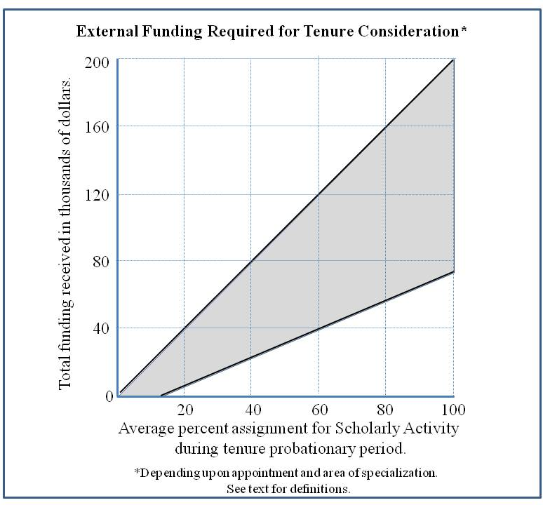
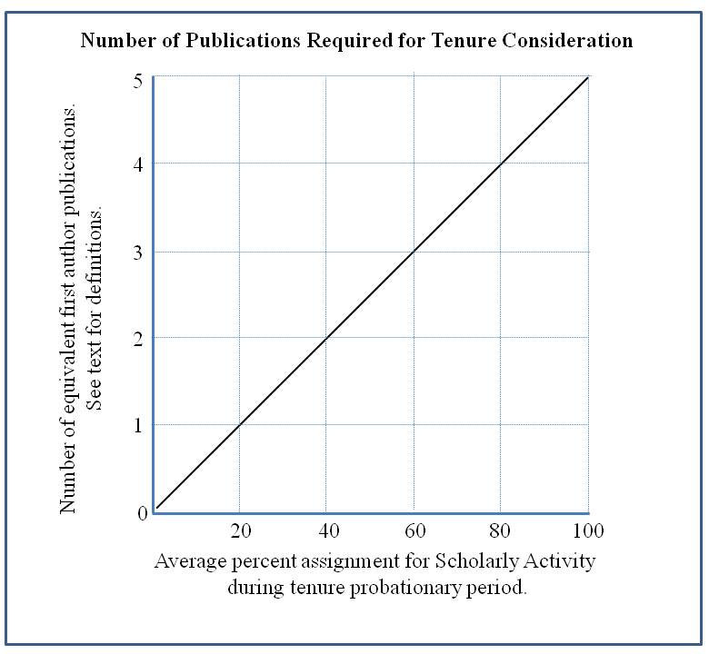

Determination of Annual Allocation of Effort and Associated Performance Levels for Promotion Consideration

This document is available at: CAHNS site → Faculty and Staff Portal → Tenure and Promotion
or directly at: http://www.tnstate.edu/agriculture/information_for_facultty_and_staff.aspx

To determine your allocation of effort, double-click the table below and enter the appropriate information for the current year period in the green boxes. Unless otherwise approved, all faculty have a 10% service allocation.

* Equivalent non-traditional contact hours are defined as: one (1) 3-credit undergraduate class is equivalent to 45 hours of communication of knowledge through planned, structured and evaluated instruction. Indirect contacts (i.e. newspaper, radio, publications, etc.) do not factor into the direct contact hour calculation. See section VII. Promotion Criteria, 1. Instruction, for information on non-traditional instruction activities.

Allocation percentages are based upon the following calculations:

100% undergraduate teaching load= 39 hours/year
100% graduate teaching load= 31 hours/year
Major professor for M.S. student = 6% each student (limit two years per student)
Major professor for PhD student = 9% each student (limit three years per student)

Determination of Performance Levels for Promotion Consideration

Annual percentage of effort for scholarly activity is averaged over the multi-year period under consideration to determine the annual percent assignment used in the charts below.

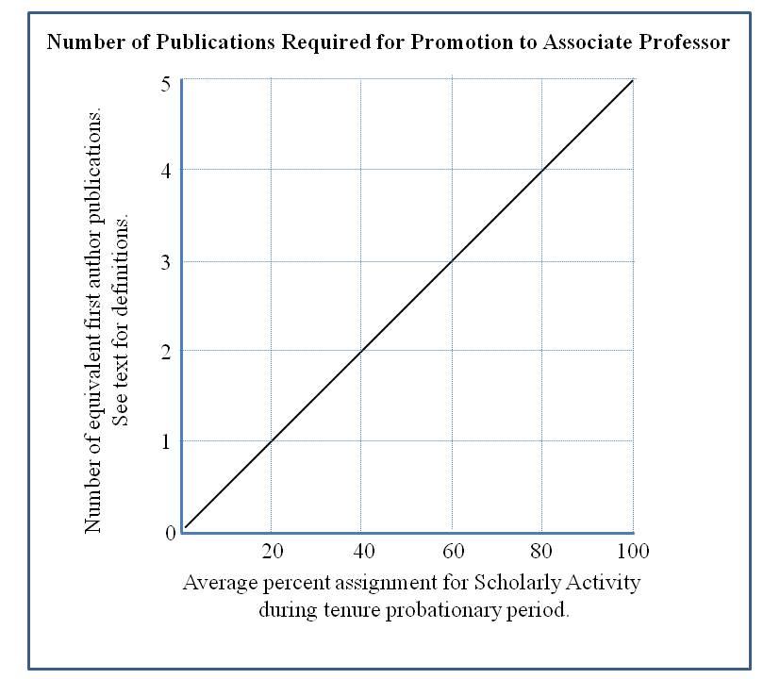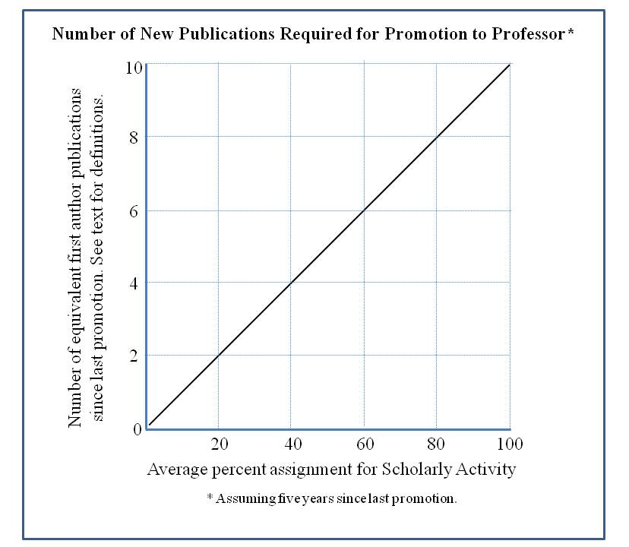
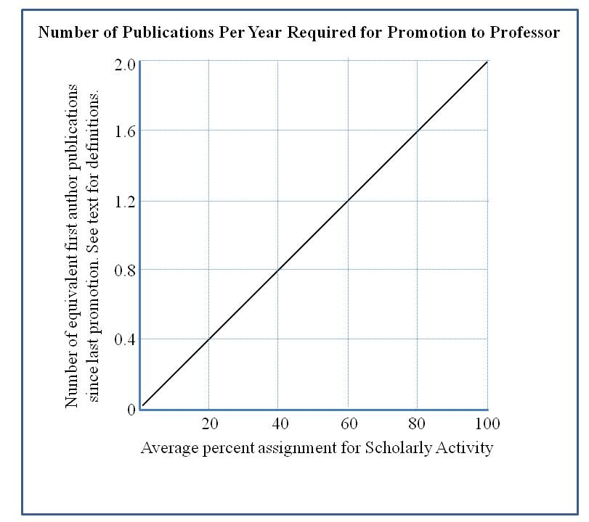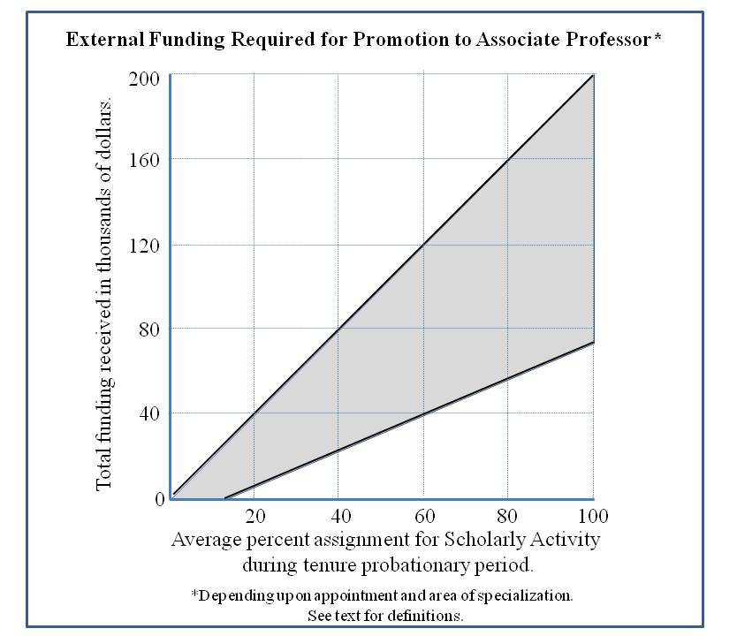
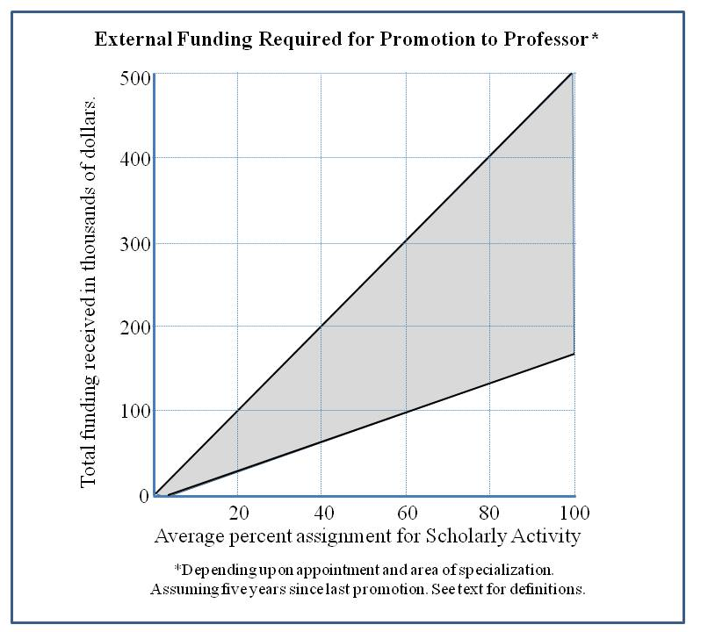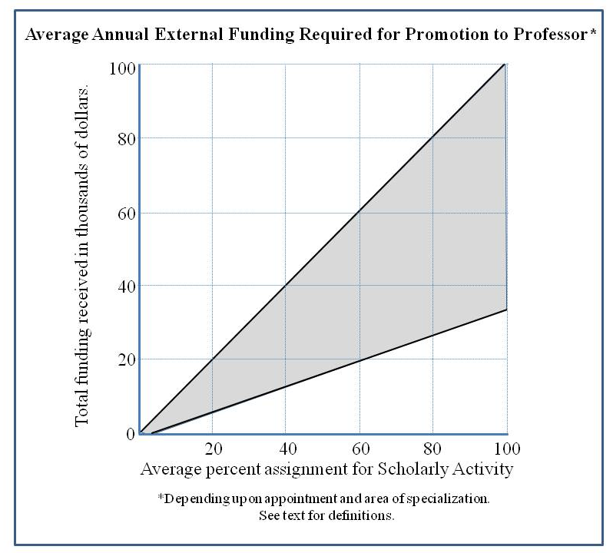
Hypothetical Scenarios for Land-grant Faculty Tenure and Promotion

Tenure/Promotion to Associate Professor Scenario

Faculty Appointment:
60% Scholarly Activity, 30% Instruction, 10% Service (example only, actual appointment percentages will vary by faculty member)

Base qualifications ¹:
One publication total during initial three-year program establishment period, two publications per year afterward
$33,000- $100,000 external funding per year after program establishment period

Requirements for to qualify for consideration of tenure consideration of this faculty member (productivity after five years):

- Three full-length, refereed senior author research publications in discipline ²
- $40,000 -$120,000 in external funding ³ (depending on appointment and area of specialization)
- Demonstrated peer recognition of program at the state, regional, national and/or international levels
- Program addresses the needs of, and is linked to, a significant state, regional, national or international end-user community
- The faculty member actively provides mechanisms for knowledge or technology transfer to the end-user community
- Documented excellence in instruction, appropriate to percentage appointment
- Documented excellence in service, appropriate to percentage appointment

¹ Following program establishment (years 1-3), and adjusted for percentage appointment in scholarly activity, a Land-grant faculty member is expected to average two full-length senior author publications per year and obtain one externally funded grant every three years (current average grant size is $300,000-$500,000). At minimum, the faculty member should obtain $33,000- $100,000 annually as PI (depending on appointment and area of specialization).

² Years one to three require one publication total, years four and five require two publications each for a total of five required publications; 60% appointment x 5 publications = 3 publications required.

³ Years one to three require no funding, years three and four require $33,000-$100,000 in funding each year for a total of $66,000-$200,000 required funding;
60% appointment x [$66,000-$200,000] = $40,000 -$120,000 funding required.

Promotion from Associate Professor to Full Professor Scenario

Faculty Appointment:
60% Scholarly Activity, 30% Instruction, 10% Service (example only, actual appointment percentages will vary by faculty member)

Base qualifications ⁴:
Two full-length refereed publications per year in discipline
$33,000- $100,000 external funding per year

Requirements for promotion to Full Professor (assuming five years since last promotion):
- Six full-length refereed senior author research publications in discipline since last promotion ⁵
- $99,000 - $300,000 (relative to percentage appointment and area of specialization) in extramural funding since last promotion or rank appointment ⁶
- Demonstrated peer recognition of program at the state, regional, national and/or international levels
- Program addresses the needs of, and is linked to, a significant state, regional, national or international end-user community
- The faculty member actively provides mechanisms for knowledge or technology transfer to the end-user community
- Documented excellence in instruction, appropriate to percentage appointment
- Documented excellence in service, appropriate to percentage appointment

⁴ Adjusted for percentage appointment in scholarly activity, an Associate Professor Land-grant faculty member is expected to average two full-length senior author publications per year and obtain one externally funded grant every three years (current average grant size is $300,000-$500,000). At minimum, the faculty member should obtain $33,000- $100,000 annually as PI (depending on appointment and area of specialization).

⁵ Two publications per year for five years for a total of ten publications;
60% appointment x 10 publications = 6 publications required.

⁶ $33,000-$100,000 per year for five years = $165,000-$500,000 total in funding required; 60% appointment x [$165,000-$500,000] = $99,000 - $300,000 funding required.

